Week 6 Preparing date: October …..,
Period 21 Teaching date: October ………….,

Unit 3: Our friends
Lesson 3 (1, 2, 3)
A. OBJECTIVES:
By the end of the lesson, Ss will be able to:
1. Knowledge:
- correctly pronounce the sounds of the letters th (voiced) and th (unvoiced) in isolation, in the words this and that, and in the sentences That’s Lucy and Thank you.
- identify the target words that and thank, and the sentences Thank you, Bill and That’s Lucy while listening.
- say the chant with the correct rhythm and pronunciation.
- Vocabulary: Review
- Skills: speaking, listening, reading and writing.
2. Competences:
- Listening: listen and recognize someone, then repeat
- Co-operation: ready to help friends in pair work/ group work.
- Sociability: Talk to each other, say good words to others.
3. Attitude/ Qualities:
- Kindness: Help partners to complete learning tasks.
- Honesty: tell the truth about feelings and emotions
B. TEACHING AIDS:
- Teacher: Teacher’s guide Pages 47, 48; audio Tracks 32, 33, 34; website sachmem.vn, posters, laptop, pictures, textbook, lesson plan, TV or projector.
- Students: Pupil’s book Page 26, notebooks, workbooks, school things.
C. PROCEDURES:
Stages/Time | Teacher’s activities | Students’ activities
1.Warm- up:  (5’)  2. Presentation  (9’)  3.Practice: (19’)  4. Homework. (2’) | Game: Find and circle the words  *Aims: to create a friendly and active atmosphere in the class to beginning the lesson.  *Procedure:  - Divide class into 2 groups  - Ask Ss to find and circle the words and characters that they learnt.  - Which groups find the best correct words is winner.  - Give Ss time to play the game.  Rows: that, this  Columns: thank, Lucy, Bill  -T checks who’s winner?  - Say “Open your book page 26” and look at “Unit 3, Lesson 3 (1,2,3)”.  Activity 1. Listen and repeat:  *Aims: Ss will be able to correctly repeat the sounds of the letters th (voiced) and th (unvoiced) in isolation, the words that and thank, and the sentences That’s Lucy. and Thank you. with correct pronunciation and intonation.  *Procedure:  - T gives instruction to the letter th (voiced) and th (unvoiced) in isolation, the words that and thank, and the sentences That’s Lucy. and Thank you.  - Play the recording for the letter th (voiced) and th (unvoiced)  - Encourage Ss to point at the letter/ word/ sentence while listening.  - Play the recording again and encourage Ss to listen and repeat. - Do this several times until Ss feel confident.  - T calls some Ss to practice.  - T gives feedbacks.  Activity 2. Listen and tick.  *Aims: Ss will be able to identify the target words that and thank while listening.  *Procedure:  - Elicit the sentences and check comprehension about three sentence options  - T ask Ss to guess the answers.  + T writes Ss’guessing on the board.  - Listen to the tape:  + Play the recording  + Play the recording again and get Ss to swap books with their partners.  + Play the recording again to check answers together as a class.  + Write the answers on the board for Ss to correct their answers. Then checks Ss’ guessing.  - Play the recording, sentence by sentence, for the class to listen and repeat in chorus.  - Invite one or two Ss to stand up and read the sentences.  Key: 1.b 2.a  Activity 3. Let’s chant  *Aims: Ss will be able to say the chant with the correct rhythm and pronunciation.  *Procedure:  - Introduce the title and lyrics of the chant.  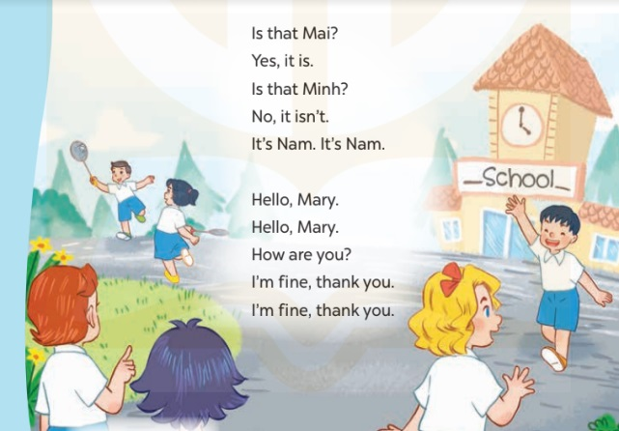  - Play the recording for Ss to listen to the whole chant.  + Have them repeat the title and lyrics line by line.  + Ask Ss to attend to the sounds of the letters th and the words that and thank.  - Play the recording all the way through for Ss to listen to pronunciation and melody.  - Play the recording line by line for Ss to listen and repeat  - Play the recording for Ss to chant and clap along.  - Ask Ss to practice chant and clap along in pairs or groups.  - Invite groups to the front of the classroom to perform the chant  -T gives feedback.  *Consolidation  *Aims: Ss will be able consolidate and wrap up the content of the lesson.  *Procedure:  - T asks ss to answer the following questions:  + What have you learnt from the lesson today?  +What are the core values of the lesson? (if the teacher can take from the lesson).  - T review the vocabulary and model sentences.  - T praises some Ss who are hardworking / active/ good…. as well as encourage others to try more.  - Practice the chant more.  - Draw and colour three pictures of your friends.  - Prepare the new lesson: Unit 3, Lesson 3 (4,5,6). | - Ss listen  -Ss listen the rules  - Ss play the game  - Ss open their books  - Ss recognize the differences about color of letter  - - Ss listen  - Ss listen and point  - Ss listen again and repeat  -Ss listen again and repeat  -Ss practice  -Ss listen  -Ss listen and say  -Ss guess the answers  - Ss listen to the tape and tick  - Ss listen again, tick and swap books with their partners.  - Ss check their answers and guessing  -Ss listen and repeat.  -Ss read the sentences  - Ss look and listen.  -Ss listen to the chant  - Ss listen and repeat line by line without clap their hands  -Ss note the sounds, words  -Ss listen to melody of the song  - Ss listen and chant line by line.  - Ss chant and clap along.  - Ss work in groups (two groups) to chant  -Ss perform in front of the class.  -Ss listen  -Ss listen.  -Ss listen  -Ss answer the questions  - Ss listen  -Ss listen and clap their hands  -Ss listen and take note
  T | H | A | T | E | R | S | C | B | T
  H | C | T | H | N | O | H | C | I | H
  C | L | U | A | A | L | A | O | L | I
  L | E | L | N | N | U | T | S | L | N
  A | A | W | K | E | C | O | E | O | K
  S | N | J | Z | R | Y | I | I | P | B
  S | R | O | E | E | T | V | C | A | H
  S | T | H | I | S | R | S | D | A | Y
  D | T | S | S | R | I | O | T | S | M

D. ADJUSTMENTS (if necessary):
………………………………………………………………………………………….…..……………………………………………………………………………...………………………………………….…..……………………………………………………………………………….……………………………………………………………………...

Week 6 Preparing date: October …..,
Period 22 Teaching date: October ………….,

Unit 3: Our friends
Lesson 3 (4, 5, 6)
A. OBJECTIVES:
By the end of the lesson, Ss will be able to:
1. Knowledge:
- read and match four target sentence patterns with four pictures
- read, understand and complete three sentences by writing the target words in the gaps.
- draw three pictures of their friends and introduce them to the class.
- Vocabulary: Review
- Skills: speaking, listening, reading and writing.
2. Competences:
- Critical Thinking: self-introduce
- Co-operation: ready to help friends in pair work/ group work.
- Self-control and independent learning: perform listening tasks.
3. Attitude/ Qualities:
- Kindness: Help partners to complete learning tasks.
- Honesty: tell the truth about feelings and emotions.
- Diligence: complete learning tasks.
B. TEACHING AIDS:
- Teacher: Teacher’s guide Pages 49, 50, website sachmem.vn, posters, laptop, pictures, textbook, lesson plan, TV or projector.
- Students: Pupil’s book Page 27, notebooks, workbooks, school things.
C. PROCEDURES:
Stages/Time | Teacher’s activities | Students’ activities
1.Warm- up:  (5’)  2.Practice: (8’)  3.Production: (19’)  4. Homework. (3’) | Game: “Chant”  *Aims: to create a friendly and active atmosphere in the class to beginning the lesson.  *Procedure:  - Ask Ss chant and do the actions in Unit 3, Lesson 3 page 26 in groups.  - Give point for the groups and encourage them.  - Say “Open your book page 27” and look at “Unit 3, Lesson 3 (4,5,6)”.  Activity 1. Read and match:  *Aims: Ss will be able to read and match four target sentence patterns with four pictures.  *Procedure:  - Ask Ss some questions:  + Who are they?  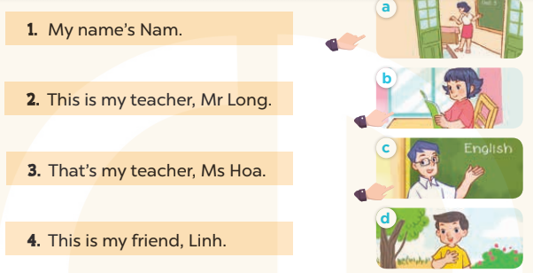  - T models with sentence 1.  + Get Ss to read Sentence 1  + Have Ss look at the pictures and match the sentences with the correct picture.  -Have Ss work in pairs and match the sentences 2, 3, 4.  - Tell Ss to swap books with a partner, then check answers together as a class.  - Write the correct answers on the board for pupils to correct their answers.  - Invite pairs of Ss to stand up and role play  -T gives feedbacks.  Key: 1. d 2. c 3. a 4. b  Activity 2. Let’s write  *Aims: Ss will be able to read, understand and complete three sentences by writing the target words in the gaps.  *Procedure:  - Write the first incomplete sentence on the board and encourage Ss to say the answer.  1.This …….. my friend, Mai.  - Give Ss time to write the answer in their notebooks.  - Ask Ss to write the answers to the sentences 2 and 3.  - Get Ss to swap books with a partner, then check the answers together as a class.  - Ask a few Ss to stand up and read the sentences in front of the class.  -T gives feedbacks.  Key: 1. Is  2. This is my  3. That’s my teacher  Activity 3. Project.  *Aims: Ss will be able to draw three pictures of their friends and use them to practise talking to their classmates.  *Procedure:  - Ask Ss to draw three pictures of their friends as homework at the beginning of Unit 3 -Lesson 3 (4,5,6)  - Show the pictures of his/ her friends and model with This is my friend, Hoa.  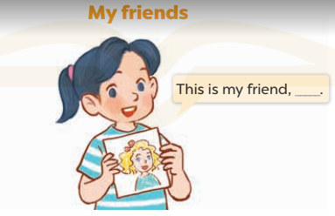  - T asks ss to work in groups and show the pictures of their friends to talk to the groups such as This is my friend, (name).  - T calls some Ss to the front of the class to present their friends, and saying Hello. My name’s….  I’m…….years old. This is my friends,……  - Have Ss to stick their pictures on the wall of the classroom  - Create a class display using the pictures and vote for the most creative.  - T gives feedback.  *Consolidation  *Aims: Ss will be able consolidate and wrap up the content of the lesson.  *Procedure:  - T asks ss to answer the following questions:  + What have you learnt from the lesson today?  +What are the core values of the lesson? (if the teacher can take from the lesson).  - T praises some Ss who are hardworking / active/ good…. as well as encourage others to try more.  - Prepare the new lesson: Unit 4, Lesson 1 (1,2,3). | - Ss listen and chant  - Ss open their books  - Ss look at the pictures and answer  My name's Nam  -Ss read and match  -Ss work in pairs and match  -Ss swap books and check  -Ss check the correct their answers  -Ss role play  -Ss listen  -Ss look at the sentence and say the answer:  +This is my friend, Mai.  -Ss write the answer  -Ss write  -Ss swap books and check their answers  -Ss read the sentences  -Ss listen  - Ss drew and coloured draw three pictures of their friends at home.  -Ss listen to the teacher  -Ss work in groups  -Ss present their pictures  - Ss stick their pictures on the wall of the classroom.  -Ss vote  -Ss listen  -Ss answer the questions  -Ss listen and clap their hands  -Ss listen and take note
D. ADJUSTMENTS (if necessary):
………………………………………………………………………………………….…..……………………………………………………………………………...…………

Week 6 Preparing date: October …..,
Period 23 Teaching date: October …..,

Unit 4: Our bodies
Lesson 1 (1, 2, 3)
A. OBJECTIVES:
By the end of the lesson, Ss will be able to:
1. Knowledge:
- use the words ear, eye, face, hand, nose in relation to the topic “Our bodies”
- understand and correctly repeat the sentences in two communicative contexts (pictures) to talk about their body parts.
- use What’s this? – It’s…………. to identify parts of the body.
- Vocabulary: face, hand, ear, eye, nose
- Skills: speaking and listening
2. Competences:
- Critical Thinking: self-introduce
- Co-operation: ready to help friends in pair work/ group work.
- Sociability: Talk to each other, say good words to others.
3. Attitude/ Qualities:
- Kindness: Help partners to complete learning tasks.
- Honesty: tell the truth about feelings and emotions
B. TEACHING AIDS:
- Teacher: Teacher’s guide Pages 51, 52, audio Tracks 35, 36, website sachmem.vn, posters, laptop, pictures, textbook, lesson plan, TV or projector.
- Students: Pupil’s book Page 28, notebooks, workbooks, school things.
C. PROCEDURES:
Stages/Time | Teacher’s activities | Students’ activities
1.Warm- up:  (3’)  2. Presentation  (16’)  3.Practice: (7’)  4.Production: (7’)  5. Homework. (2’) | Sing: My body song  *Aims: to create a friendly and active atmosphere in the class to beginning the lesson.  *Procedure:  - Show the song on the screen.  https://www.youtube.com/watch?v=AlKXoHvwluA  - Ask pupils to listen, sing and dance the song.  - Say “Open your book page 28” and look at “Unit 4, Lesson 1 (1,2,3)”.  Activity 1. Vocabulary.  *Aims: Ss will be able to know the vocabulary in front of starting the new lesson.  *Procedure:  -T elicits the new words  + face : khuôn mặt (realia)  + eye :con mắt (realia)  + ear :tai (realia)  + nose : mũi (realia)  + hand :bàn tay (realia)  - T models (3 times).  - T writes the words on the board.  - Checking: Rub out and remember  Activity 2. 1. Listen, point and repeat:  *Aims: Ss will be able to understand and correctly repeat the sentences in two communicative contexts (pictures) focusing on identifying parts of the body.  *Procedure:  - Have Ss look at Pictures a and b and identify the characters in the pictures.  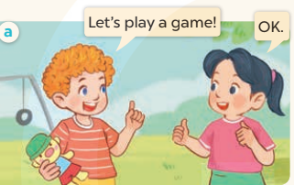  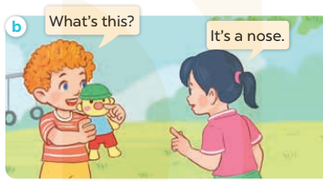  - Play the audio twice (sentence by sentence). Correct their pronunciation where necessary.  - Have Ss to practice the dialogue  - T invites a few pairs to the front of the class to practice.  - T checks pronunciation for ss.  Activity 3 2. Listen, point and say.  *Aims: Ss will be able to correctly say the words and use What’s this? – It’s …….. to identify parts of the body.  *Procedure:  * Model sentences:  - T asks Ss look at picture b and helps Ss know the structure from the dialogue.  - T introduces new structure for Ss.  - T explains, models and gives meaning.  -Have Ss repeat the model sentences.  A: What’s this?  B: It’s a nose.  *Drill pictures  - Elicit and check comprehension the parts of the body.  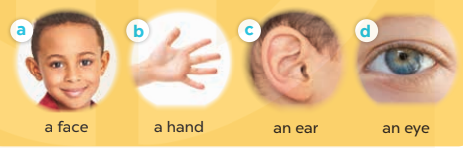  - Run through all the pictures.  - Run through model sentences.  - Have Ss to practise:  + T asks the first picture, Ss answer  + Ss asks the second picture, T answers  + Group A asks the third picture, group B answers  + Group B asks the last picture, group A answers.  - Ask Ss to work in pairs.  - T controls and corrects.  - Invite a few pairs to come to the front of the classroom, point at the pictures, and say the questions and answers in front of the class.  - T gives feedbacks.  Activity 4. Let’s talk.  *Aims: Ss will be able to enhance the correct use of What’s this? and It’s ……. to identify parts of the body in context.  *Procedure:  - Have Ss look at the two bubbles and picture to understand how the question and answer are used.  +What’s this? It’s ……..  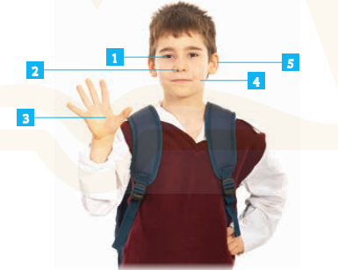  - T fills the gaps and writes the sentences on the board.  - T models  - T asks Ss to ask and answer the parts of body (groups of four)  - Have Ss point at their body parts and ask and answer questions about them using the structures learnt.  - Give feedbacks  *Consolidation  *Aims: Ss will be able consolidate and wrap up the content of the lesson.  *Procedure:  - T asks ss to answer the following questions:  + What have you learnt from the lesson today?  +What are the core values of the lesson? (if the teacher can take from the lesson).  - T review the vocabulary and model sentences.  - T praises some Ss who are hardworking / active/ good…. as well as encourage others to try more.  - Learn the vocabulary and model sentences by heart  - Prepare the new lesson: Unit 4, Lesson 1 (4,5,6). | - Ss sing and dance the song  - Ss open their books  -Ss listen and answer  - - Ss listen and repeat  + Choral repetition (3 times).  + Individual repetition (3 ss)  - Ss take note  - Ss look, remember and match  -Look at the pictures and get to know the characters in the pictures.  + In picture a: Bill says: Let’s play a game! And Mai says: OK  + In picture b: Bill asks: What’s this. And Mai answers: It’s a nose.  -Ss listen and repeat in chorus (twice)  -Ss work in pairs to practice  -Ss practice the dialogue  -Ss listen  -Ss look at the picture and answer.  -Ss listen  -Ss listen and repeat  -Ss repeat to parts of the body.  - Ss look, listen and answer  +Picture a: a face  + Picture b: a hand  + Picture c: an ear  + Picture d: an eye  -Ss listen and repeat  -Ss practice in chorus  -Ss work in pairs to practice  -Ss point and say  -Ss listen.  -Ss look at the bubbles and picture and answer  + It’s ………..  -Ss note  - Ss answer  -Ss work in groups  -Ss perform in front of the class.  -Ss answer the questions  - Ss listen  -Ss listen and clap their hands  -Ss listen and take note

D. ADJUSTMENTS (if necessary):
………………………………………………………………………………………….…..……………………………………………………………………………...………………………………………….…..……………………………………………………………………………….……………………………………………………………………...

Week 6 Preparing date: October …..,
Period 24 Teaching date: October …..,

Unit 4: Our bodies
Lesson 1 (4,5,6)
A. OBJECTIVES:
By the end of the lesson, Ss will be able to:
1. Knowledge:
- listen to and understand two communicative contexts in which Ss ask and answer the question to identify parts of the body
- read and complete the sentences correctly.
- sing the song “Parts of the body” with the correct pronunciation and melody.
- Vocabulary: Review
- Skills: speaking, listening, reading and writing.
2. Competences:
- Critical Thinking: self-introduce
- Co-operation: ready to help friends in pair work/ group work.
- Self-control and independent learning: perform listening tasks.
3. Attitude/ Qualities:
- Kindness: Help partners to complete learning tasks.
- Honesty: tell the truth about feelings and emotions.
- Diligence: complete learning tasks.
B. TEACHING AIDS:
- Teacher: Teacher’s guide Pages 53, 54; audio Tracks 37, 38; website sachmem.vn, posters, laptop, pictures, textbook, lesson plan, TV or projector.
- Students: Pupil’s book Page 29, notebooks, workbooks, school things.
C. PROCEDURES:
Stages/Time | Teacher’s activities | Students’ activities
1.Warm- up:  (5’)  2.Practice: (27’)  3. Homework. (3’) | Game: Who is faster?  *Aims: to create a friendly and active atmosphere in the class to beginning the lesson.  *Procedure:  - Divide the class into 2 big groups: Boys and Girls.  - Have two Ss stand back to back. Give them each a different flashcard to hold facing out and away from them.  - When teacher says Go, they walk three steps, turn to face each other and say what the other Ss has.  - The faster one will get a point.  - Say “Open your book page 29” and look at “Unit 4, Lesson 1 (4,5,6)”.  Activity 1. Listen and tick:  *Aims: Ss will be able to listen to and understand two communicative contexts in which pupils ask and answer questions to identify parts of the body  *Procedure:  - Elicit the names of the body part in each picture.  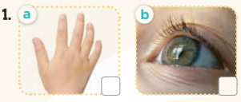  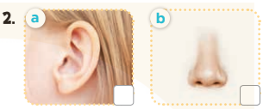  - T ask Ss to guess the answers.  + T writes Ss’guessing on the board.  - Listen to the tape:  + Play the recording  + Play the recording again and get Ss to swap books with their partners.  + Play the recording again to check answers together as a class.  + Write the answers on the board for Ss to correct their answers. Then checks Ss’ guessing.  - Play the recording, sentence by sentence, for the class to listen and repeat in chorus.  Key: 1.a 2.a  Activity 2. Look, complete and read.  *Aims: Ss will be able to complete four target sentence patterns with the help of the picture cues.  *Procedure:  - Get Ss to look at the pictures and identify the body parts in the pictures.  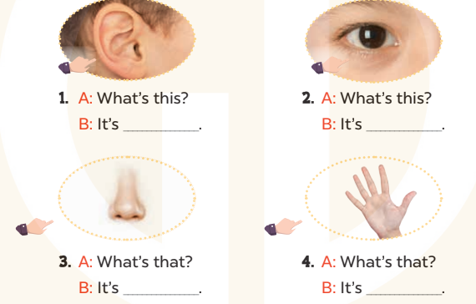  - Have Ss look at the four incomplete dialogues and elicits the missing words in the sentences.  - T models with picture 1  + Ask Ss what is missing in the sentence.  + Have Ss look at the picture and complete the gap, then read the completed sentence in chorus.  -Have Ss work in groups and complete the picture 2, 3 and 4.  - Ask a few Ss to stand up and read the completed sentences aloud.  -T gives feedbacks.  Key: 1. an ear 2. an eye  3. a nose 4. a hand  Activity 3. Let’s sing.  *Aims: Ss will be able to sing the song Parts of the body with the correct pronunciation and melody.  *Procedure:  - Introduce the title and lyrics of the song: “ Parts of the body ”  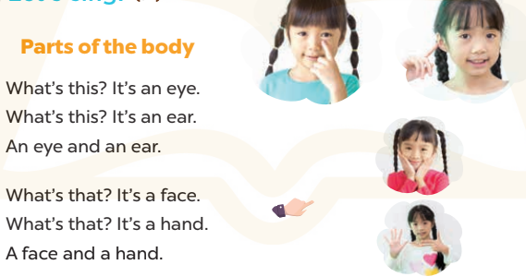  - Play the recording for Ss to listen to the whole song.  + Have them repeat the title and lyrics line by line.  + Tell Ss to point at the parts of their body while singing his or her name.  - Play the recording all the way through for Ss to listen to pronunciation and melody of the song.  - Play the recording line by line for Ss to listen, repeat and point to the part of their body  - Play the recording for Ss to sing and do actions.  - Ask Ss to practice singing and doing actions in pairs or groups.  - Invite groups to the front of the classroom to perform the song  -T gives feedback.  *Consolidation  *Aims: Ss will be able consolidate and wrap up the content of the lesson.  *Procedure:  - T asks ss to answer the following questions:  + What have you learnt from the lesson today?  +What are the core values of the lesson? (if the teacher can take from the lesson).  - T praises some Ss who are hardworking / active/ good…. as well as encourage others to try more.  - Practice part 5 again.  - Prepare the new lesson: Unit 4, Lesson 2 (1,2,3). | - Ss listen to the rule  - Ss play game  -Ss listen  - Ss open their books  -Look at the pictures and say:  + Picture 1a: a hand  + Picture 1b: an eye  + Picture 2a: an ear  + Picture 2b: a nose  -Ss guess the answers  - Ss listen to the tape and tick  - Ss listen again, tick and swap books with their partners.  - Ss check their answers and guessing  -Ss listen and repeat.  -Ss look at the picture and say:  + an ear, an eye, a nose and a hand.  -Ss look and answer  -Ss answer: It’s an ear….  -Ss look, complete and read the completed sentence in chorus.  -Ss complete the sentences  -Ss read aloud  - Ss look and listen.  -Ss listen to the song  - Ss listen and repeat line by line without the action.  -Ss point to the parts of their body while singing  -Ss listen to melody of the song  - Ss listen and sing line by line.  - Ss sing and do actions.  + Ss work in groups (two groups) to sing.  -Ss perform in front of the class.  -Ss listen  -Ss answer the questions  -Ss listen and clap their hands  -Ss listen and take note

D. ADJUSTMENTS (if necessary):
………………………………………………………………………………………….…..……………………………………………………………………………...………………………………………….…..……………………………………………………………………………….……………………………………………………………………...

