UNIT 20
WHERE’S SAPA?

Part 1. Vocabulary.
English | Pronunciation | Vietnamese
north | /nɔːθ/ | miền/hướng bắc
south | /saʊθ/ | miền/hướng nam
central | /ˈsentrəl/ | miền trung
near | /nɪə(r)/ | gần
far | /fɑː(r)/ | xa
bay | /beɪ/ | vịnh
mountain | /ˈmaʊntɪn/ | ngọn núi
village | /ˈvɪlɪdʒ/ | làng, xã
city | /ˈsɪti/ | thành phố
town | /taʊn/ | thị trấn
where | /weə(r)/ | ở đâu
Water Puppet Theatre | /ˈwɔːtər ˈpʌpɪt ˈθɪətər/ | rạp múa rối nước
temple | /ˈtempl/ | ngôi đền
museum | /mjuːˈziːəm/ | viện bảo tàng
place | /pleɪs/ | địa điểm
Part 2. Grammar.
1. Khi muốn hỏi về một nơi chốn (địa danh) nào đó ở đâu, ta thường sử dụng mẫu câu sau:
Where is + danh từ chỉ địa danh?......Ở đâu
Và để trả lời cho câu hỏi trên, chúng ta sử dụng mẫu câu sau:
It's in + từ chỉ vị trí. Nó ở .....
Từ chỉ vị trí ở đây là: North (miền Bắc), Central (miền Trung), South (miền Nam)
Ex: Where is Nha Trang?
Nha Trang ở đâu?
It's in Central Vietnam.
Nó ở miền Trung Việt Nam.
2. Khi muốn hỏi về khoảng cách của địa danh này với địa danh khác, ta có thể sử dụng cấu trúc sau:
Is + danh từ chỉ địa danh + near + danh từ chỉ địa danh? ... gần... phải không?
Để trả lời cho câu hỏi trên, chúng ta có 2 cách trả lời:
- Nếu trả lời đúng với ý câu hỏi thì:
Yes, it is.
Vâng, nó gần.
- Còn nếu trả lời không đúng (nó không gần) với ý câu hỏi thì:
No, it isn’t. It’s far from + danh từ chỉ địa danh.
Không, nó không gần. Nó xa so với...
Part 3. Practice .
Task 1. Odd one out.
1) A. North B. central C. south D. Sapa
2) A. from B. in C. is D. of
3) A. Da Nang B.Hue C. Sapa D. Bay
4) A. far B. near C. big D. how
5) A. She B. He C. You D. It
Task 2.
1. Where is Sapa? | a. It is in North Vietnam. | 1. ………
2. Where are you cycling? | b. It's cloudy and windy. | 2. ………
3. What's the weather like in Hanoi? | c. In the park. | 3. ………
4. What are they doing? | d. Yes, it is. | 4. ………
5. Is it sunny today? | e. They are flying kites | 1. ………
Task 3. Choose the answer.
- Is Hue……….. Da nang?- Yes, it is
A. far B.near C.new D.out
2. This....................a photo of Ha Long Bay ?
A. are B. is C. being D. it
3. How many……….are there?
A. cloud B. clouds C. cloudy D. cloudys
4 ………is that? - That is my father.
A. What B. Who C. How D.It
5. Where is Ha Noi? It is in ..................Viet nam
A. North B. central C. south D. from
Task 4. Look and write. There is one example.
Example: | hoscol → school | 

1. contury → c_ _ _ _ _ _ | 2. cyit → c_ _ _ | 3. yab → b_ _
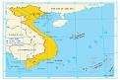 | 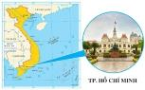 | 
4. lavigel → v_ _ _ _ _ _ | 5. leka → l_ _ _
 | 
Task 5. Look and read. Tick or cross the box. There are two examples.
Examples:
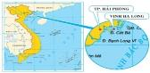  - Ha Long Bay is near Hai Phong. | 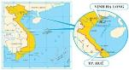  B. Ha Long Bay is near Hue.

1. Hải Duong is near Ha Noi.  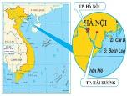 | 2. Ho Chi Minh City is in central Viet Nam.  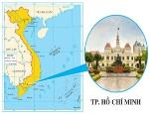
3. Ha Long Bay is in north Viet Nam.  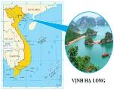 | 4. Hoi An is far from Ha Noi.  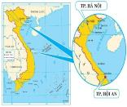
5. I live near a bay.   | 6. Ho Chi Minh is in South. Viet Nam.  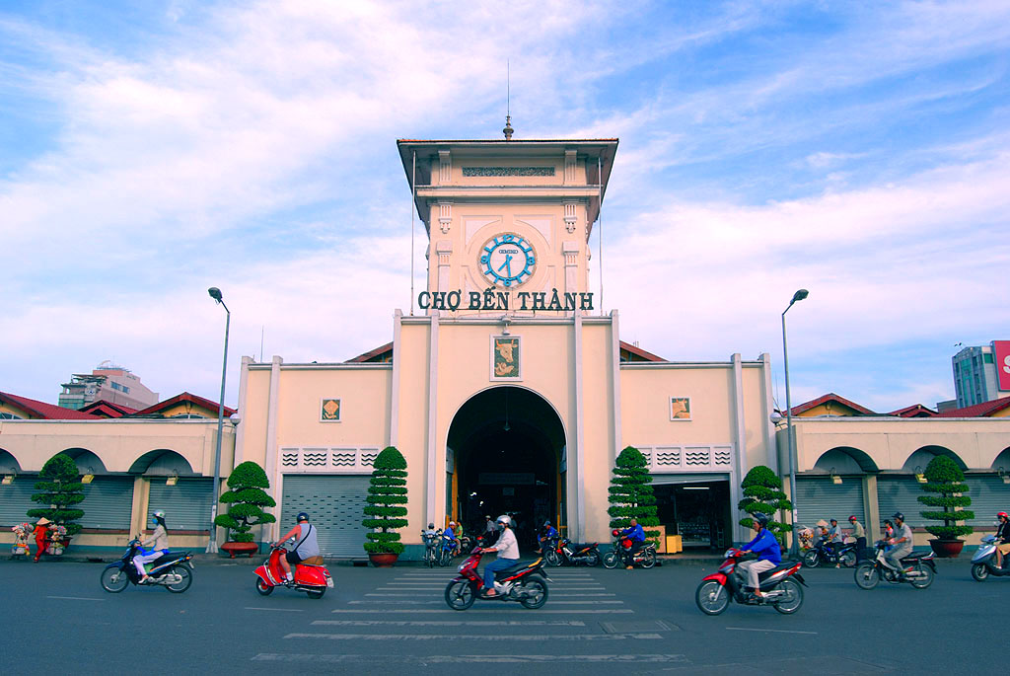
Task 6. Read and complete. There is one example (0).

far
central
North
Sapa
too
map

Look at the (0) map of Viet Nam. It is a big country. This is (1) ______ . It is a small town in (2) ______ Viet Nam. Hai Phong is in north Viet Nam (3) ______ . Hoi An and Da Nang are in (4) ______ Viet Nam. Hoi An is near Da Nang but (5) ______ from Ha Noi. Ho Chi Minh City is a big city in south Viet Nam. Where is your place?
Task 7. Choose the answer.
1.Is Hue……….. Da nang?- Yes, it is
A. far B.near C.new D.out
2. This....................a photo of Ha Long Bay ?
A. are B. is C. being D. it
3. How many……….are there?
A. cloud B. clouds C. cloudy D. cloudys
4 ………is that? - That is my father.
A. What B. Who C. How D.It
5. Where is Ha Noi? It is..................Viet nam
A. North B. central C. south D. From
Task 8. Look at the picture and answer the questions.

1. Where is Sapa?  ……………………………………………………….  2. Where is Hue ?  ……………………………………………………….  3. Where is Thanh Hoa?  ……………………………………………………….  4. Is Ha Noi near Ha Long Bay ?  ……………………………………………………….  5. Where is Ho Chi Minh city ?  ……………………………………………………….  6. Is Ho Chi Minh near Hoi An ?  ……………………………………………………….  7. Is Hue in South Vietnam?  ……………………………………………………… | 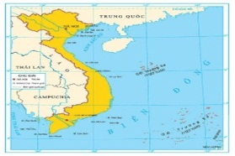
Task 9. Read and tick () or cross ().
Dear Linda,
Today my family is in Thanh Hoa city. It’s a small city in central Viet Nam. It’s far from Ha Noi. There are many interesting places in the city. We want to visit Tay Thanh Market, Hoi An Park, Ha Van Mao Zoo. The weather is nice. It’s sunny and a little windy. I love the city very much.
Write to me soon.
Best wishes,
Hang
1) Thanh Hoa city is a small city.
2) It’s in North Viet Nam.
3) The city is near Ha Noi.
4) Hang loves her city very much .
5) Hang and her family want to go to Hoi An Park.
Task 10.Put the words in order.
1. family / My / is/ Phu Yen/ in/ .
……………………………………………………….……………………………………………………….
2. Is/ Da Nang/ in/ Viet Nam/ central / ?
……………………………………………………………………………………….……………………….
3.is / Phu Yen / Binh Dinh / between/ Khanh Hoa/ and/ .
……………………………………………………….……………………………………………………….
4.very / far/ It/ is / and/ Ho Chi Minh/ from / Ha Noi city/ .
……………………………………………………….……………………………………………………….
5.and/ sea / There / rice / fields, / mountains, / are rivers/ .
……………………………………………………….……………………………………………………….
6.Viet Nam. / is / a / Ho Chi Minh city / in / south/ big / city
……………………………………………………….……………………………………………………….
7. Is / Hue/ near/ Ho Chi Minh / city/ ?
……………………………………………………….……………………………………………………….
8. weather/ What’s / the / Ha Noi/ like / in .
……………………………………………………….……………………………………………………….
ĐÁP ÁN
UNIT 20
Task 1.
1.D 2.C 3.D 4.D 5
Task 2.
1.a 2.c 3.b 4.e 5.d
Task 3.
1.B 2.B 3.B 4. B 5.A
Task 4.
1. country 2. city 3. bay 4. village 5. lake
Task 5.
1. 2. 3. 4. 5.
Task 6.
1.Sa Pa 2. north 3. too 4. central 5. Far
Task 7.
1.B 2.B 3.B 4.B 5.A
Task 8.
1. Sapa is in North Vietnam.
2. Hue is in central Vietnam.
3. Thanh hoa is in central Vietnam..
4.Yes, it is.
5. Ho Chi Minh city is in South Vietnam.
6.No, it isn’t.
7. No, it isn’t.
Task 9.
1. 2.x 3.x 4. 5.
Task 10.
1. My family is in Phu Yen.
2. Is Da Nang in central Viet Nam?
3.Phu Yen is between Binh Dinh and Khanh Hoa.
4.It is very far from Ha Noi and Ho Chi Minh city.
5.There are rice fields, mountains, rivers and sea.
6.Ho Chi Minh city is a big city in south Viet Nam.
7. Is Hue near Ho Chi Minh city ?
8. What’s the weather like in Ha Noi

