UNIT 18
WHAT ARE YOU DOING ?

Part 1. Vocabulary .
English | Pronunciation | Vietnamese
read | /riːd/ | đọc
cook | /kʊk/ | nấu
watch | /wɒtʃ/ | xem
sing | /sɪŋ/ | hát
dance | /dɑːns/ | nhảy, múa
skate | /skeɪt/ | trượt (ván, băng)
draw | /drɔː/ | vẽ
play | /pleɪ/ | chơi
listen | /ˈlɪsn/ | nghe
ride | /raɪd/ | lái
drive | /draɪv/ | lái (ô tô)
read books | /riːd bʊks/ | đọc sách
cook meals | /kʊk miːlz/ | nấu (các bữa) ăn
watch television | /wɒtʃˈtelɪvɪʒn/ | xem TV
draw pictures | /drɔː ˈpɪktʃə(r)z/ | vẽ tranh
play the piano | /pleɪðəpiˈænəʊ/ | chơi đàn piano
listen to music | /ˈlɪsn tuː ˈmjuːzɪk/ | nghe nhạc
do homework | /duː ˈhəʊmwɜːk/ | làm bài tập về nhà
do housework | /duː ˈhaʊswɜːk/ | làm việc nhà
ride a bike | /raɪd ə baɪk/ | lái xe đạp
drive a car | /draɪv ə kɑː(r)/ | lái ô tô
Part 2. Grammar.
1. Hỏi và đáp ai đó đang làm gì:
Để hỏi ai đó đang làm gì, chúng ta sử dụng cấu trúc sau:
Hỏi:
What are you doing?Bạn đang làm gì?
Đáp:
I’m + V-ing...Tôi đang...
Ex: What are you doing? Bạn đang làm gì?
I'm making a lantern. Tôi đang làm lồng đèn.
What are you doing on Sunday evening?Bạn sẽ làm gì vào tối Chủ nhật?
I am watching TV. Tôi sẽ xem tivi.
2.Khi chủ ngữ trong câu ở ngôi thứ 3 số ít là she/ he (cô ấy/ cậu ấy), chúng ta sử dụng cấu trúc sau:
Hỏi:
Ex: What's he doing? Cậu ấy đang làm gì?
He's making a lantern. Cậu ấy đang làm lồng đèn.
Part 3. Practice.
Task 1.
1.   | A. singing | B. listening | C. watching | D.doing
2.  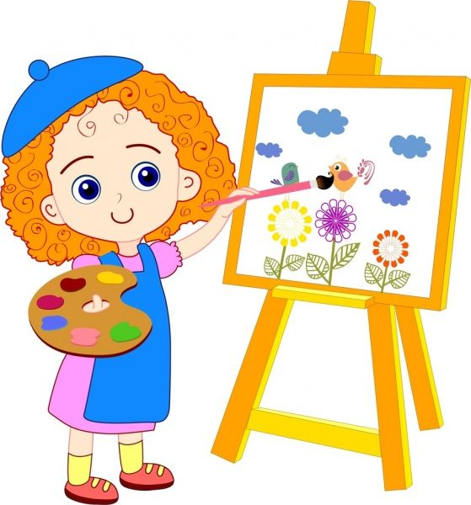 | A.playing | B.drawing | C.flying | D.riding
3.   | A.sleeping | B.reading | C.writing | D.cooking
4.   | A.skipping | B.calling | C.listening to music | D.skating
5.  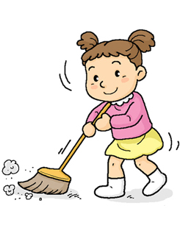 | A.riding | B.cleaning | C.cycling | D.playing the piano
6.   | A.talking | B.watching tv | C. reading | D.dancing
Task 2. Circle the odd one out.
 | a) reading | b) cooking | c) cleaning | d) sing
 | a) home | b) room | c) kitchen | d) today
 | a) house | b) dog | c) parrot | d) rabbit
 | a) floor | b) music | c) there | d) piano
 | a) in | b) on | c) under | d) sing
 | a) love | b) draw | c) watch | d) much
 | a) How | b) What | c) Where | d) There
 | a) do | b) is | c) are | d) am
Task 3. Complete the sentences with the word in the boxes.
drawing
reading
doing
sitting

playing
cleaning
cooking
writing

. He is ……………….. in his bedroom.
2. She is …………………… a picture in the garden.
3. Hoa and Ann are …………….. in the kitchen.
4. The cat is ………………… the ball on the chair.
5. The pupils are ……………… in the classroom.
6. Lan is ……………… exercise in the gym.
7. My father is ……………… the letter to my sister in the living room.
8. My brother is ……………….. his bedroom
Task 4. Look and write. There is one example.
Example:  einragd → r e a d i n g | 1. oginock → c _ _ _ _ _ _ | 2. niltnesgi → l _ _ _ _ _ _ _ _
 |  | 
3. necalnig → c _ _ _ _ _ _ _ | 4. cinghawt → w_ _ _ _ _ _ _ | 5. insgign → s _ _ _ _ _ _
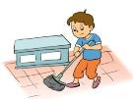 |  | 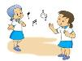
Task 5. Look and read. Tick or cross the box.
Examples:
  A. She is riding a bike. | B. She is singing.

1. She’s watching TV. |   2. He’s playing the piano. |   3. She’s singing.
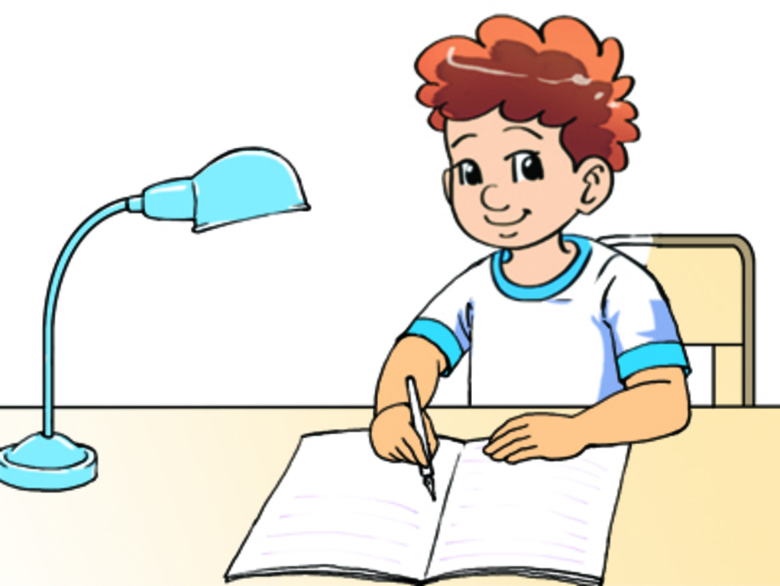  4. He’s reading a book. | 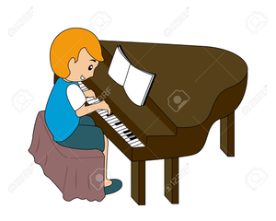  5. He’s playing the piano.
Task 6. Read and complete. There is one example (0).

Where
cleaning
kitchen

bedroomm
cooking
what

Nga: (on the telepone) Where are you, Mai?
Mai: I’m in my (0) bedroom.
Nga: (1) _________ are you doing?
Mai: I’m doing my homework.
Nga: (2) _________ are your parents?
Mai: They’re in the (3) _________.
Nga: What are they doing?
Mai: My dad’s (4) _________ the floor and my mum’s (5) _________.
Task 7. Complete the sentences with the following words
are
is
am
does
do

1. I ………….. listening to music.
2. ………… Lan cooking in the kitchen? – Yes, she ………
3. …………. Quang and Hoa skating in the park? Yes, they …………….
4. Mr. Third and Mrs. Third ……….. watching TV in the living room.
5. Where ………your dogs? ……….. they in your bedroom?
6. What pets ……… you like? I like dog. My dog ……… playing the garden with its ball.
7. How many pupils …… there in your classroom? There …….. fifty pupils.
8. ……… this your dog? Yes, it ………
9. What ……. Lan doing? She and her mother ………cooking in the kitchen.
10. What ………..Quynh do at break time?
Task 8.Read and do the task.
I’m Mike . I and my friends are drawing in my bedroom. We are drawing my garden. It is very beautiful. The fence is around the garden. It is white and blue. There are many trees and flowers in the garden. The trees are green and brown. The flowers are red and yellow. A dog is playing with its ball. There is a pond in the garden. It is very large. The pond has many fish and turtles. We are drawing many things but I like my dog. It is very funny. Its name is Kiki.
A.Tick True or False.
 | True | False
1. He is drawing his family.
2. The flowers are pink.
3. Mike loves his dog
4. Mike is in his bedroom.
B.Answer the questions.
1. What are they doing?
………………………………………..
2. What does his garden have?
………………………………………..
3. What is his dog doing?
………………………………………..
4. What does he like?
………………………………………..
Task 9. Answer the questions.
 |  | 
- What are you doing , Ha ? | - What are you doing, Phong ? | - What is she doing ?
…………………………………. | …………………………………. | ………………………………….

- What is he doing ? | - What is Lola doing ? | - What is she doing ?
…………………………………. | …………………………………. | ………………………………….
Task 10. Read and complete.
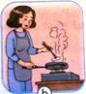
My name is Peter. Today, my family (1)…………….. at home. We are (2)…………….. the living room. My father is (3) …………….. TV. My mother is (4)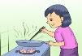…………….. the dinner. My sister is (5)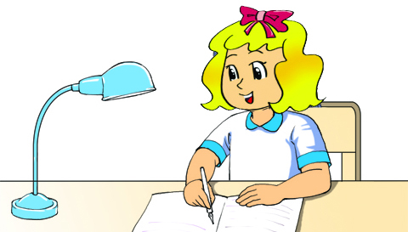……………..

her homework and I am playing computer game.
ĐÁP ÁN
UNIT 18
Task 1.
1.A 2.B 3.C 4.C 5.B 6.C
Task 2.
1.d 2d 3a 4c 5d 6d 7d 8a
Task 3.
1 - sitting
2 - drawing;
3 - cooking;
4 - playing;
5 - reading
6 - doing;
7 - writing;
8 - cleaning;
Task 4.
1.cooking 2. listening 3. cleaning 4. watching 5. singing
Task 5.
1. 2. 3. 4. 5.
Task 6.
- What 2. Where 3. kitchen 4. cleaning 5. Cooking
Task 7.
1 - am; 2 - Is - is; 3 - Are - are; 4 - are; 5 - are - Are;
6 - do - is; 7 - are - are; 8 - Is - is; 9 - is - are; 10 - does;
Task 8.
A.
1 - False; 2 - False; 3 - True; 4 - True;
B.
1 - They are drawing.
2 - It has many trees, flowers, a dog, a pond; fish and turtles.
3 - It is playing with its ball.
4 - He likes his dog.
Task 9.
- What are you doing , Ha ? | - What are you doing, Phong ? | - What is she doing ?
I am drawing ( a picture) | I am playing the piano . | She is reading a book.
- What is he doing ? | - What is Lola doing ? | - What is she doing ?
He is watching TV | She is cleaning the floor. | She is listening to music.
Task 10.
1.is 2. in 3. watching 4.cooking 5.doing

