UNIT 17
WHAT TOYS DO YOU LIKE ?

Part 1. Vocabulary.
English | Pronunciation | Vietnamese
Toy | /tɔɪ/ | đồ chơi
Ship | /ʃɪp/ | tàu
Truck | /trʌk/ | xe tải
Kite | /kaɪt/ | con diều
Plane | /pleɪn/ | máy bay
Dominoes | /ˈdɒmɪnəʊ/ | trò dominoes
Car | /kɑː(r)/ | xe ô tô
Fun | /fʌn/ | niềm vui
Playroom | /ˈpleɪrʊm/ | phòng vui chơi
Doll | /dɒl/ | con búp bê
Keep | /kiːp/ | giữ, duy trì
Goldfish | /ˈgəʊld fɪʃ/ | cá vàng
Parrot | /ˈpærət/ | con vẹt
Rabbit | /ˈræbɪt/ | con thỏ
Part 2. Grammar.
1.Khi muốn hỏi bạn thích đồ chơi nào (gì), chúng ta có thể sử dụng cấu trúc.
What toys do you like? Bạn thích đồ chơi nào?
I like + từ chỉ loại đồ chơiTôi thích + ...
Ex: What toys do you like? Bạn thích đồ chơi nào?
I like trucks.Tôi thích những chiếc xe tải.
2. Khi chúng ta muốn hỏi ai đó có thích đồ chơi đó không, chúng ta có thể sử dụng cấu trúc sau. Like (thích) là động từ thường, câu sử dụng ở thì hiện tại đơn mà chủ ngữ chính là he/ she ở ngôi thứ 3 số ít nên ta phải mượn trợ động từ “does”.
Does she/ he like + từ chỉ loại đồ chơi?Cô ấy/ Cậu ấy có thích...?
- Nếu cậu ấy/ cố ấy thích đồ chơi đó thì trả lời:
Yes, she/ he does.Vâng, cô ấy/ cậu ấy thích.
No, she/ he doesn’t.Không, cô ấy/ cậu ấy không thích.
Ex: Does she like dolls? Cô ấy có thích búp bê không?
Yes, she does./ No, she doesn't.
Cô ấy thích./ Cô ấy không thích.
3. Nếu chủ ngử chính là “you/they” thì ta phải mượn trợ động từ “do”
Hỏi:
Do you/ they like + từ chỉ loại đồ chơi?Bạn/ Họ có thích...?
Đáp: Đây là dạng câu hỏi "có, không", nên:
- Nếu bạn/ họ thích đồ chơi đó thì trả lời:
Yes, l/ they do.Vâng, tôi/ họ thích.
- Nếu bạn/ họ Không thích đồ chơi đó thì trả lời:
No, I/ they don’t.Không, tôi/ họ không thích.
Ex: Do you like dolls? Bạn có thích búp bê không?
Yes, I do./ No, I don't.
Tôi thích./ Tôi không thích.
2. Hỏi và đáp về số lượng con vật.
Khi muốn hỏi về số lượng con vật bạn có bao nhiêu con chúng ta có thể dùng cấu trúc sau:
Hỏi:
Ex: How many dogs do you have?Bạn có bao nhiêu con chó?
I have two dogs. Tôi có 2 con chó.
Part 3. Practice.
Task 1. Circle the odd one out
1. A. puzzle | B. kite | C. car | D. bread
2. A. glob | B. map | C. door | D. board
3. A. forty | B. study | C. twenty | D. fifty
4. A. p  rple | B. puddle | C. brown | D. orange
5. A. TV | B. doll | C. toy | D. kite
Task 2. Read and match.
1. How many cats do you have, Tom? | a. Yes, I do. | 1-
2. What toys do you like? | b. He likes trcucks and robots. | 2-
3. What toys does he like? | c. I have three cats. | 3-
4. What toys does she like? | d. I like dolls and planes. | 4-
5. Do you like kites? | e. She likes puzzles. | 5-
6. How many parrots does your sister have? | f. He has four ships. | 6-
7. How many ships does your brother have? | g. She has one parrot. | 7-
Task 3. Look and write. There is one example.
Example: labls → b a l l s | 

1. osty → t _ _ _ | 2. sarport → p _ _ _ _ _ _ | 3. epst → p_ _ _
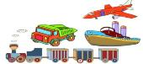 |  | 
4. btorbso → r_ _ _ _ _ | 5. ikest → k_ _ _ _
 | 
Task 4. Look and read. Tick or cross the box. There are two examples
Examples:  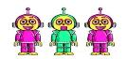  A. I like robots. |   B. I have three parro  s.

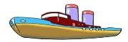  1.  A: What toys do you like?  B: I like ships. | 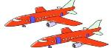  2.  A: How many planes does he have?  B: He has ten. |   3.  A: How many goldfish do you have?  B: I have two.
 |   4.  A: Do you like flying a kite?  B: Yes, I do. I have a big kite. |   5.  A: How many dogs do you have?  B: I have three.

Task 5. Read and complete. There is one example (0).
Garden
has
cat

likes
two
pets

Hoa and her brother, Minh are in the (0) garden. They are playing with pets. Hoa likes fish and birds. She (1)_________ ten goldfish and three parrots. Minh (2)_________ dogs and cats. He has (3)_________ dogs and a small (4)_________.
They like (5)_________ very much.
Task 6. Read and complete the sentences.
 | 1) How many planes do you have ?  -> I ……………..three planes.
 | 2) How many ships does your brother have?  -> He …………….. two ……………..
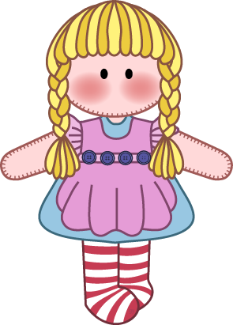 | 3) How many …………….. does your sister have ?  -> She ……………..one doll.
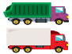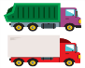 | 4) How many trucks does he have?  -> My brother ……………..four ……………..
     | 5) How many cars …………….. Nam have?  ->……………………..six cars.
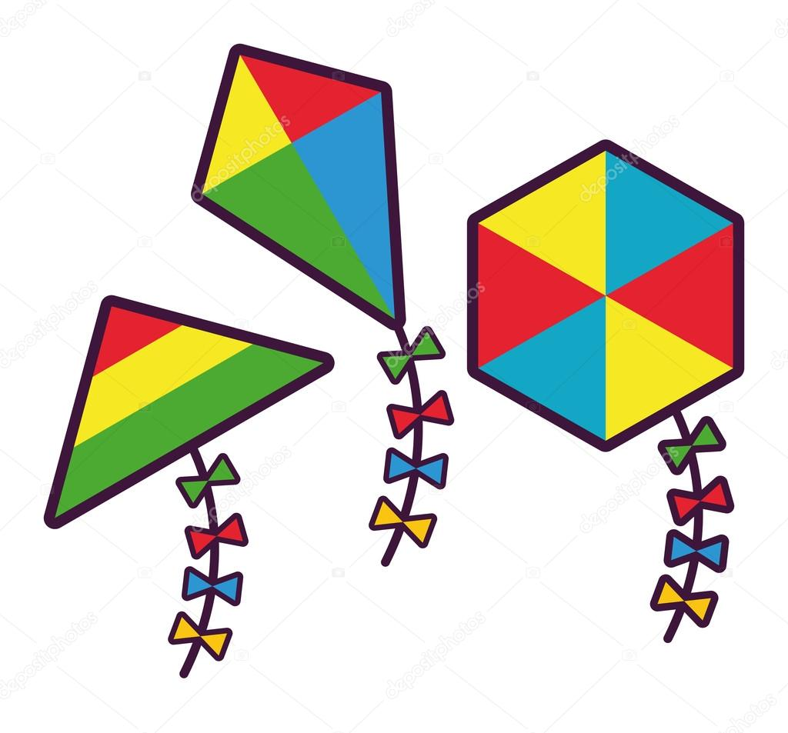 | 6) How many kites does Lan have?  -> She ………………………………..
Task 7.Put the words in order. Then read aloud.
1) you –like - Do–pets?
……………………………………………………………………………
2) Do –any –you –have–kites?
……………………………………………………………………………
3) do– you–What –toys– like?
……………………………………………………………………………
4)many– kites –How –do –you –have?
……………………………………………………………………………
5)two– cats –and - Linda –has –three –dolls.
……………………………………………………………………………
6) Quan– has – three–four –parrots –and- ships.
……………………………………………………………………………
7)the shelf – on – I - the toys - keep
……………………………………………………………………………
8) How many – does – she - cats - have?
……………………………………………………………………………
9) your sister – What – toys – does – like ?
……………………………………………………………………………
10) How – Tom – many – does – cars – have ?
……………………………………………………………………………
11) toys – keep – Where – you – your - do ?
……………………………………………………………………………
Task 8. Choose the best answer.
1. How many dolls (are /is /am ) there in the box ?
2. How many ( parrot/parrots ) do you have ? I have a parrot.
3. She ( likes / like ) dolls and cars.
4. How many birds are there (in /on ) the cage ?
5. Do you have ( some / any ) dolls ? Yes, I do.
6. ( Do/ Does ) your sister have any trucks? No, she doesn’t.
7. My brother ( like / likes ) rabbits.
Task 9. Read and complete the passage.
Hello! My name is Nam. I have many (1)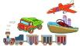…………………………… .I (2)………………………………….. a robot. It’s red. I have a plane. It is (3) ……………………………………I have three balls.(4)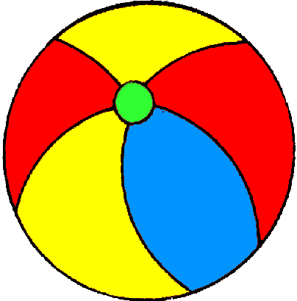………………..are black and white. I have a long (5)……………….It can run fast. I love my toys very
?

much. What about you? (6) ………………. many toys do you have ?
ĐÁP ÁN
UNIT 17
Task 1.
1 - D; 2 - C; 3 - B; 4 - B; 5 - A;
Task 2.
1.c 2.d 3.b 4.e 5.a 6.g 7.f
Task 3.
1. toys 2. parrots 3. pets 4. robots 5. kites
Task 4.
1. 2. 3. 4. 5.
Task 5.
1. has 2. likes 3. two 4. cat 5. Pets
Task 6.
1) How many planes do you have ?
-> I have three planes.
2) How many ships does your brother have?
-> He has two ships.
3) How many dolls does your sister have ?
-> She has one doll.
4) How many trucks does he have?
-> My brother has four trucks .
5) How many cars does Nam have?
->he has six cars.
6) How many kites does Lan have?
-> She has three kites.
Task 7.
1 - Do you like pets?
2 - Do you have any kites?
3 - What toys do you like?
4 - How many kites do you have?
5 - Linda has two cats and three dolls.
6 - Quan has four parrots and three ships.
7. I keep the toys on the shelf.
8. How many cats does she have?
9. What toys does your sister like ?
10. How many cars does Tom have ?
11. Where do you keep your toys?
Task 8.
1. How many dolls (are /is /am ) there in the box ?
2. How many ( parrot/parrots ) do you have ? I have a parrot.
3. She ( likes / like ) dolls and cars.
4. How many birds are there (in /on ) the cage ?
5. Do you have ( some / any ) dolls ? Yes, I do.
6. ( Do/ Does ) your sister have any trucks? No, she doesn’t.
7. My brother ( like / likes ) rabbits.
Task 9.
1.toys 2.have 3.big 4.They 5.train 6.How

