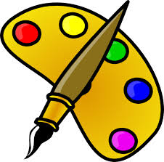
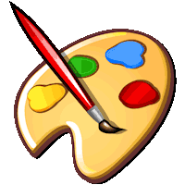
UNIT 9
WHAT COLOR IS IT ?

Part 1. Vocabulary 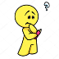
English | Pronunciation | Vietnamese
Desk | /desk/ | cái bàn học sinh
Eraser | /ɪˈreɪzə(r)/ | cục tẩy
Bench | /bentʃ/ | ghế dài
Chair | /tʃeə(r)/ | ghế tựa
Board | /bɔːd/ | bảng
Chalk | /tʃɔːk/ | phấn
bookshelf | /ˈbʊk ʃelf/ | giá sách
bookcase | /ˈbʊk keɪs/ | giá sách
classmate | /ˈklɑːs meɪt/ | bạn cùng lớp
rainbow | /ˈreɪn bəʊ/ | cầu vòng
Box | /bɒks/ | cái hộp
Red | /red/ | đỏ tươi
colour | /ˈkʌlər/ | màu sắc
Yellow | /ˈjeləʊ/ | vàng
orange | /ˈɒrɪndʒ/ | da cam
Pink | /pɪŋk/ | hồng
Blue | /bluː/ | xanh dương
Green | /ɡriːn/ | xanh lá
Black | /blæk/ | đen
Violet | /ˈvaɪələt/ | tím
brown | /braʊn/ | nâu
White | /waɪt/ | trắng
Part 2. Grammar.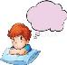
1. What colour is + danh từ số ít (singular noun)?
... màu gì?
2. What colour are + danh từ số nhiều (plural noun)?
... màu gì?
- Và để trả lời cho mẫu câu trên, chúng ta sử dụng:
Danh từ số ít (singular noun) + is...
Danh từ số nhiều (plural noun) + are ..
Ex: 1. What colour is your hat?
Cái mũ của bạn màu gì?
It is blue. Nó màu xanh.
2. What colour are the sunflowers?
Những đóa hoa hướng dương màu gì?
They are yellow. Chúng màu vàng.
Part 3. Practice. 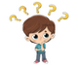
Task 1. Read and odd one out.
0. a. two | b. four | c. nice | d. five

1. a. out | b. can | c. in | d. on
2. a. his | b. your | c. I | d. her
3. a. she | b. they | c. my | d. he
4. a. it | b. those | c. these | . they
5. a. rubber | b. pencil | c. orange | d. pencil case
6. a. school | b. school bag | c. desk | d. pencil
7. a. hello | b. hi | c. sharpener | d. goodnight
8. a. books | b. notebooks | c. ruler | d. rubbers
9. a. pens | b. notebook | c. pencil | d. pencil case
10. a. big | b. year | c. old | d. large
Task 2. Look and write. There is one example.
Example: edr → r_ _→ red
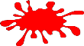
1. labkc →  b_ _ _ _ | 
2. owbnr →  b_ _ _ _ | 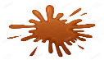
3. lebu→  b_ _ _ | 
4. energ →  g_ _ _ _ | 
5. locuro →  c_ _ _ _ _ | 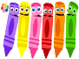
Task 3. Read and match
1. What colour are your pens? | a. It’s black and brown. | 1. ……
2. How old is she? | b. It’s big. | 2.……
3. Are those her rulers? | c. No, it isn’t. | 3.……
4. May I write, sir? | d. His name is Hung. | 4.……
5. What colour is your school bag? | e. She’s nine. | 5.……
6. What’s his name? | f. Yes, they are. | 6.……
7. Is your classroom big or small? | g. No, you can’t. | 7.……
8. Is this your desk? | h. They are green and white. | 8.……
Task 4.Choose the correct answer .
1. They are my ............... . (friend/ pen/ rulers/ rubber)
2. ............... is my bookcase. ( they/ those/ these/ this)
3. Those ............... my pencils. (is/ am/ are/ do)
4. What colour ............... your book, Nam? ( is/ am/ are/ do)
5. What colour ............... your pens? (is/ am/ are/ do)
6. Is ............... your desk? (those/ these/ that/ they)
7. What colour ............... they? (is/ am/ are/ do)
8. The bookcase is ............... . (seven/ colour/ orange/ not)
9. ............... are her pencil case. (this/ that/ those/ it)
10. Is the gym ............... ? (stand/ large/ sit/ come)
11. May I ............... down? (stand/ come/ ask/ sit)
12. ............... to meet you. (nine/ nice/ night/ ny)
13. How do you spell ............... name? ( you/ your/ they/ she)
14. May I go out? – no, you ............... . (can/ aren’t/ isn’t/ can't)
15. How old are you? - .......... .(fine, thanks/ I’m fine, thanks/ I'm nine/ thank you)
16. My school is big and ............... . (stand/ new/ up/ sit)
17. The ............... are blue. (pen/ pencil/ bookcase/ rulers)
18. ............... is my notebook. (They/ she/ he/ it)
19. What ............... are her book? – They are brown. (old/ this/ that/ colour)
20. Are they your ............... ? (friend/ pen/ pencil/ friends)
Task 5. Look and read. Tick or cross the box. There are two examples.
 | I'm Mai. | I'm Quan.
Examples: | 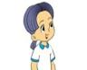 | 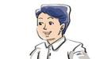
 | A. | B.

  1.
  It’s a pen. | 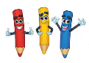
  2.
  That’s a school bag. | 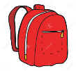
  3.
  That’s a pencil sharpener. | 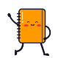
  4.
  This is a ruler . | 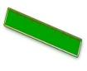
5.
These are blue my pens. | 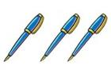

Task 6. Read and complete. There is one example.
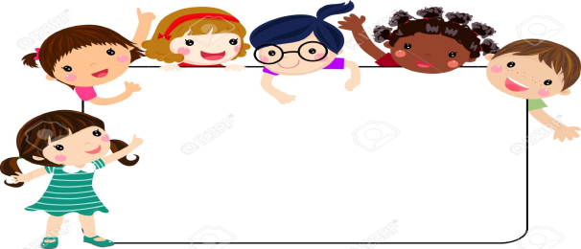
what colour
white
boxes
yellow
this
it's
Quan: Look! These are our (0) boxes.
Nga: (1) ________ are they, Tony?
Tony: They are (2) ________, green, black, brown and white.
Nga: Is (3) ________ your box, Quan?
Quan: Yes, it is. (4) ________ black.
Nga: Is your box green, Tony?
Tony: No, it isn’t. Look! It’s (5) ________.

Task 7. Read and circle T (True )and F (false)
Hi . I’m Phong . Those are my new school things. Look at my school bag. It’s yellow .That is my book . It’s red. That is my pen . It’s brown. Those are my rulers. They are orange and blue. Those are my rubbers. They are black and purple. I like my new school things . I want to keep them clean.
 | T | F
a. Phong has new school things.
b. The school bag is blue.
c. The book is pink.
dThe rulers are orange and blue.
e. The rubbers are white and purple.
Task 8.Read and answer the questions
Hello, I’m Mai. I’m (0)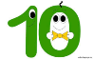 ten years old. I’m in class 3B at Le Loi

Primary School. My school is big and new. My class is big and new, too. This is my (1)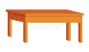…………………It is brown. These are my (2)………
………They are yellow. This is my notebook. It’s (3) ..………………….
i-n-k-p
These are my pens. They are black and (4)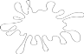...……………………. This is

my rubber. It’s orange and white. And this is my school bag. It’s blue, green and red. What about you? What colour are your (5)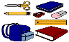……………………?
6. What’s her name?
……………………………………………………….
7. How old is she?
……………………………………………………….
8. Is her school big and new?
……………………………………………………….
9. What colour is her desk?
……………………………………………………….
10. What colour is her school bag?
……………………………………………………….
11. What colour are her books?
……………………………………………………….
12. What colour are her pens?
……………………………………………………….
13. Is her rubber red?
……………………………………………………….
Task 9. Look at the pictures and complete the sentences.
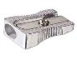 | a) Is this your____________? | Yes , ___________.
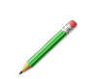 | b) Is that your school bag ? | No , ____________.
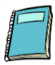 | c) Is that your notebook ? | Yes, ____________.
 | d) Are these your __________? | Yes , they are.
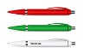 | e) Are those your pencils ? | No , ____________.
Task 10. Complete the sentences using this, that, these or those
1. _____________rulers are red. (That, Those)
2. Look at_____________bag over there. (this, that)
3. _____________is a beautiful day today. (That, This)
4. Do you like_____________flowers? (that, those)
5. What are the answers to_____________questions? (this, these)
6. I love_________shoes but I don't like_____________shirt. (these, that).
7. Let's watch a movie. ______________ a good idea. (This is, That's)
8. Whose house is_____________? (those, that)
9. This book isn't very good , but_____________book's great. (that/those)
10. I like ____________ picture. (this, these).
ĐÁP ÁN
UNIT 9
Task 1.
0. c
1. b | 2. c | 3. c | 4. a | 5. c | 6. a | 7. c | 8. c | 9. a | 10. b
Task 2.
1. black 2. brown 3. blue 4. green 5. colour
Task 3.
1 - h; 2 - e; 3 - f; 4 - g; 5 - a; 6 - d; 7 - b; 8 - c
Task 4
1 - rulers
2 - This
3 - are
4 - is
5 - are
6 - that
7 - are
8 - orange
9 - Those
10 - large
11 - sit
12 -Nice
13 - your
14 - can't
15 - I'm nine
16 - new
17 - rulers
18 - It
19 - colour
20 -friends
Task 5.
1. X 2. V 3. X 4. X 5. V
Task 6.
1. What colour 2. yellow 3. this 4. It’s 5. white
Task 7.
- Phong has new school things. T F
- The school bag is blue. T F
- The book is pink. T F
- The rulers are orange and blue. T F
- The rubbers are white and purple. T F
Task 8.
1.desk 2.books 3. Pink 4. White 5. school things
6 - Her name is Mai.
7 - She is ten years old.
8 - yes, it is.
9 - It is brown.
10 - It’s blue, green and red.
11 - They are yellow.
12 - They are black and white.
13- It’s orange and white.
Task 9.

 | a) Is this your pencil sharpener ? | Yes , it is.
 | b) Is that your school bag ? | No , it isn’t.
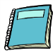 | c) Is that your notebook ? | Yes, it is.
 | d) Are these your school bags? | Yes , they are.
 | e) Are those your pencils ? | No , they aren’t .

Task 10.
1.that 2.that 3. This 4. Those 5.these
6. These 7.that’s 8.that 9.that 10.this

