
UNIT 4
HOW OLD ARE YOU?

Part 1. Vocabulary.
WORDS | Pronunciation | Meaning
1. How | /haʊ/ | như thế nào
2. Old | /ould/ | Già, cũ
3. how old | /haʊ ould/ | Bao nhiêu tuổi
4. Year | /jə:/ | Năm
5. Too | /tu:/ | Cũng
6. One | /wʌn/ | số 1
7. Two | /tu:/ | số 2
8. Three | /θri:/ | số 3
9. Four | /fɔ:/ | số 4
10. Five | /faiv/ | số 5
11. Six | /siks/ | số 6
12. Seven | /'sev(ə)n/ | số 7
13. Eight | /eit/ | số 8
14. Nine | /nain/ | số 9
15. Ten | /ten/ | số 10

Part 2.Grammar 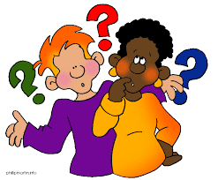
1. Hỏi tên người nào đó:
(?) Who is + this/that?
(+) It is + name.
Example
- Who is this? (Đây là ai?)
It is Mai. (Đây là Mai.)
- Who is that? (Đó là ai?)
It is Minh. (Đó là Minh.)
2. Hỏi tuổi của bạn:
(?) How old are you?
(+) I am ... years old.
Example
How old are you? (Bạn bao nhiêu tuổi?)
I am seven years old. (Tớ 7 tuổi.)
3. Hỏi tuổi ai đó:
(?) How old is + he/ she?
(+) He/ She + is ... years old.
Example
How old is she?(Chị ấy bao nhiêu tuổi?)
She is eight years old. (Chị ấy 8 tuổi.)
Part 3. Practice . 
Task 1. Choose the word that has the underlined part pronounced differently from that of the others.
1) A.name | B. thank | C. that
2) A. seven | B. ten | C. evening
3) A. hi | B. fine | C. children
4) A. old | B. morning | C. hello
5) A. spell | B. pencil | C. repeat
Task 2. Read and circle the right option.
- His name is / are Tony.
- What /Who is this ? This is Anna.
- How /How old are you ? I’m fine . Thank you
- Where / When do you live ? I live in Vinh city.
- Is / Are she eight years old ? Yes, she is.
- Nice / Nine to meet you.
- Is she eleven years old ? No , she is / she isn’t.
- How/What do you spell your name ?
- My sister is ten years /year old.
- Is your brother sixteen years old ? Yes, he / she is.
Task 3. Look and write. There is one example.
Example: iehn → Miss H_ _ _ → Hien

1. net→  t_ _ | 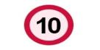
2. vefi→  f_ _ _ | 
3. xis→  s_ _ | 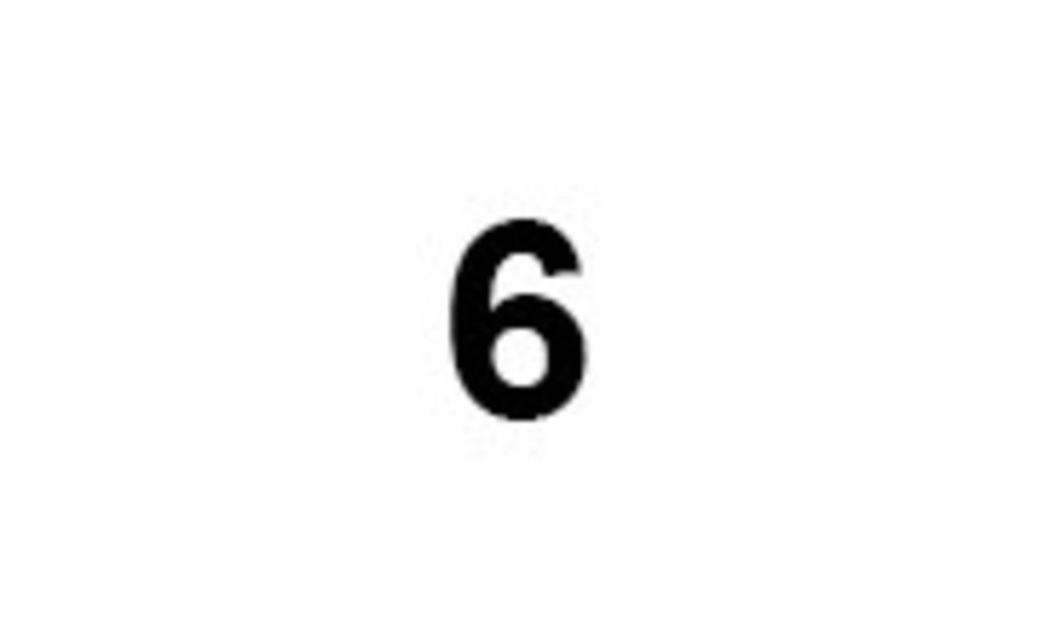
4. ighet→  e_ _ _ _ | 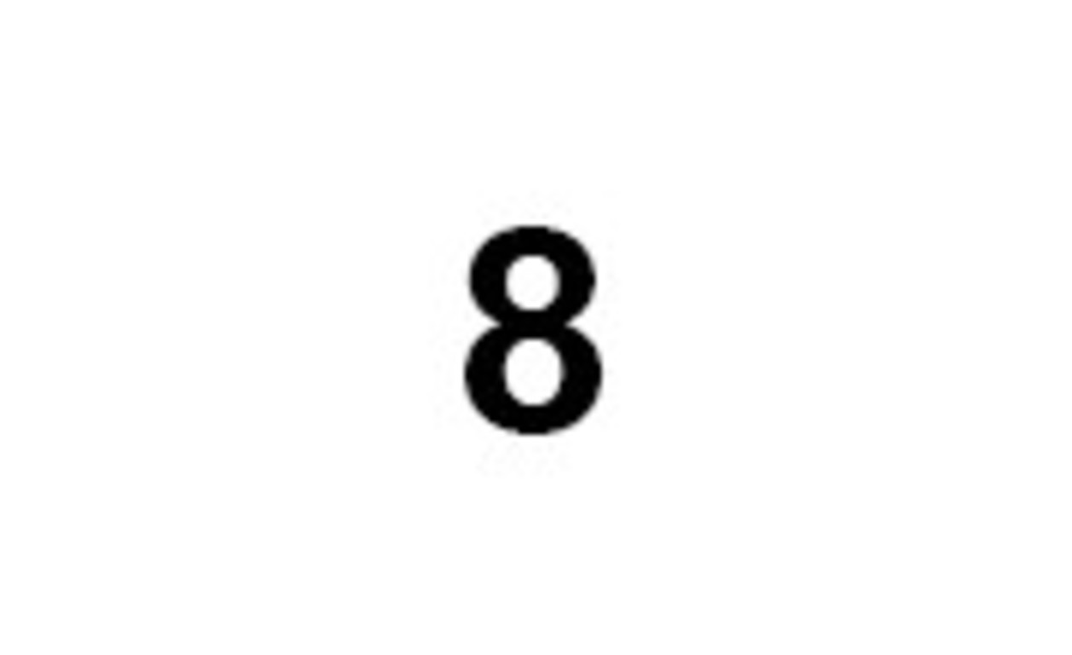
5. hwo→  w_ _ | 
Task 4. Look and read. Tick or cross the box. There are two examples.

 | I'm Mai. | I'm Quan.
Examples: |  | 
 | A. | B.

  1.
  Who is this? | 
  2.
  Hi, I’m Mai. I’m eight years old. | 
  3.
  Who’s that? | 
  4.
  Linda is eight years old. | 
5.
Peter is five years old. | 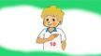

Task 5. Choose the correct answer
1. What’s ……..name? His name is Tony .
A. my B. his C. her
2. How are you today ? I’m ………….
A. five B. nine C. fine
3. How old is your grandmother ? She is eighty ……………..old.
A. years B. year C. yes
4. ……………….to meet you.
A. nine B. Nice C. good
5. Bye. See you …………………….
A. late B. nice C. again
6. What’s this ? It’s ………apple
A. an B. a C. some
7. What’s hisname ? ………………. name is Ben.
A. my B. her C. his
8. ……………….old is she ? She’s twenty years old.
A. What B. Why C. How
9. ………………..do you live ? I live in Ho Chi Minh city.
A. What B. Who C. Where
10. Who is he? …………is my friend
A. he B. I C. she
11. …………she eight years old ? Yes, she is.
A. Am B. Is C. Are
12. What …………do you like ? I like yellow and green.
A. color B. food C. animals
13. Are you sixteen years old ? …………, I’m not.
A. Yes B. OK C. No
14. How old is your dad ? ………… dad is fifty years old.
A. his B. My C. her
Task 6. Read and complete. There is one example.
old
ten
how about
and
who's
eight

Linda: I'm (0) eight. How old are you Nam?
Nam: I'm eight, too. (1) ________ you, Peter?
Peter: I'm seven years (2) ________.
Linda: (3) ________ you, Phong?
Phong: I'm (4) ________.
Peter: Look! (5) ________ that?
Phong: It's Mai.
Task 7. Read and match
- What’s your name ? | - I’m seventeen years old.
- How old are you, Phong ? | - No , I’m not.
- Are you eight years old, Minh ? | - My name is Hoa.
- What’ s your brother’s name ? | - Yes, he is.
- Is Tom nine years old ? | - He is Hai.
- What ’s her name ? | - No, she isn’t . She’s six years old.
- Is your sister five years old ? | - Her name is Linda.
- How old is your mother ? | - She’s forty -five years old.
- How old is your Dady ? | - I’m fine , thanks.
- How are you, Nam ? | - He is fifty four
Task 8. Complete the sentences.
- How old are you? I ___________ seven years old.
- ___________ is she ? She is thirteen years old.
- How old is your brother? _____________ is fourteen years old.
- __________ are you ? I am eleven years old.
- Is Mai nine years old ? No , she _____________ .
- Are you sixteen years old ? Yes, I ____________
Task 9. Reoder the the words to make sentences.
1.
old
seven
years
I’m

2.
are
you?
how
old

3.
is
boy?
who
that

4.
is
Nam ?
old
how
5.
Mai
?
is
that

6.
old.
nine
years
She is
your
7.
mother?
is
How old

8.
Phong .
is
my
name
Hoa
9.
old.
ten years
is
Task 10. Read and answer the questions.
Hello . My name is Nga . I am seven yearsold. This is Phong .He is eight years old. That is Tuan. He is eight years old,too. And that is Hoa . She is nine years old. We are good friends.
1. What is her name?
………………………………………………………………………
2. How old is she ?
………………………………………………………………………
3. How old are Phong and Tuan?
………………………………………………………………………
4.How old is Hoa ?
………………………………………………………………………
ĐÁP ÁN
Unit 4
Task 1.
1.a 2.c 3.c 4.b 5.c
Task 2.
- His name is / are Tony.
- What /Who is this ? This is Anna.
- How /How old are you ? I’m fine . Thank you
- Where / When do you live ? I live in Thanh Hoa city.
- Is / Are she eight years old ? Yes, she is.
- Nice / Nine to meet you.
- Is she eleven years old ? No , she is / she isn’t.
- How/What do you spell your name ?
- My sister is ten years /year old.
- Is your brother sixteen years old ? Yes, he / she is.
Task 3.
1. ten 2. five 3. six 4. eight 5. who
Task 4.
1. V 2. X 3. X 4. V 5. X
Task 5.
1. What’s ……..name? His name is Tony .
A. my B. his C. her
2. How are you today ? I’m ………….
A. five B. nine C. fine
3. How old is your grandmother ? She is eighty ……………..old.
A. years B. year C. yes
4. ……………….to meet you.
A. nine B. Nice C. good
5. Bye. See you …………………….
A. late B. nice C. again
6. What’s this ? It’s ………apple
A. an B. a C. some
7. What’s hername ? ………………. name is Linda.
A. my B. her C. his
8. ……………….old is she ? She’s twenty years old.
A. What B. Why C. How
9. ………………..do you live ? I live in Quang Ninh.
A. What B. Who C. Where
10. Who is he? …………is my friend
A. he B. I C. she
11. …………she eight years old ? Yes, she is.
A. Am B. Is C. Are
12. What …………do you like ? I like yellow and green.
A. color B. food C. animals
13. Are you sixteen years old ? …………, I’m not.
A. Yes B. OK C. No
14. How old is your dad ? ………… dad is fifty years old.
A. his B. My C. her
Task 6.
1.How about 2. old 3. And 4. ten 5. Who’s
Task 7.
a.3 b.1 c.2 d.5 e.4 f.7 g.6 h.8 i. 10 j.9
task 8.
1.am 2.how old 3. He 4. How old 5. Isn’t 6.am
Task 9.
1. I’m seven years old.
2. how old are you ?
3. who is that boy?
4.How old is Nam?
5.Is that Mai?
6.She is nine years old.
7.How old is your mother ?
8.My name is Phong.
9. Hoa is ten years old.

