ĐỀ 9 | ĐỀ ÔN TẬP CUỐI HỌC KỲ II  NĂM HỌC 2025-2026  MÔN: TIẾNG ANH LỚP 4
PART I. LISTENING (3 points)
Question 1: Listen and draw lines. There is one example (1 point).
  0 |  |  | 
13 |  |  | 
2 |  |  | 
3 |  |  |   50k
4 |  |  | 

Question 2: Listen and choose True or False. There is one example (1 point).
Questions | True | False
- You can go straight. | 
- She looks young with short hair.
- I play basketball with my friends in the morning.
- The teacher is building a campfire.
- These animals are peacocks.
Question 3: Listen to two passages of two pupils talking some information then choose the correct answer. There is one example (1 point).
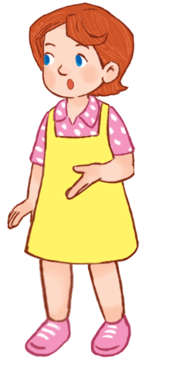
Hello. My name is Lucy. I am (0) _________________ of my family We are having dinner. This man is my father. He is a (1)________________. He works very hard at a ___________________. That woman is my mother. Every Sunday, my mother does (2)________ at the ___________________.

0. | A. drawing a picture | B. taking a photo | C. painting
1. | A. doctor/hospital | B. worker /factory | C. farmer/farm
2. | A. yoga/gym | B. exercise/gym | C.yoga/sport center

Hi everyone, I am Nam. The weather was (3)___________ yesterday, so we were at a bookshop. It is next to the pet shop. My sister bought some books. It is (4)_____________ dong. We had a lot of fun.

3. | A. sunny | B. windy | C. cloudy
4. | A. fifty thousand | B. forty thousand | C. thirty thousand

PART II. READING (2.5 points)
Question 4. Fill in each blank with one given phrase of words. There is one example (0.75 points).
five o’clock wash the dishes with the cooking in the morning
Good morning, everyone! My name is Thuy Duong. I get up at six thirty (0) in the morning. I go to school at seven thirty. I have lunch at school with my classmates at noon. I go home at (1) ____________________. I help my mom (2) _____________________ in the evening. We have dinner at seven o’clock. After dinner, I (3) _____________________. I go to bed at nine thirty. Can you tell me about your daily routines? | 
Question 5. Read and choose A, B or C. There is one example (1 point).
 | Linh wants to go to the library. It is __________ Chu Van An Street.
 | - in | - on | - at
 | Where does your brother go ___________ Sundays?
 | - at | - in | - on
 | Do you want to go ________ the cinema?
 | - in | - to | - for
 | The kids are dancing _________ the campfire.
 | - in | - on | - around
 | Nam and I are __________ the shopping centre.
 | - at | - on | - under
Question 6. Read and tick True or False. There is one example (0.75 points).
Hello, I’m Harry. It is sunny today. I and my family are at the zoo. I and my sister like the animals at the zoo. Look! They are lions. I like them because they roar loudly. These are hippos. They are swimming in the pond. I can see two giraffes. They are running very quickly on the field. My sister, Linda, likes birds because they sing merrily. She can see a couple of peacocks. She likes them because they dance beautifully. We have a lot of fun at the zoo! | 
 |  | True | False
- The hippos are swimming in the river. |  |  | ✓
- The giraffes are running slowly on the field.
- Harry likes lions because they roar loudly.
- Linda likes peacocks because they sing merrily.
PART III. WRITING (2.5 points)
Question 7. Fill in the blanks. There is one example (1 point).
 |  |  | 
 | - What are these animals?  - They are crocodiles. |  | - Do you want to go to the _____________________?  - Great! Let’s go.
 | 
- Where’s the bookshop?
- It’s _____________________ the bakery.
 |  |  | 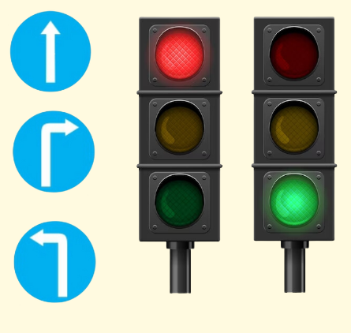
 | - What do you do in the evening?  - I _____________________ in the evening. |  | - How can I get to the food stall?  - Go straight and _____________________.
Question 8. Answer the questions with the given words. There is one example (0.75 points).
- What does your father do? (office worker)
My father is an office worker. / He’s an office worker.
- What does your sister look like? (short, big)
_______________________________________________________________
- What does your mother do on Sundays? (clean the house)
_______________________________________________________________
- How much is this book? (forty-five thousand dong)
_______________________________________________________________
Question 9. Use the given words to make sentences. There is one example (0.75 points).
- Bookshop/ between/ bakery/ food stall.
The bookshop is between the bakery and the food stall.
- Why/ you/ like/ elephants?
_______________________________________________________________
- Kids/ dancing/ around the campfire.
_______________________________________________________________
- I/ like/ peacocks/ because/ dance beautifully.
_______________________________________________________________

PART IV. SPEAKING (2 points)
Question 10. Introduction (0.5 points).
Teacher asks students to answer questions:
- What’s your name? How old are you?
- What’s your hobby? What do you do at break time?
Question 11. Describe the picture by answering the following questions (0.75 points).
Teacher shows the picture and asks students to answer questions:
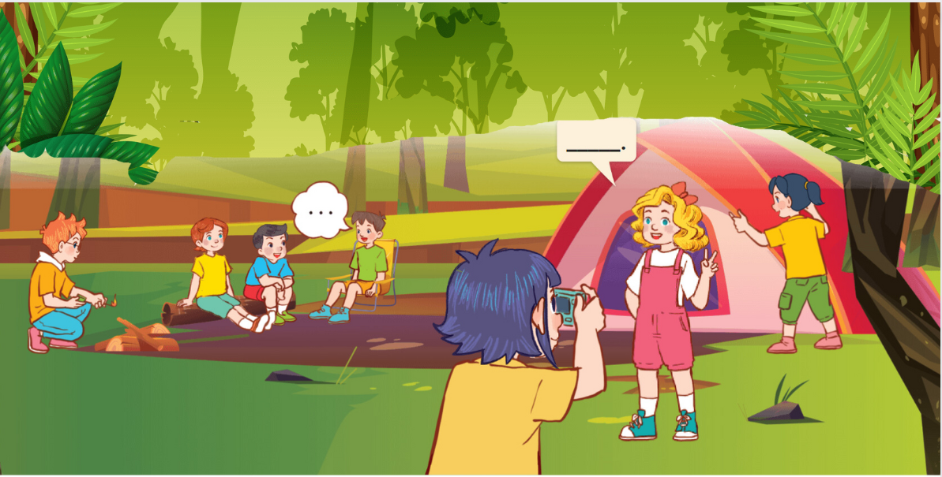
Q: Where are the kids?
A: _______________________________________________________________
The teacher may point at every kid in the picture and ask the student the following questions:
Q: What’s she/he doing? What are they doing?
A: _______________________________________________________________
Q: Are they happy?
A: _______________________________________________________________
Question 12. Let’s talk (0.75 points).
Teacher asks students to answer questions:
- Do you like any animals at the zoo? Why do you like them?
- What do your father and mother do on Sundays?
- When do you do your homework? What do you do in the evening?
ĐÁP ÁN
PART I. LISTENING (3 points)
QUESTION 1: Listen and draw lines (1 point)
Mỗi câu đúng 0.25 điểm (0.25x4)
- A | - E | - B | - D
QUESTION 2: Listen and choose True or False (1 point)
Mỗi câu đúng 0.25 điểm (0.25x4)
- True | - False | - True | - False
QUESTION 3: Listen to two passages of two pupils talking some information then choose the correct answer (1 point)
Mỗi câu đúng 0.25 điểm (0.25x4)
- B | - A | - A | - C
PART II. READING (2.5 points)
QUESTION 4: Fill in each blank with one given phrase of words (0.75 points)
Mỗi câu đúng 0.25 điểm (0.25x3)
- five o’clock | - with the cooking | - wash the dishes
QUESTION 5: Read and choose A, B or C (1 point)
Mỗi câu đúng 0.25 điểm (0.25x4)
- C | - B | - C | - A
QUESTION 6: Read and tick True or False (0.75 points)
Mỗi câu đúng 0.25 điểm (0.25x4)
- False | - True | - False
PART III. WRITING (2.5 points)
QUESTION 7: Fill in the blanks (1 point)
Mỗi câu đúng 0.25 điểm (0.25x4)
- bakery | - opposite | - clean the floor | - turn left
Question 8. Answer the questions with the given words (0.75 points)
Mỗi câu đúng 0.25 điểm (0.25x3)
- She is short and big.
- She cleans the house on Sundays.
- It’s forty-five thousand dong.
Question 9. Use the given words to make sentences (0.75 points)
Mỗi câu đúng 0.25 điểm (0.25x3)
- Why do you like elephants?
- The kids are dancing around the campfire.
- I like peacocks because they dance beautifully.
PART IV. SPEAKING (2 points)
QUESTION 10: Introduction (0.5 points)
Mỗi câu trả lời 0.25 điểm (0.25x2)
Question 11. Describe the picture by answering the following questions (0.75 points)
Mỗi câu trả lời 0.25 điểm (0.25x3)
- They are at a campsite.
- She is taking a photo.
She is putting up a tent.
They are talking. / They are telling a story.
He is building a campfire.
- Yes, they are.
QUESTION 12: Let’s talk (0.75 points)
Mỗi câu trả lời 0.25 điểm (0.25x3)

