ĐỀ 6 | ĐỀ ÔN TẬP CUỐI HỌC KỲ II  NĂM HỌC 2025-2026  MÔN: TIẾNG ANH LỚP 4
PART I. LISTENING (3 points)
Question 1: Listen and match. There is one example (1 point).
 | 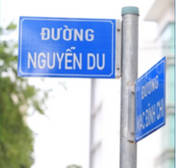 | 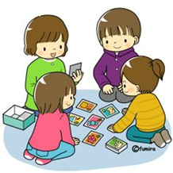 |  | 
 |  |  |  | 
Question 2: Listen and tick Right (✓) or Wrong (☓). There is one example (1 point).
Sentences | Right (✓) | Wrong (☓)
- It’s sunny. | ✓
- I live in a small house in a village.
- She doesn’t have long hair and big eyes.
- They are crocodiles.
- The gift shop is between the bakery and the bookshop.
Question 3: Listen and complete. There is one example (1 point).
My name is Lisa. I am tall and (0) …slim... This is my father, Tony. He works in a (1)…………………………………….. This is my mother, Daisy. She has a (2)……………………. She works in a school as a Maths teacher. My mother often goes to the (3)……………………………………………… on Mondays. Today, my parents will take me to the campsite in the mountain. My class is playing (4)…………………………………………………. at the campsite. I am very happy.
PART II. READING (2.5 points)
Question 4. Circle the odd one out. There is one example (1 point).
 | actor | farm | farmer | policeman
 | big | tall | eyes | slim
 | rainy | sunny | weather | cloudy
 | bakery | T-shirt | bookshop | supermarket
 | crocodiles | giraffes | lions | dance
Question 5. Fill in each blank with one given word. There is one example (0.75 points).
straight left  library books  Today is Sunday. It is sunny and warm. Thuy Duong likes reading (0) books. She wants to go to the (1) ____________. It is in Chu Van An Street. How can she get there? She can go (2) ____________and turn right. The library is on the (3) ____________. | 
Question 6. Read and choose A, B or C. There is one example (0.75 points).
Hello, I am Thang. Today is Saturday. It is sunny and hot. Because I like swimming, my family goes to the water park. I can swim and play there. | 
 | Hi there! I’m Dao. It is windy outside. My mother and I go to the shopping centre because my mother wants to buy clothes for winter. There is a bakery in the shopping centre. We can go there to have some cakes as well.
- Where is Thang?  - He is in the shopping centre with his family.  - He is in the water park with his family.  - He is in the playground. | - Is swimming Thang’s hobby?  - Yes, it is.  - No, it isn’t.  - No information is given.
- Where is Dao?  - She is in the water park with her family.  - She is in the bakery.  - She is in the shopping centre with her mother. | - Why do Dao and her mother go to the shopping centre?  - Because she wants some cakes.  - Because her mother wants to buy clothes.  - Because they want to go to the bakery.
PART III. WRITING (2.5 points)
Question 7. Fill in the blanks. There is one example (1 point).
 | 
- What do you do in the evening?
- I clean the floor.
 |  |  | 
 | - Where’s the gift shop?  - It is ____________ the bookshop and the food stall. |  | - What are they doing?  - They are ________________________.
 |  |  | 
 | - How much is this skirt?  - It is ______________________. |  | - Why do you like peacocks?  - Because they ________________________.
Question 8. Use the given words to make sentences. There is one example (0.75 points).
- My mother/ work/on a farm
My mother works on a farm.
- What/ you/ do/ morning?
____________________________________________________________
- I/ live/ 12 Tran Hung Dao Street
____________________________________________________________
- Do/ you/ want/ go/ supermarket?
____________________________________________________________
Question 9. Answer the questions with the given words. There is one example (0.75 points).
- What does your sister look like? (round face, big eyes)
She has a round face and big eyes.
- When do you wash the clothes? (afternoon)
____________________________________________________________
- What does your father do on Saturdays? (play tennis)
____________________________________________________________
- What are Huong and Son doing? (build/ campfire)
____________________________________________________________
PART IV. SPEAKING (2 points)
Question 10. Introduction (0.5 points).
Teacher asks students to answer questions:
- What’s your name? How old are you?
- What time do you go to school?
Question 11. Describe the pictures by answering the following questions (0.75 points).
Teacher shows the pictures and asks students to answer questions:
1. |  | Q: What was the weather like last weekend?  A: _________________________________.
2. |  | Q: What are they doing?  A: _________________________________.
3. | 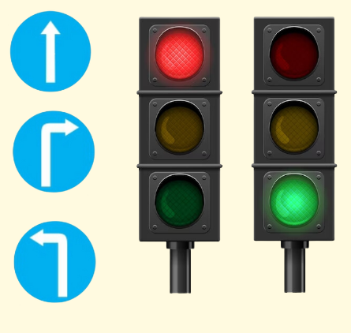 | Q: What does it say?  A: ________________________________.
Question 12. Let’s talk (0.75 points).
Teacher asks students to answer questions:
- What does your mother do on Saturdays? Do you help her with the housework?
- What animals do you like? Why do you like them?
- What’s the weather like today? Where do you want to go after the exam?
ĐÁP ÁN
PART I. LISTENING (3 points)
QUESTION 1: Listen and match (1 point)
Mỗi câu đúng 0.25 điểm (0.25x4)
- D | - A | - E | - C
QUESTION 2: Listen and tick Right or Wrong (1 point)
Mỗi câu đúng 0.25 điểm (0.25x4)
- ☓ | - ☓ | - ✓ | - ✓
QUESTION 3: Listen and complete (1 point)
Mỗi câu đúng 0.25 điểm (0.25x4)
- factory | - small face | - swimming pool | - tug of war
PART II. READING (2.5 points)
QUESTION 4: Circle the odd one out (1 point)
Mỗi câu đúng 0.25 điểm (0.25x4)
- eyes | - weather | - T-shirt | - dance
QUESTION 5: Fill in each blank with one given word (0.75 points)
Mỗi câu đúng 0.25 điểm (0.25x3)
- library | - straight | - left
QUESTION 6: Read and choose A, B or C (0.75 points)
Mỗi câu đúng 0.25 điểm (0.25x3)
- A | - C | - B
PART III. WRITING (2.5 points)
QUESTION 7: Fill in the blanks (1 point)
Mỗi câu đúng 0.25 điểm (0.25x4)
- between | - playing tug of war | - ninety thousand dong | - dance beautifully
Question 8. Use the given words to make sentences (0.75 points)
Mỗi câu đúng 0.25 điểm (0.25x3)
- What do you do in the morning?
- I live at 12 Tran Dung Dao Street.
- Do you want to go to the supermarket?
Question 9. Answer the questions with the given words. (0.75 points)
Mỗi câu đúng 0.25 điểm (0.25x3)
- I wash the clothes in the afternoon.
- He plays tennis on Saturdays.
- They are building a campfire.
PART IV. SPEAKING (2 points)
QUESTION 10: Introduction (0.5 points)
Mỗi câu trả lời 0.25 điểm (0.25x2)
Question 11. Look at the picture and answer the following questions. (0.75 points)
Mỗi câu trả lời 0.25 điểm (0.25x3)
- It was rainy.
- They are singing and dancing around the campfire.
- It says “go/ stop/ go straight/ turn left/ turn right”.
QUESTION 12: Let’s talk (0.75 points)
Mỗi câu trả lời 0.25 điểm (0.25x3)

