ĐỀ 5 | ĐỀ ÔN TẬP CUỐI HỌC KỲ II  NĂM HỌC 2025-2026  MÔN: TIẾNG ANH LỚP 4

PART 1. LISTENING (3 points)
Question 1: Listen and number. There is one example (1 point).
 |  |  | 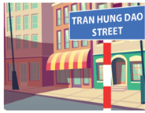 | 
 | 0

Question 2: Listen and tick or cross. There is one example (1 point).
 |  |  |  | 

Question 3: Listen and choose the answer for the question. There is one example (1 point).
 |  | - They are playing badminton.  - They are doctors.
 |  | - She has small eyes.  - He has small eyes.
 |  | - Yes, I do.  - At noon.
 | 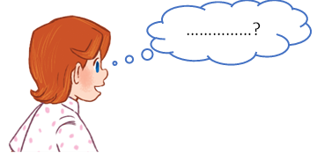 | - She goes to the sports center.  - She has a round face.
4. |  | - It’s windy.  - They are dancing.
PART II. READING (2.5 points)
Question 4. Read and match. There is one example (1 point).
 | - Where do you live?  - I live in a village. |  |  | 
 | - Does she work at a hospital?  - No, she doesn’t. She works at a nursing home. |  |  | 
 | - What do you do in the evening?  - I help my mother with the cooking. |  |  | 
 | - What does it say?  - It says “GO”. |  |  | 
 | - What animals do you like?  - I like lions because they roar loudly. |  |  | 

Question 5. Read and choose A, B or C. There is one example (0.75 points)
- What does your brother do on Sundays?
- He __________ television on Sundays.
 | - listens to | - watch | - watches
- What does your mother ____________?
- She is tall and slim.
 | - look like | - like | - look
 | My father wants some grapes and beans. He goes to the _____________.
 | - cinema | - supermarket | - swimming pool
- Why do you like birds?
- Because they ________________.
 | - run quickly | - roar loudly | - sing merrily
Question 6. Read and tick True or False. There is one example (0.75 points).
The weather is sunny today. We are at the campsite. Son is putting up a tent with Kiem. Dao and Huong are taking a photo. Hao is building a campfire to cook some food. Thuy Duong is singing a song. They are having a lot of fun together. | 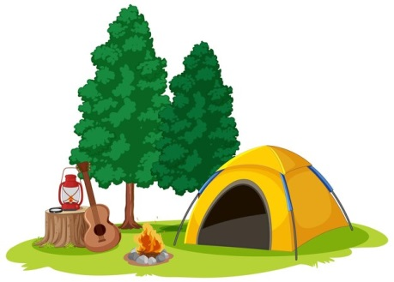
 |  | True | False
- It’s rainy today. |  |  | ✓
- Son and Huong are taking a photo.
- Kiem is putting a tent.
- Hao wants to cook some food.
PART III. WRITING (2.5 points)
Question 7. Reorder the letters to make a word. There is one example (1 point).

0. sTitrh → T-shirt
 | 
1. copielanm → ________________ | 2. kopsoboh → ________________
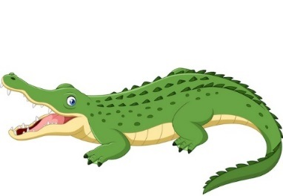 | 
3. ilcoderco → ________________ | 4. doucly → ________________
Question 8. Reorder the words to make complete sentences. There is one example (1 point).
- sister/ has/ My/ hair./ long
My sister has long hair.
- the/ Turn/ to/ get/ stall./ to/ left/ food
_______________________________________________________________
- much/ this/ is/ bag?/ How
_______________________________________________________________
- the/ Because/ roar/ lions/ loudly.
_______________________________________________________________
- Sundays./ My/ washes/ clothes/ the/ mother/ on
_______________________________________________________________
Question 9. Answer the questions with the given words. There is one example (0.5 points).
- What does his father do? (factory worker)
He’s a factory worker.
- What’s the weather like today? (sunny and windy)
_______________________________________________________________
- How can I get to the cinema? (go straight, turn right)
_______________________________________________________________
PART IV. SPEAKING (2 points)
Question 10. Introduction (0.5 points)
Teacher asks students to answer questions:
- What’s your name? How old are you?
- What’s your favorite subject? Why do you like it?
Question 11. Look at the picture and answer the following questions (0.75 points).
Teacher shows the map and asks students to answer questions about directions:
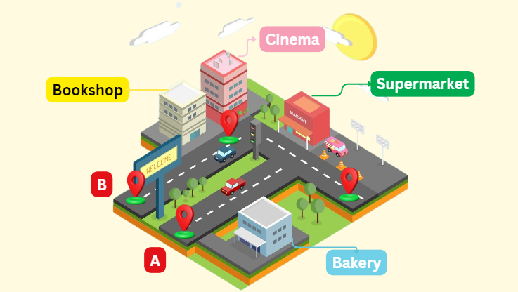
- You are at the point A. How can you get to the cinema?
- You are at the point A. How can you get to the supermarket?
- You are at the point B. How can you get to the bakery?
Question 12. Let’s talk (0.75 points).
Teacher asks students to answer questions:
- What does your father look like? Do you look like him?
- What do you do in the evening? Do you help your mother with the cooking?
- How much is your bag?
ĐÁP ÁN
PART I. LISTENING (3 points)
QUESTION 1: Listen and number (1 point)
Mỗi câu đúng 0.25 điểm (0.25x4)
- D | - C | - A | - E
QUESTION 2: Listen and tick or cross (1 point)
Mỗi câu đúng 0.25 điểm (0.25x4)

QUESTION 3: Listen and choose the answer for the question (1 point)
Mỗi câu đúng 0.25 điểm (0.25x4)
- B | - B | - A | - B
PART II. READING (2.5 points)
QUESTION 4: Read and match (1 point)
Mỗi câu đúng 0.25 điểm (0.25x4)
- C | - A | - E | - D
QUESTION 5: Read and choose A, B or C (0.75 points)
Mỗi câu đúng 0.25 điểm (0.25x3)
- A | - B | - C
QUESTION 6: Read and tick True or False (0.75 points)
Mỗi câu đúng 0.25 điểm (0.25x3)
- False | - True | - True
PART III. WRITING (2.5 points)
QUESTION 7: Reorder the letters to make a word (1 point)
Mỗi câu đúng 0.25 điểm (0.25x4)
- policeman | - bookshop | - crocodile | - cloudy
Question 8. Reorder the words to make complete sentences (1 point)
Mỗi câu đúng 0.25 điểm (0.25x4)
1. Turn left to get to the food stall.
2. How much is this bag?
3. Because the lions roar loudly.
4. My mother washes the clothes on Sundays.
Question 9. Answer the questions with the given words. (0.5 points)
Mỗi câu đúng 0.25 điểm (0.25x2)
1. It’s sunny and windy.
2. Go straight and turn right.
PART IV. SPEAKING (2 points)
QUESTION 10: Introduction (0.5 points)
Mỗi câu trả lời 0.25 điểm (0.25x2)
Question 11. Look at the picture and answer the following questions. (0.75 points)
Mỗi câu trả lời 0.25 điểm (0.25x3)
- Go straight and turn left, then go straight. The cinema is in the corner.
- Go straight and turn left. The supermarket is on the right.
- Go straight and turn right, then turn right again, then go straight. The bakery is on the left.
QUESTION 12: Let’s talk (0.75 points)
Mỗi câu trả lời 0.25 điểm (0.25x3)

