ĐỀ 21 | ĐỀ ÔN TẬP CUỐI HỌC KỲ I  NĂM HỌC 2025-2026  MÔN: TIẾNG ANH 4

PART A: LISTENING
- Listen and tick ( ) . There is 1 example .(1 point)

0.
A
B

1. 2.
A
B
B
A

3. 4.
A B A B

Listen and number . There is 1 example .(1 point)

0
D
C
B
A
E

Listen and tick ( ) or cross ( ) . There is 1 example .(0.5 point)

0. A.
B.



2.
1.

Listen and write . There is 1 example .(0.5 point)
  - A: Can you play the piano ?
B: Yes, I can.

  - A: Why do you like English ?
B: Because I want to be an English
.
  - A: How many are there at your
school?
B: There are three.

PART B: READING
    - Look, read and circle a or b. There are examples. ( 1.25 point)


0. - What time is it ?
It’s seven o’clock.
a.
1. My friend is from England.
b
.
2. I study at school on Tuesdays.
d. 
c.

3. There is one playground at my school.


4. – Where were you last weekend?
I was in the countryside.
e.

f.
5. – What do you want to eat ?
I want some chips.

Read and tick ( ) True or False. There is 1 example .(1.25 points)

Hello, everyone. My name is Trang. I’m a student in class 4A at a primary school. Uyen, Bao and Duong are my classmates. Uyen likes English, because she wants to be an English teacher. Bao likes P.E., because he wants to be a footballer. Duong likes art, because he wants to be a famous artist. I like music, because I want to be a singer. We are very happy at our school.
T F
- Trang is a primary student.
- Trang, Bao, Uyen and Duong are in the same class.
- Uyen likes P.E. because she wants to be a P.E. teacher.
- Bao likes English very much.

- Duong wants to be a famous artist.
- Trang wants to be a singer.

PART C: WRITING
  - Complete the sentences. There is 1 example .(1.25 points)

0. It’s

Monday
today.


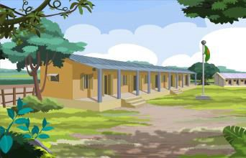1. I on Sundays. 2. – Where is your school?
It’s in the .

- I have on Tuesdays and Thursdays.
- She can .

- I at 6.30 in the evening.

Reorder the words. There are examples. ( 1.25 points)

0. from/ Viet Nam/ I’m/ .

I’m from Viet Nam.

- buildings/ three/ are/ school/ my/at/ There/.
.

- today/ It/ Sunday/ is/.
.

- breakfast/ 6.15/eat/I/at/.
.
- can’t/ badminton/ I/ play/.
.

- in/ last/ Da Nang/ was/ I/weekend/.
.

PART D: SPEAKING
  - Look and answer the questions. There is one example. ( 1 point)

  - Where is he from ?
.

He’s from Japan.

  - What do you do on Mondays?
.

3. What’s your favourite subject ?
.

Answer about you. ( 1 point)

1. What’s your favourite subject ?
.
2. Can she ride a bike ?
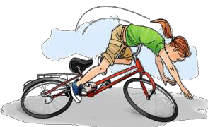 .

4. Why do you like Music ?
.

- Where were you last summer ?
.

- How many classrooms are there at your school ?
.
- What do you do on Sunday ?
.

The end
Keys
PART A: LISTENING
I. Listen and tick
1. B 2. A 3. A 4. B
II. Listen and number
1. B 2. C 3. D 4. A
III. Listen and tick or cross
1. X 2. V
IV. Listen and write
1. Teacher 2. buildings
PART B: READING
I. Read and match
1. E 2. A 3. B 4. F 5. D
II. Read and answer the questions
1. T 2. F 3. F 4. T 5. T
PART C: WRITING
I. Look and complete
1. listen to music 2. village
3. Science 4. ride a bike 5. Eat dinner
II. Reorder the words to make sentences
1. There are three buildings at my school.
2. It is Sunday today.
3. I eat breakfast at 6.15.
4. I can’t play badminton.
5. I was in Da Nang last weekend.
PART D: SPEAKING
I. Look and answer the questions
1. I study at school (on Mondays.)
2. No, she can’t./ No.
3. It’s Art./ Art.
4. Because I want to be a singer.

