ĐỀ 20 | ĐỀ ÔN TẬP CUỐI HỌC KỲ I  NĂM HỌC 2025-2026  MÔN: TIẾNG ANH 4

PART A: LISTENING
- Listen and tick ( ) . There is 1 example .(1 point)

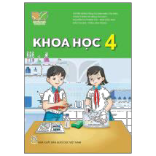0.
B
2.
A
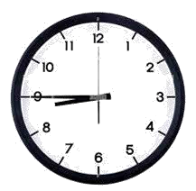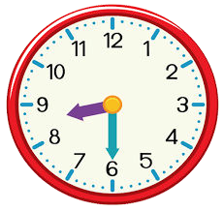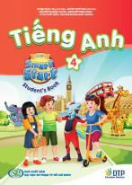A
B

1.
B
A



3. 4.
A B A B

Listen and number . There is 1 example .(1 point)

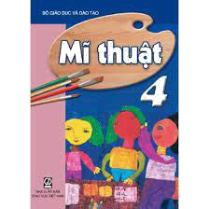0
D
C
B
A E

Listen and tick ( ) or cross ( ) . There is 1 example .(0.5 point)

0. A.
B.


1.
2.

Listen and write . There is 1 example .(0.5 point)
  - A: Can you play the piano ?
B: Yes, I can.

  - A: What do you do on Thursday ?
B: I .
  - A: Where’s your school, Bill ?
B: It’s in the .

PART B: READING
    - Look, read and circle a or b. There are examples. ( 1.25 point)
- - What time is it ?
  - It’s seven o’clock. b. It’s seven fifteen .

- a. I like maths because I want to be a math teacher.
b. I like art because I want to be an art teacher.
- a. I have breakfast at six thirty .
b. I have breakfast at six fifty.

– What do you want to eat ?
  - I want some chips .
  - I want some grapes .

– What do you do on Sundays ?
  - I listen to music
  - I do housework .

– When’s your birthday ?
  - It’s in August.
  - It’s in March.

    - Read and complete the sentences. There is 1 example .(1.25 points)

Hello, everyone. My name is Gia Bao. I’m nine years old. I live in Nam Dinh province with my family. My school is not very big. It’s in the town. There are three buildings, a garden and a yard at my school. The garden has many trees and flowers. The playground is very big. The students can play football, badminton and skip there. I love my school because it is very beautiful.
0. The boy’s name is Gia Bao.

1. He is years old. 2. His school is in the .

- There are three at his
school.
- There are many trees and flowers in the
.

- The students can play football and skip in the
.

PART C: WRITING
- Complete the sentences. There is 1 example .(1.25 points)

0. It’s

Monday
today.

1. - Can she ? Yes, she can

3. – Were you at the yesterday? Yes, I was.

2. My favourite subject is .


- A: What do you do on Tuesday?
B: I .

- A: What do you want to drink?
B: I want some .

- Reorder the words. There are examples. ( 1.25 points)

0. from/ Viet Nam/ I’m/ .

I’m from Viet Nam.

- eat ?/ do/ What/ to/ want/ you/
.

- today/ It/ Saturday/ is/.
.

- school/ at/ go/ I/ to/6.45/ .
.
- can/ piano/play/She/ the/.
.

- in/ last/ Da Nang/ was/ I/summer/.
.

PART D: SPEAKING
- Look and answer the questions. There is one example. ( 1 point)

  - Where is he from ?
.

He’s from Japan.

  - Where were you last summer ?
.
  - When do you have music?
 .

  - What time do you get up ?
.
  - What do you want to drink ?
 .

Answer about you. ( 1 point)

1. What’s your favourite subject ?
.
- Where were you last summer ?
.

- How many classrooms are there at your school ?

- What do you do on Sunday ?
.

. The end
Keys
PART A: LISTENING
I. Listen and tick
1. B 2. A 3. A 4. B
II. Listen and number
1. C 2. D 3. B 4. A
III. Listen and tick or cross
1. V 2. X
IV. Listen and write
1. study at school 2. town
PART B: READING
I. Read and circle
1. B 2. A 3. A 4. B 5. A
II. Read and answer the questions
1. nine/9
2. town
3. buildings
4. garden
5. playground
PART C: WRITING
I. Look and complete
1. roller skate 2. music
3. campsite 4. Study at school 5. lemonade
II. Reorder the words to make sentences
1. Whatdo you want to eat?
2. It is Saturday today.
3. I go to school at 6.45.
4. She can play the piano.
5. I was in Da Nang last summer.
PART D: SPEAKING
I. Look and answer the questions
1. I was at the campsite./ At the campsite.
2. I have it on Wednesdays./ On Wednesdays.
3. I get up at 5.30 ( five thirty) / At five thirty.
4. I want some juice./ some juice.

