ĐỀ 19 | ĐỀ ÔN TẬP CUỐI HỌC KỲ I  NĂM HỌC 2025-2026  MÔN: TIẾNG ANH 4

PART A: LISTENING
- Listen and tick ( ) . There is 1 example .(1 point)


B
0.
A
B

1. 2.
A B A

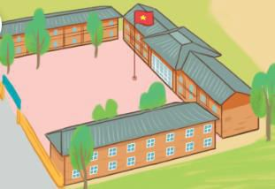

3. 4.
A B A B

Listen and number . There is 1 example .(1 point)


A
B
C
D
0
E

Listen and tick ( ) or cross ( ) . There is 1 example .(0.5 point)



0. A.
B.

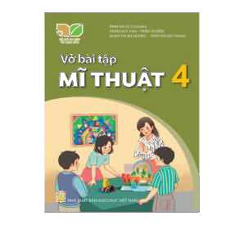
1.
2.

Listen and write . There is 1 example .(0.5 point)
  - A: Can you play the piano ?
B: Yes, I can.

  - A: I can fly a kite .
B: I can
  - A: What do you do on ?
B: I go to school .

PART B: READING
    - Look, read and tick ( )the correct picture. There are examples. ( 1.25 point)

- A: What time is it ?
B: It’s seven o’clock. a. b.

- A: What day is it today ?
B: It’s Tuesday. a. b.
- My favourite subject is PE. a.  b.
- A: What time do you go to school?
B: I go to school at 7.15. a. b.

- I was at the campsite last weekend. a.  b.
- A: What do you want to eat?
B: I want some jam. a. b.

Read the passage and answer the questions. There is 1 example .(1.25 points)

Hello, everyone. My name is Duong and I’m 10 years old. I’m a student at a primary school. It’s big and it is in the village. There are three buildings and a large garden at our school. The garden has a lot of trees and flowers. There is a big and beautiful playground at my school, too. Students often play sports and games there at break time. Nam is my penpal friend. His school is in the city. It’s a big and modern school in Ha Noi. There are two computer rooms and four high
buildings at his school. I wish I will have a chance to visit his school some day.
0. How old is Duong?

He’s 10 years old. / 10/ Ten

1. Where is Duong’s school?

3. Is there a garden at his school?

2. How many buildings are there at his school?

.
- Where is Nam’s school?

.

- How many computer rooms are there at Nam’s school?

.
PART C: WRITING
- Complete the sentences. There is 1 example .(1.25 points)

0. It’s

Monday
today.



1. I have and Vietnamese on
Mondays. 
3. I get up at everyday.
2. I was in the last weekend.

- A: What do you do on Sundays?
B: I .

- A: What do you want to eat?
B: I want some .

Reorder the words. There are examples. ( 1.25 points)

0. from/ Viet Nam/ I’m/ .

I’m from Viet Nam.

- big/ There/ a/ is/ at/ playground/ school/ my/
.

- some/ want/ lemonade/ I/.
.

- breakfast/ I/ at/ 6.30/ have/.
.
- zoo/ I/ at/ the/ was/ yesterday/.
.

- Mondays/ maths/ I/ and music/ have/ on
.

PART D: SPEAKING
- Look and answer the questions. There is one example. ( 1 point)

  - Where is he from ?
.

He’s from Japan.

  - Can your sister ride a horse?
 .

3. When’s the sports day?
.
  - Where is the school ?
 .

4. What day is it today?
.

Answer about you. ( 1 point)

- What time do you get up?
.
- When do you have maths?
.

- Were you at school yesterday ?

- Can you play the guitar?
.

The end
`Keys
PART A: LISTENING
I. Listen and tick
1. B 2. A 3. A 4. B
II. Listen and number
1. C 2. A 3. D 4. B
III. Listen and tick or cross
1. X 2. V
IV. Listen and write
1. skip 2. Wednesdays
PART B: READING
I. Read and tick the correct picture
1. B 2. B 3. A 4. B 5. A
II. Read and answer the questions
1. It’s in the village./ In the village.
2. There are three (buildings). / three/ 3/.
3. Yess, there is./ Yes.
4. It’s in the city./ In the city.
5. There are two/2 (computer rooms)./ 2/ Two.
PART C: WRITING
I. Look and complete
1. Math 2. countryside
3. 5.45/ five forty-five 4. Listen to music 5. grapes
II. Reorder the words to make sentences
1. There is a big playground at my school.
2. I want some lemonade.
3. I have at 6.30.
4. I was at the zoo yesterday.
5. I have maths on Mondays.
PART D: SPEAKING
I. Look and answer the questions
1. Yes./ Yes, She can.
2. It’s in the city./ In the city.
3. It’s in September./ In September.
4. It’s Friday./ Friday.

