ĐỀ 18 | ĐỀ ÔN TẬP CUỐI HỌC KỲ I  NĂM HỌC 2025-2026  MÔN: TIẾNG ANH 4
18

PART A: LISTENING
- Listen and tick ( ) . There is 1 example .(1 point)

0.
A
B



1. 2.

B
A B A

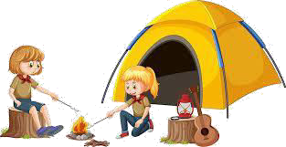3. 4.
A B A B

Listen and number . There is 1 example .(1 point)

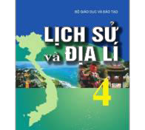0
D
C
A
B E

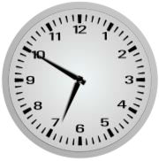Listen and tick ( ) or cross ( ) . There is 1 example .(0.5 point)

0. A.
B.



2.
1.

Listen and write . There is 1 example .(0.5 point)
  - A: Can you play the piano ?
B: Yes, I can.

  - A: When do you have ?

B: I have it on Wednesday.
  - Our sports day is in .

PART B: READING
    - 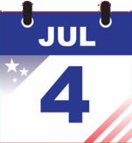Look, read and match. There are examples. ( 1.25 point)

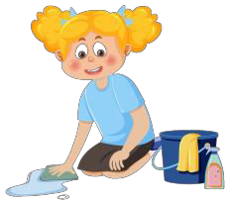
0. A: What time is it ?
B: It’s seven o’clock.
a.
1. A: How many playgrounds are
there at your school?
B: There is one..
b.
2. A: What do you do on Sundays?
B: I do housework.
c.
3. I was on the beach yesterday.
d.
4. My birthday is in July.
e.

f.
5. A: Why do you like music?
B: Because I want to be a singer.

Read and complete the sentences. There is 1 example .(1.25 points)

draw friends ride badminton can’t piano

Hello, everyone. My name is Uyen. At school, I have many (0) friends . We can do different things. Thu can play (1) , but she (2) swim. Nam can roller skate, but he can’t (3) a horse . Linh likes music so much. She can play both the (4) and the guitar well. I can
(5) , but I can’t play sports. We can all ride a bike. Everyday, we often go to school by bike together.

PART C: WRITING
      - Complete the sentences. There is 1 example .(1.25 points)

today.  
0. It’s
Monday
1. My friends want some . 2. I at 6.45.

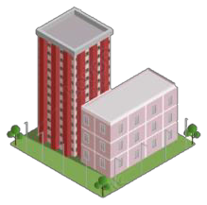

- I like art because I want to be a .
- There are two at my school.

- My friend, Hakim is from .

Reorder the words. There are examples. ( 1.25 points)

0. from/ Viet Nam/ I’m/ .

I’m from Viet Nam.

- music/ on/ have/ Mondays/ I/ .
.
- birthday/ is/ My/ in/ August/.
.

- subject/ art/ My/ is/ favourite/.
.
- get up/ at/ five thirty/ I/.
.

- at/ school/ many/ gardens/ How/ are/ you/ there/ ?
.

PART D: SPEAKING
- Look and answer the questions. There is one example. ( 1 point)

  - Where is he from ?
.

He’s from Japan.

  - 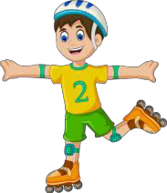Can he roller skate?
.
2. What’s her favourite subject?
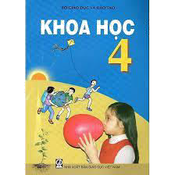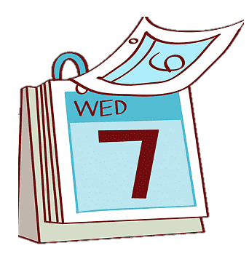 .

- 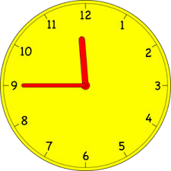What time is it ?
.
- What day is it today?
.

Answer about you. ( 1 point)

- Where is your school ?
.
- Where were you last summer?
.

- What do you do on Saturdays?
.

- Can you play the guitar?
.

The end

Keys
PART A: LISTENING
I. Listen and tick
1. B 2. A 3. A 4. B
II. Listen and number
1. C 2. D 3. B 4. A
III. Listen and tick or cross
1. V 2. X
IV. Listen and write
1. music 2. February
PART B: READING
I. Read and match
1. D 2. E 3. A 4. C 5. B
II. Read and complete
1. badminton 2. Can’t
3. ride 4. piano 5. draw
PART C: WRITING
I. Look and complete
1. grapes 2. go to school
3. painter 4. buildings 5. Malaysia
II. Reorder the words to make sentences
1. I have music on Mondays.
2. My birthday iss in August.
3. My favourite subject iss art.
4. I get up at five thirty
5. How many garderns are there at your school?
PART D: SPEAKING
I. Look and answer the questions
1. No, he can’t./ No.
2. Her favourite subject iss Science./ It’s Science/ Science.
3. It’s eleven forty-five./ Eleven forty-five/ 11.45.
4. It’s Wednesday./ Wednesday.

