ĐỀ 17 | ĐỀ ÔN TẬP CUỐI HỌC KỲ I  NĂM HỌC 2025-2026  MÔN: TIẾNG ANH 4

PART A: LISTENING
- Listen and tick ( ) . There is 1 example .(1 point)

0.
A
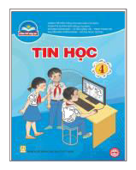B
B

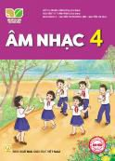1. 2.
A
A B

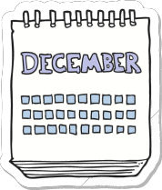

3. 4.
A B A B

Listen and number . There is 1 example .(1 point)

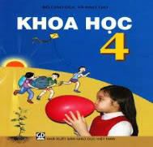
B C
0
E
D
A

Listen and tick ( ) or cross ( ) . There is 1 example .(0.5 point)

0. A.
B.



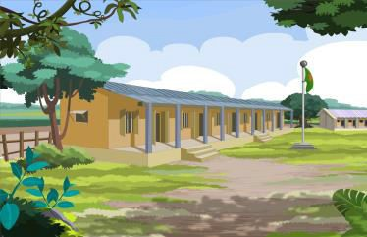2.
1.

Listen and write . There is 1 example .(0.5 point)
  - A: Can you play the piano ?
B: Yes, I can.

  - A: Where’s he from?
B: He’s from
  - A: What subjects do you have today?
. B: I have .

PART B: READING
- Look, read and write true (T) or false (F). There are examples. ( 1 point)


T
F

- a. A: What time is it ?
B: It’s seven o’clock.


- A: Where were you last weekend?
B: I was on the beach.
- b. A: When do you have science?
B: I have it on Thursday.


  - My favourite subject is English.
I want to be an English teacher.

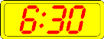
  - My school is in the city. 4. A: What time do you go to school?
B: I go to school at six thirty.

- My friend is from America.

Read and complete the sentences. There is 1 example .(1.25 points)

Hi! My name is Bao. I’m ten years old and I am a student at a primary school. My school is in the village and it is near my house. Everyday, I often get up at six o’clock . After breakfast, I ride my bike to school at six forty – five. I have many subjects at school, but my favourite subject is English. I want to be an English teacher. Mai is my best friend in my class. Her favourite subject is music, because she wants to be a singer.

0. Bao is 10/ ten years old.
1. Bao’s school is in the .
2. He gets up at .
3. Bao’s favourite subject is .
4. Bao wants to be a(n) .

5. Mai’s favourite subject is music. She wants to be a(n) .

PART C: WRITING
  - Complete the sentences. There is 1 example .(1.25 points)

0. It’s

Monday
today.


1. I at 9.30. 2. Last Sunday, I was .

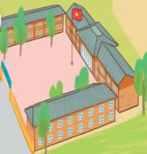

- There are three at my school.
- I like art, because I want to be a .


- A: What do you want to drink?
B: I want some .

Reorder the words. There are examples. ( 1.25 points)
0. from/ Viet Nam/ I’m/ .

I’m from Viet Nam.

- yesterday?/ were/ Where/ you/
.
- on/ Sundays/ I/ listen/ music/ to/.
.

- music/ have/ I/ on/ Thursdays/.
.
- six forty-five./ breakfast/ at/ I/ have/
.

- subject/ is/ My/ favourite/ maths/.
.

PART D: SPEAKING
- Look and answer the questions. There is one example. ( 1 point)
- Where is he from ?

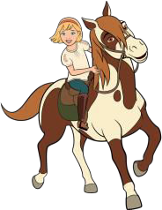 He’s from Japan. .

- 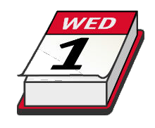What day is it today ?
.
- Can she ride a horse ?
.

3. When’s your sports day?
.
- Where is your school ?
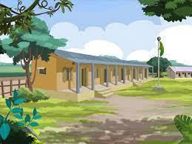 .

Answer about you. ( 1 point)

  - Can you swim ?
.

2. What’s your favourite subject?
.

- What time do you go to school?
.
- What subjects do you have today?
.

The end
Keys
PART A: LISTENING
I. Listen and tick
1. A 2. B 3. B 4. A
II. Listen and number
1. B 2. C 3. D 4. A
III. Listen and tick or cross
1. V 2. X
IV. Listen and write
1. Malaysia 2. Science
PART B: READING
I. Read and write T or F
1. T 2. F 3. F 4. T 5. F
II. Read and complete
1. village 2. 6 o’clock
3. English 4. English teacher 5. Singer
PART C: WRITING
I. Look and complete
1. go to bed 2. At the zoo
3. buildings 4. Painter 5. Lemonade
II. Reorder the words to make sentences
1. Where were you yesterday?
2. I listen to music on Sundays.
3. I have music on Thursdays.
4. I have breakfast at six forty – five.
5. My favourite subject is Math.
PART D: SPEAKING
I. Look and answer the questions
1. It’s Wednesday. / Wednesday.
2. Yes, she can./ Yes.
3. It’s in November./ November.
4. It’s in the village./ In the village.

