ĐỀ 16 | ĐỀ ÔN TẬP CUỐI HỌC KỲ I  NĂM HỌC 2025-2026  MÔN: TIẾNG ANH 4

Skill | Listening | Reading | Writing | Speaking | Total
Mark
LISTENING
PART 1:Listen and tick. There is one example.(1pt)

0. |  |  | 
  A.
  B.
  C.
1. |  |  | 
  A.
  B.
  C.
2. |  |  | 
  A.
  B.
  C.
3. | 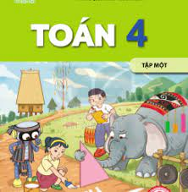 | 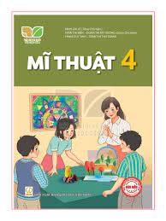 | 
  A.
  B.
  C.
4. |  |  | 
  A.
  B.
  C.

PART 2: Listen and number. There is one example.(1pt)
A   | B   | C   | D   | E  
0

PART 3: Listen and draw line. There is one example. (1pt)

 | A   | B   | C  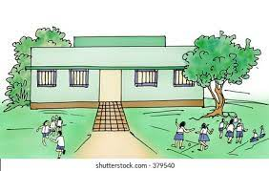 | D   | E  
4
3
2
1
0

PART 4: Listen and write. There is one example.(1pt)
0. What subjects do you have today? – I have English and Art.
1. I …………to be a painter.
2. Were you at the …………………….. yesterday?
3. My family have breakfast at ………………… o’clock
4. My new friend is from ………..………………

READING
PART 1: Read and match the words with pictures. There is one example. (1pt)
(0) Example  0) get up | A 
1. Maths teacher | B 
2. ride a bike | C 
3. on the beach | D 
4. computer room | E 
PART 2. Read and choose A, B or C to complete text. There is one example. (0,75pts)
My school is (0) in the village. It has many trees. There is one playground. (1)…………………… is one computer room with many computers in it. And there (2)…………………two gardens. At break time, I and my friends often (3)…………… football and game in the playground.I love my school very much.
0.a. with b.on c.in
1. a. The b. There c. There’s
2. a. are b. is c. am
3. a. playing b. playes c. play
PART 3 .Read and tick (√) True or False. There is an example .(0,75pts)
Good afternoon! I'm Linh. I'm in Class 4C. This is my classroom. Today is Wednesday. We're having an English class now. We always have English on

Wednesdays and Fridays. Mrs Hoa, my mother, is our English teacher. I like English classes very much. I can speak English and sing many English songs, but I can’t play football.
 |  | TRUE | FALSE
0. | 0. Linh is in Class 4C. |  | √
1. | 1. Today is Thursday
2. | 2. Today, Linh is having Music class now.
3 | 3. Linh’s mother is Mrs Hoa. She’s an English teacher.

WRITING
PART 1.Look at the pictures and the letters. Write the words. (0,75pts)

 |  | 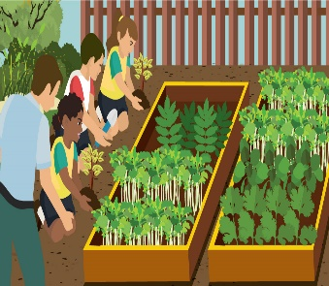
Example (0).  - danlihaT  -> Thailand | 1.retwa  ->____________ | 2. denrag  ->____________ | 3. nEshilg  ->_____________
PART 2. Rearrange the words to make the sentences. There is one example. (0,75pts)

(0). music/ Sundays/ I/ to/ listen/on/./

→ I listen to music on Sundays.

1. subject / your / What’s / favourite/ ?/

………………………………………………………………………………………

2. school / two / are / my / There / buildings / at /.

………………………………………………………………………………………

3. you / do / What / Tuesdays/ do / on?

………………………………………………………………………………………

SPEAKING . (2pts)

Part 1

Part 2

Part 3

The end

ĐÁP ÁN VÀ BIỂU ĐIỂM
LISTENING
PART 1. (0,25*4 =1pt)
1.B 2.C 3.A 4.B
PART 2. (0,25*4 =1pt)
1.A 2.D 3.E 4.C
PART 3.(0,25*4 =1pt)
1.D 2.E 3.A 4.C
PART 4. (0,25*4 =1pt)
1. want 2. campsite 3. six 4. Japan
READING
PART 1(0,25*4 =1pt)
1.D 2. A 3. E 4.C
PART 2 (0,25*3 =0.75 pts )
1.B 2. A 3. C
PART 3 (0,25*3 =0.75 pts )
1. FALSE 2. FALSE 3. TRUE
WRITING
PART 1 (0,25*3 =0.75 pts )
1. water 2.garden 3. English
PART 2 (0,25*3 =0.75 pts )

1. What’s your favourite subject?

2.There are two buildings at my school.

3.What do you do on Tuesdays?

SPEAKING
Greeting & test taker’s name check.
The examiner says “My name is…It’s nice to talk to you today.”
Part 1: Getting to know each other
The examiner asks 3 questions below:
- What’s your name?
- Where’s your school?
- What subjects do you have today?
Part 2: Point at the picture and say the words / sentences
The examiner point to the pictures and ask ss some questions.
- What time is it?
- When’s your birthday?
- Where’s he/ she from?
- Where were you last summer?

 |  | 
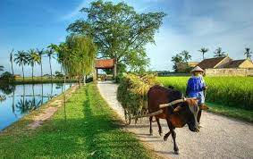 |  |  | 
 |  |  | 
Part 3: Answer the questions:
The examiner asks 3 questions below:
- Why do you like…………?
- What do you do on…………..?
- What do you want ot eat/ drink?
That’s the end of the speaking test. You did a great job. Thank you.

