ĐỀ 15 | ĐỀ ÔN TẬP CUỐI HỌC KỲ I  NĂM HỌC 2025-2026  MÔN: TIẾNG ANH 4

Skill | Listening | Reading | Writing | Speaking | Total
Mark
LISTENING
PART 1:Listen and tick. There is one example.(1pt)

0. | 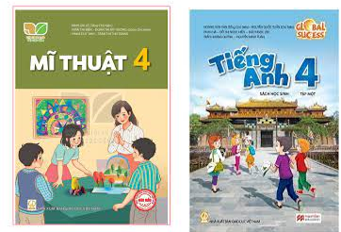 | 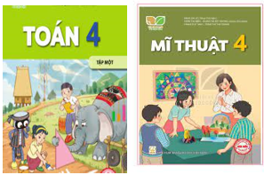 | 
  A.
  B.
  C.
1. |  |  | 
  A.
  B.
  C.
2. |  |  | 
  A.
  B.
  C.
3. |  |  | 
  A.
  B.
  C.
4. | 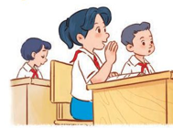 |  | 
  A.
  B.
  C.

PART 2: Listen and number. There is one example.(1pt)
A  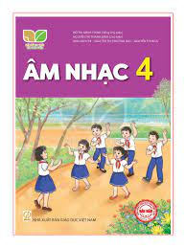 | B   | C   | D   | E  
0

PART 3: Listen and draw line. There is one example. (1pt)

 | A  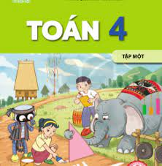 | B   | C   | D   | E  
4
3
2
1
0

PART 4: Listen and write. There is one example.(1pt)
0. Nam can ride a bike.
1. I want to be a ………………………
2. She’s from …………………………
3. He goes to …………………at six fifteen.
4. What do you do on ………..………? – I listen to music.

READING
PART 1: Read and match the words with pictures. There is one example. (1pt)
(0) Example  0) painter | A 
1. birthday party | B 
2. buildings | C 
3. study at school | D 
4. play the guitar | E 
PART 2. Read and choose A, B or C to complete text. There is one example. (0,75pts)

Dear penfriend,
Hi ! My (0) name is Mary. I’m (1)______________America. My birthday is in (2)________________. I have many presents from my family. My parents give me a new blue bike and I receive a new pink doll from my sister. I’m very happy. What about you? (3)_____________your birthday?

0.a. English b.Vietnamese c.name
1. a. from b. singing c. cooking
2. a. nineteen b. nine c. September
3. a. When b. When’s c. Where

PART 3 .Read and tick (√) True or False. There is an example .(0,75pts)
Hello, My name is Lan. I have four friends: Mary, Lucy, Ben, Minh. Mary can play the piano, but she can’t play the guitar. Lucy can cook, but she can’t ride a bike. Ben can ride a horse, but he can’t draw. Minh can play football, but he can’t roller skate. I can cook, but I can’t swim. We all can sing and dance.
 |  | TRUE | FALSE
0. | 0. Lan has three friends. |  | √
1. | 1. Mary can play the piano, but she can’t play the guitar.
2. | 2. Ben can ride a horse and draw.
3 | 3. Lan, Mary, Lucy, Ben and Minh can sing and dance.

WRITING
PART 1.Look at the pictures and the letters. Write the words. (0,75pts)
 |  |  | 
Example (0).  niraBit  -> Britain | 1.nuringn  ->____________ | 2. sepgar  ->____________ | 3. saninomut  ->_____________
PART 2. Rearrange the words to make the sentences. There is one example. (0,75pts)

(0). were/ last/ Where/ summer/ you/ /?/

→ Where were you last summer?

1. she/ Where/ from/ is /?/

………………………………………………………………………………………

2. in/ My/ February/ is/ birthday /. /

………………………………………………………………………………………

3. up/ I/five/ at/ get/ forty-five /./

………………………………………………………………………………………

SPEAKING . (2pts)

Part 1

Part 2

Part 3

The end

ĐÁP ÁN VÀ BIỂU ĐIỂM
LISTENING
PART 1. (0,25*4 =1pt)
1.C 2.A 3. B 4.C
PART 2. (0,25*4 =1pt)
1.D 2.A 3.E 4.C
PART 3.(0,25*4 =1pt)
1.C 2.E 3.A 4.D
PART 4. (0,25*4 =1pt)
1 painter 2. Thailand 3. school 4. Friday
READING
PART 1(0,25*4 =1pt)
1.D 2. A 3. E 4.C
PART 3 (0,25*3 =0.75 pts )
1.A 2. C 3. B
PART 2 (0,25*3 =0.75 pts )
1. TRUE 2. FALSE 3. TRUE
WRITING
PART 1 (0,25*3 =0.75 pts )
1. running 2.grapes 3. mountains
PART 2 (0,25*3 =0.75 pts )

1.Where is she from?

2.My birthday is in February.

3.I get up at five forty – five.
SPEAKING
Greeting & test taker’s name check.
The examiner says “My name is…It’s nice to talk to you today.”
Part 1: Getting to know each other
The examiner asks 3 questions below:
- What’s your name?
- What’s your favourite subject?
- What day is it today?
Part 2: Point at the picture and say the words / sentences
The examiner point to the pictures and ask ss some questions.
- Where’s he/ she from?
- How many……………….are there at the school?
- Can he/ she…………..?
- Is sports day in…………..?

 | 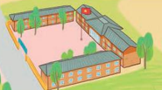 |  | 
 |  |  | 
 |  |  | 
Part 3: Answer the questions:
The examiner asks 3 questions below:
- What do you want to eat/ drink?
- When’s your birthday?
- Were you …………..last weekend?
That’s the end of the speaking test. You did a great job. Thank you.

