ĐỀ 14 | ĐỀ ÔN TẬP CUỐI HỌC KỲ I  NĂM HỌC 2025-2026  MÔN: TIẾNG ANH 4

Skill | Listening | Reading | Writing | Speaking | Total
Mark
LISTENING
PART 1:Listen and tick. There is one example.(1pt)

0. |  |  | 
  A.
  B.
  C.
1. |  |  | 
  A.
  B.
  C.
2. |  | 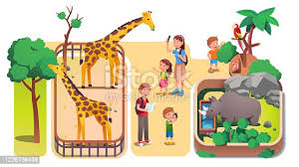 | 
  A.
  B.
  C.
3. | 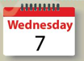 | 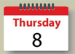 | 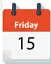
  A.
  B.
  C.
4. |  |  | 
  A.
  B.
  C.

PART 2: Listen and number. There is one example.(1pt)
A   | B   | C  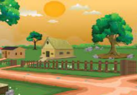 | D  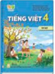 | E  
0

PART 3: Listen and draw line. There is one example. (1pt)

 | A   | B   | C   | D   | E  
4
3
2
1
0

PART 4: Listen and write. There is one example.(1pt)
0. I study at school.
1. I’m from ………………………
2. I want to be a ………………… teacher.
3. He likes ……………………..
4. When’s your birthday? – It’s in ………..……………
READING
PART 1: Read and match the words with pictures. There is one example. (1pt)
(0) Example  0) IT | A 
1. grapes | B 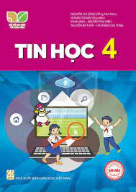
2. English teacher | C 
3. Britain | D 
4. listen to music | E 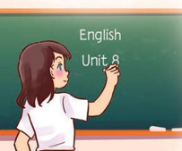

PART 2. Read and choose A, B or C to complete text. There is one example. (0,75pts)
There are four people in my (0) family. My father (1)……………….…… swim very well. My mother can cook but she can’t (2)……………….… the piano. My brother can play football and play the guitar but he can’t dance. I like music, I can sing (3)………… dance but I can’t cook.
0.a. friend b.teacher c.family
1. a. do b. can c. is
2. a. play b. does c. do
3. a. on b. to c. and

PART 3 .Read and tick (√) True or False. There is an example .(0,75pts)
Hello. My name is Lucy. It is Wednesday today. It is a school day. My friend Mary and I go to school on Mondays, Tuesdays, Wednesdays, Thursdays and Fridays. At the weekend, we stay at home. We do housework on Saturdays. We listen to music and watch TV on Sundays.
 |  | TRUE | FALSE
0. | 0. Today is Wednesday. | √
1. | 1. Mary and Lucy goes to school from Mondays to Fridays.
2. | 2. At the weekend, they don’t stay at home.
3 | 3. On Saturdays, they do homework.

WRITING
PART 1.Look at the pictures and the letters. Write the words. (0,75pts)
 |  |  | 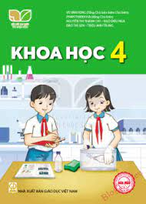
Example (0).  koco -> cook | 1.shicp  ->____________ | 2. misw  ->____________ | 3. cecisen  ->_____________
PART 2. Rearrange the words to make the sentences. There is one example. (0,75pts)

(0). is/ What/ time/ it /?/

→ What time is it?

1. six/ I/ at/ breakfast/ have/ fifteen/./

………………………………………………………………………………………

2. want/ do/ What/ to/ you/ eat/ ? /

………………………………………………………………………………………

3. school/ has/ My/ playground/ a/./

………………………………………………………………………………………

SPEAKING . (2pts)

Part 1

Part 2

Part 3

The end

ĐÁP ÁN
LISTENING
PART 1. (0,25*4 =1pt)
1.B 2.A 3.C 4.B
PART 2. (0,25*4 =1pt)
1.D 2.A 3.E 4.C
PART 3.(0,25*4 =1pt)
1.A 2.E 3.C 4.D
PART 4. (0,25*4 =1pt)
1. America 2. Maths 3. running 4. January
READING
PART 1(0,25*4 =1pt)
1.C 2. E 3. A 4.D
PART 2 (0,25*3 =0.75 pts )
1.B 2. A 3. C
PART 3 (0,25*3 =0.75 pts )
1. TRUE 2. FALSE 3. FALSE
WRITING
PART 1 (0,25*3 =0.75 pts )
1. chips 2.swim 3. Science
PART 2 (0,25*3 =0.75 pts )
- I have breakfast at six fifteen.
- What do you want to eat?
- My school has a playground.
SPEAKING
Greeting & test taker’s name check.
The examiner says “My name is…It’s nice to talk to you today.”
Part 1: Getting to know each other
The examiner asks 3 questions below:
- What’s your name?
- What time is it?
- Where are you from?
Part 2: Point at the picture and say the words / sentences
The examiner point to the pictures and ask ss some questions.
- Can he/ she…………..?
- Where’s he/ she from?
- Is sports day in…………..?
- Why do you like………….?

 |  |  | 
 | 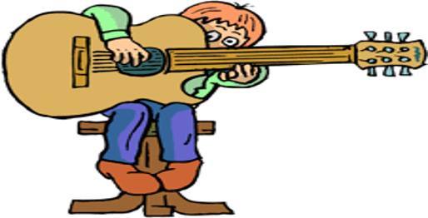 | 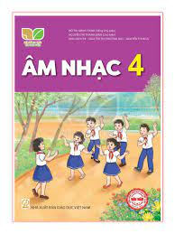
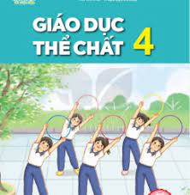 |  | 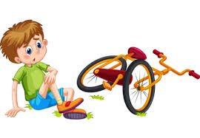 | 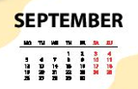
Part 3: Answer the questions:
The examiner asks 3 questions below:
- What do you want to eat/ drink?
- When’s your birthday?
- What do you do on………….?
That’s the end of the speaking test. You did a great job. Thank you.

