ĐỀ 13 | ĐỀ ÔN TẬP CUỐI HỌC KỲ I  NĂM HỌC 2025-2026  MÔN: TIẾNG ANH 4

Skill | Listening | Reading | Writing | Total
Mark
LISTENING
PART 1:Listen and tick. There is one example.(1pt)

0. |  |  | 
  A.
  B.
  C.
1. |  |  | 
  A.
  B.
  C.
2. |  |  | 
  A.
  B.
  C.
3. |  |  | 
  A.
  B.
  C.
4. |  |  | 
  A.
  B.
  C.

PART 2: Listen and number. There is one example.(1pt)
A   | B  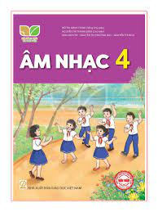 | C   | D   | E  
0

PART 3: Listen and draw line. There is one example. (1pt)

 | A  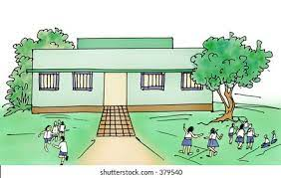 | B   | C   | D  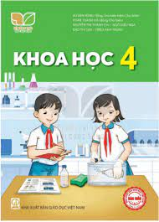 | E  
4
3
2
1
0

PART 4: Listen and write. There is one example.(1pt)
0. He’s at the zoo at weekends.
1. There’s some …………………. on the table.
2. He’s from ……………………………
3. What day is it today? – It’s ……………………..
4. My favourite subject is………..…………………

READING
PART 1: Read and match the words with pictures. There is one example. (1pt)
(0) Example  0) computer room | A 
1. go to bed | B 
2. water | C 
3. nine forty-five | D 
4. birthday party | E 
PART 2. Read and choose A, B or C to complete text. There is one example. (1pt)
Hello, My name is Hoa. I’m from (0 ……… I was on holiday in Nha Trang last summer. The beach was very beautiful.We went(1)……………….……… in the sea and then built sandcastles in the afternoon.
In the evening, we had seafood at a restaurant, it was excellent. The people were friendly (2)………………….helpful. We also watched a film at the (3)………………., it was interesting. My holiday was very nice.
0.a. English b.Vietnamese c.Viet Nam
1. a. swimming b. singing c. cooking
2. a. of b. and c. on
3. a. mountain b. hospital c. cinema

PART 3 .Read and tick (√) True or False. There is an example .(1.0 pt )
Hung is a pupil at Quang Trung Primary school. Every day he gets up at 6 o’clock. He has breakfast at six twenty and goes to school at six forty- five. School starts at 7:00 a.m and finishes at 10:30 a.m. He goes home at 10: 45. He has lunch at 11.15. In the afternoon, he often plays football with his friends at 4:00. In the evening he does his homework or listens to music. Then, he goes to bed at 9:30.
 |  | TRUE | FALSE
0. | 0. Hung is a pupil at Quang Trung Primary school.
1. | 1. He has breakfast at 6: 25.
2. | 2. School starts at seven a.m and finishes at ten thirty a.m.
3 | 3. In the evening, he does his housework or listens to music.

WRITING
PART 1.Look at the pictures and the letters. Write the words. (2.0 pts)
 |  |  | 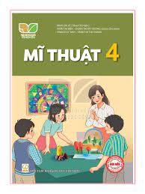
Example (0).  - cingoko  -> …………….. | 1.niraBit  ->____________ | 2. naledemo  ->____________ | 3. tar  ->_____________
PART 2. Rearrange the words to make the sentences. There is one example. (2.0pt)
- day/ your/When’s /sports /?/

→ ……………………………………………………………………………………………

2. five/ I/ at/ get/ thirty / up /./

………………………………………………………………………………………

3. subject/your / What’s /favourite/ ? /

………………………………………………………………………………………

4. do/on/ I/ Sunday/ housework/./

………………………………………………………………………………………

ĐÁP ÁN
LISTENING
PART 1. (0,25*4 =1pt)
1.B 2.C 3.A 4.B
PART 2. (0,25*4 =1pt)
1.E 2.A 3.D 4.C
PART 3.(0,25*4 =1pt)
1.E 2.D 3.C 4.A
PART 4. (0,25*4 =1pt)
1 jam 2 Australia 3. Friday 4 Maths
READING
PART 1(0,25*4 =1pt)
1.D 2. E 3. A 4.C
PART 3 (0,25*3 =0.75 pts )
1.A 2. B 3. C
PART 2 (0,25*3 =0.75 pts )
1. TRUE 2. TRUE 3. FALSE
WRITING
PART 1 (0,25*3 =0.75 pts )
1. Britain 2.lemonade 3. art
PART 2 (0,25*3 =0.75 pts )

1.I get up at five thirty.

2.What’s your favourite subject?

3.I do housework on Sunday.
SPEAKING
Greeting & test taker’s name check.
The examiner says “My name is…It’s nice to talk to you today.”
Part 1: Getting to know each other
The examiner asks 3 questions below:
- What’s your name?
- Where are you from?
- What’s your favourite subject?
Part 2: Point at the picture and say the words / sentences
The examiner point to the pictures and ask ss some questions.
- What time is it?
- Can he/ she…………..?
- How many……………….are there at the school?
- Is sports day in…………..?

 |  | 
 |  |  | 
 |  |  | 
Part 3: Answer the questions:
The examiner asks 3 questions below:
- What time do you……………?
- What do you want to eat/ drink?
- When’s your birthday?
That’s the end of the speaking test. You did a great job. Thank you.

