ĐỀ CƯƠNG MÔN TIẾNG ANH 4 HỌC KÌ I

I. SPEAKING: NÓI ( 2 pts )
1. What’s your name?
2. How old are you?
3. How are you today?
4. Where are you from?
5. When’s your birthday?
6. What time do you get up/ go to school/ have breakfast/ have lunch/ go to bed……?
7. What subjects do you have today?
8. When do you have English/ Maths/ Vietnamese/ PE/ IT/ Music…………?
9. When’s your Sports Day?
10. What’s your favourite subject? Why do you like it?
II. LISTENING : NGHE ( 3 pts)
III. READING : ĐỌC ( 2.5 pts)
PART 1: Question 1- 4: Read and circle the correct word. There is one example. (1pt)
am
0. A: Where are you from? B: I am / is from Viet Nam
1. I have / has science on Mondays and Fridays.
2. How many garden / gardens are there at your school?
3. What do you want to eat / drink? -I want some grapes.
4. My birthday is in Monday / September.
PART 2: Question 1- 4. Look and read. Put a tick () True or False in the box. There is one example: (1pt)

My name is Ben. I am nine years old. I am from Australia. I am a pupil at Rose Primary School. I go to school from Mondays to Fridays. I like sports and music. I play football on Tuesdays. I play the guitar on Wednesdays. At the weekend, I stay at home and do housework with my mother. 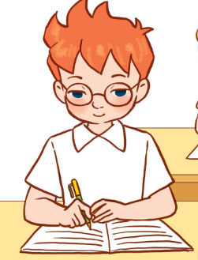

 | True | False
- His name is Ben
- He is from Australia.
- He doesn’t go to school on Saturdays and Sundays.
- He plays the piano on Wednesdays.
- He stays at home and does housework on Tuesdays.
PART 3: Question 1- 4: Read and match. There is one example (1pt)

0. What time is it? |  | a. She’s from Singapore.
- Where’s she from? |  | b. It’s six thirty.
2. When’s your birthday? |  | c. I have English, maths and Vietnamese.
3. What do you want to drink? |  | d. It’s in October.
4. What subjects do you have today? |  | e. I want some milk and juice.

PART 4: Question 1- 4: Read and match. There is one example

0. What time is it? |  | a. I have music class at eight fifteen.
1. What do you do on sports day? |  | b. It’s six thirty.
2. What time do you have music class? |  | c. No, he can’t.
3. Can your brother ride a bike? |  | d. I stay at home.
4. What do you do on Sundays? |  | e. We play sports and games.

PART 5: Question 1- 4: Read and complete. There is one example
Sports day   | village   | sing   | computer rooms   | Music  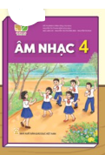
My name is Trung. I study at Nghia Lam Primary School. My school is in the (0) village. There are twenty classrooms, two (1)………………….……. and a beautiful garden. My favourite subject is (2)……………. I can play the piano and (3)………….…. with my friends. It is our (4)……………………. today. The activities there are fun. It is very great. How about your school?

PART 6: Question 1- 4: Read and tick the correct picture. There is one example
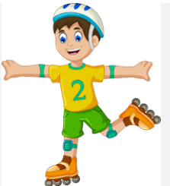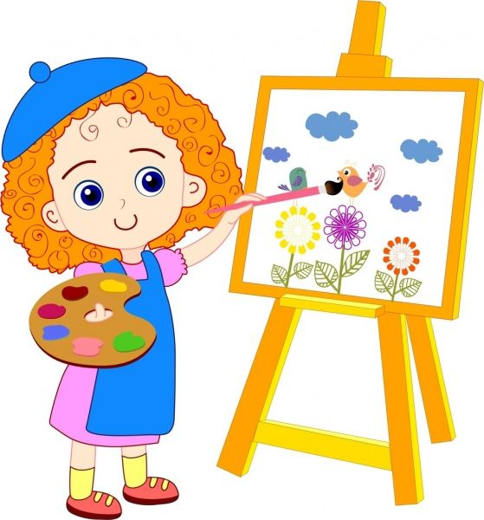

0. I can roller skate.

- B.
3. My school is in the town.
1. He is from Singapore.  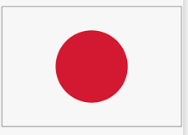  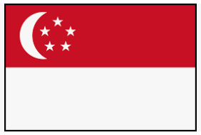  - B. | 2. I want some chips.    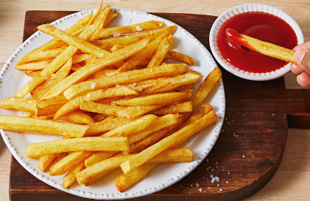  - B.
4. I like music because I want to be a singer.  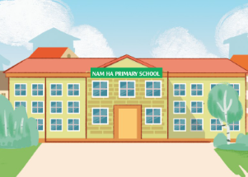    - B. |     - B.

IV. WRITING : VIẾT ( 2.5 pts)
PART 1: Question 1- 3: Look at the picture and complete the sentences. There is one example.

Example: 0. This is Ben | 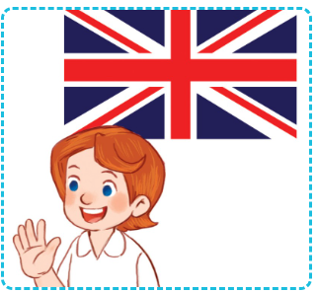  1. Lucy is from……………………
  2. I want some……………. at the party | 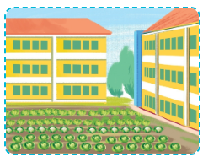  - There is one………..…...at my school.

PART 2: Question 1- 3: Reorder the words to make a correct sentence. There is one example.
0. Huong / My / is/ name.
=> My name is Huong.

1. subject. / Music / his / favourite / not / is /
=> ………………………………………………………..…….
2. play / on / Sports day. / basketball / They/
=> ………………….……………..………………………...…..
3. Mondays / Fridays. / from / to / go to school / We /
=> …………………….……………………………………..…..
4. weekend. / We / housework / the / do / at /
=> ………………….……………..………………………...…..
5. one / There is / building / my school. / at /
=> …………………….……………………………………..…..

6. and Thurdays. / They / English / have / Tuesdays / on /
=> ………………………………………………………..…….
7. can’t / sister / play the piano / My / she / sing. / can/ but /
=> ………………….……………..………………………...…..
8. an/ English teacher. / I/ to/ because/ English/ like/ I/ be/ want
=> ………………….……………..………………………...…..
9. are / There / my school. / three / buildings / at /
=> ………………….……………..………………………...…..
10. on/ Mondays. / history and geography/ have/ I
=> ………………….……………..………………………...…..
PART 3: Question 1- 2: Write the missing letter. There is one example.
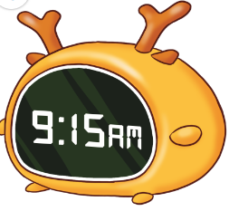 | 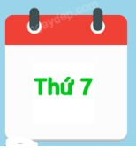 | 
- nine fifteen | 1. Sat _ _ day | 2. vi_ _ _ge

Question 3- 4: Look at the picture and complete the sentences. There is one example.
Example: 0. This is Ben | 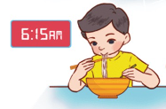  1. I have breakfast at six………………
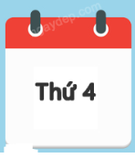  2. I go to school on ……….………. | 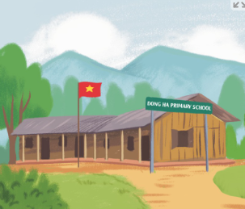  3. My school is in the…………………

CÁC MẪU CÂU CỦA TỪNG UNIT

UNIT 1: My friends
Where are you from? → I’m from…………………………………………
Where’s he/ she from? → He’s / She’s from………………………………………..
UNIT 2: Time and daily routines
What time is it? → It’s ……………………………………………………
What time do you get up/ go to bed/ go to school/ have breakfast?
→ I………. …………… at……………………………..
UNIT 3: My week
What day is it today? → It’s Monday/ Tuesday/ Wednesday/ Thursday/ Friday/ Saturday/ Sunday.
What do you do on……………? → I do housewwork/ listen to music/ study at school..
UNIT 4: My birthday party
When’s your birthday? → It’s in…………………………………………….
What do you want to eat/ drink? → I want some……………………………………..
UNIT 5: Things we can do
Can you cook/ draw/ play the piano/ play the guitar/ ride a bike/ ride a horse……..? → Yes, I can/ No. I can’t
Can he/ she ……..? → Yes, he/ she can / No, he/ she can’t but he/ she can…….
UNIT 6: Our school facilities
Where’s your school? → It’s in the city/ mountains/ village/ town.
How many buildings/ computer rooms/ gardens/ playgrounds are there at your school?
→ There are……………………………………………………………………….
UNIT 7: Our timetables
What subjects do you have today? → I have art/ English/ history and geography/ maths/ music/ science/ Vietnamese.
When do you have English/ Maths…………….? → I have it on ……………..
UNIT 8: My favourite subjects
What’s your favourite subject? → It’s IT/ PE……………
Why do you like it? → Because I want to be a/ an English teacher/ maths teacher/ painter/ singer.
UNIT 9: Our sports day
Is your Sports Day in December? → Yes, it is/ No, it isn’t. It’s in……………
When’s your Sports Day? → It’s in January/ February/ March/ April/ May/ June/ July/ August/ September/ October/ November/ December.

