ĐỀ ÔN THI CUỐI HỌC KỲ I-ĐỀ 12
MÔN: TIẾNG ANH 4

Listen and number.
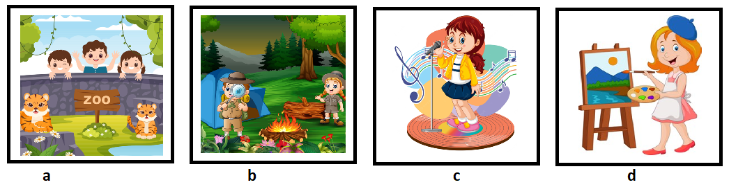
Question 1. Number 1
A. d B. a C. c D. b
Question 2. Number 2
A. d B. b C. a D. c
Question 3. Number 3
A. d B. a C. c D. b
Question 4. Number 4
A. a B. d C. c D. b
Listen and tick or cross.
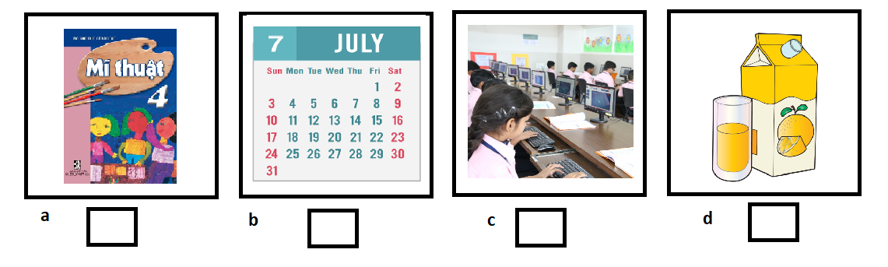
Question 5. Picture a
A. tick B. cross
Question 6. Picture b
A. tick B. cross
Question 7. Picture c
A. tick B. cross
Question 8. Picture a
A. tick B. cross
Listen and write True or False.
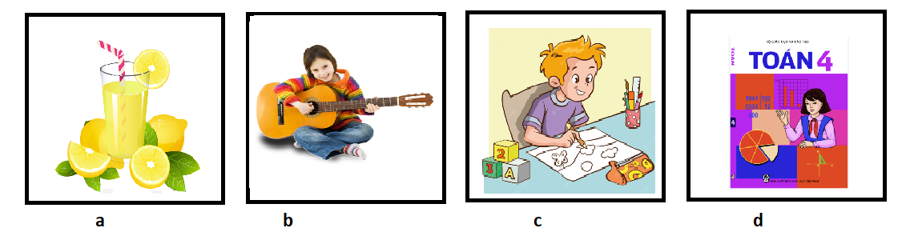
Question 9. Picture a
A. True B. False
Question 10. Picture b
A. True B. False
Question 11. Picture c
A. True B. False
Question 12. Picture d
A. True B. False
Read and choose A,B or C.
My name is Minh. I go to school from Mondays to Fridays. I have Vietnamese and maths today. I have English on Mondays, Thursdays and Fridays. I have science on Wednesdays and Thursdays. I have music on Tuesdays. I like music very much.

Question 13. I go to school from Mondays to _______.
A. Wednesday B. Fridays C. Sundays D. Friday
Question 14. I have English ____ Mondays.
A. on B. in C. at D. of
Question 15. I _______ music very much.
A. likes B. loves C. loving D. like
Reorder words.
Question 16. subjects?/favourite/your/What's →
Question 17. There/buildings./are/three →
Question 18. one/is/garden./There →
Question 19. draw?/Can/he →
Question 20. summer?/were/Where/last/you →
Question 21. I/in/Sydney./was →
Question 22. the/at/campsite/Were/last/you/weekend?
→
Question 23. your/December?/sports/in/day/Is →
Question 24. maths?/Why/you/do/like →
Question 25. a/to/want/be/I/teacher./Because/maths
→
Read and choose Yes/ No
Our sports day is in November. It is in the school playground. There are many pupils and teachers. We play different sports and games. The boys play badminton. The girls play football. The teachers play basketball. It is a lot of fun.

Question 26. Our sports day is in January.
A. Yes B. No
Question 27. It is in the school classroom.
A. Yes B. No
Question 28. There are many pupils and teachers.
A. Yes B. No
Question 29. We play different sports and games.
A. Yes B. No
Question 30. The boys play badminton.
A. Yes B. No

KEYS
1. C | 2. C | 3. A | 4. D | 5. A | 6. A | 7. A | 8. B | 9. A | 10. B
11. A | 12. A | 13. B | 14. A | 15. D
16. What's your favourite subjects?
17. There are three buildings.
18. There is one garden.
19. Can he draw?
20. Where were you last summer?
21. I was in Sydney.
22. Were you at the campsite last weekend?
23. Is your sports day in December?
24. Why do you like maths?
25. Because I want to be a maths teacher.
26. B | 27. B | 28. A | 29. A | 30. A

