ĐỀ ÔN THI CUỐI HỌC KỲ I-ĐỀ 11
MÔN: TIẾNG ANH 4
Listen and circle.
Question 1. Is your sports day in _____?
A. July B. February C. January
Question 2. I like ______.
A. July B. January C. cycling
Listen and tick or cross.
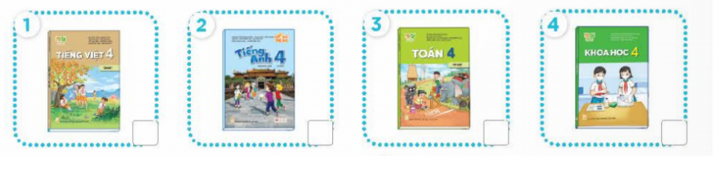
Question 3. Number 1
A. Tick B. Cross
Question 4. Number 2
A. Tick B. Cross
Question 5. Number 3
A. Tick B. Cross
Question 6. Number 4
A. Tick B. Cross
Listen and tick.
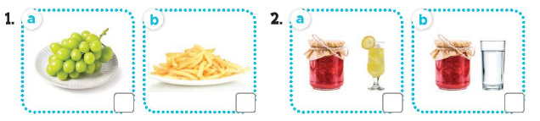
Question 7. Number 1
A. a B. b
Question 8. Number 2
A. a B. b
Choose the best option.
Question 9. What time do you go to school?
A. I can swim. B. On Mondays. C. It's 7 o'clock in the morning. D. At the weekend.
Question 10. Can he draw?
A. No, she can't. B. Yes, he can. C. No, he can. D. Yes, she can.
Question 11. When do you have maths?
A. I have English on Tuesdays. B. I like maths.
C. I don't go to school on Sundays. D. I have it on Mondays and Thursdays.
Question 12. I have it on Mondays and Fridays.
A. Do you like English? B. When do you have English?
C. What subjects do you have today? D. What's favorite subject?
Question 13. When’s your sports day?
A. It's in Mondays. B. It’s in October.
C. It was at the weekend. D. It was on the beach.
Question 14. Where were you last summer?
A. I am in England. B. I am in Tokyo. C. She was in Malaysia. D. I was in Tokyo.
Reorder words to make right sentences.
Question 15. summer?/Were/on/last/the/beach/you
→
Question 16. were/weekend?/last/Where/you →
Question 17. in/is/day/sports/February./Our →
Question 18. in/birthday/July./is/My →
Question 19. My/favorite/is/English./subject →
Question 20. have/science/today./We →
Question 21. mountains./the/school/is/in/My →
Question 22. near/my/are/school./villages/There/three
→
Question 23. some/I/water./want →
Read and chose True or False.
Dear pen friend,
My name’s Bill. I’m from Britain. I’m nine years old. My birthday’s in March. It’s coming soon. I want some chips and some lemonade at my party. What about you? When’s your birthday? What do you want to eat and drink at your party?
Write to me soon.
Bill
Question 24. Bill's from Britain.
A. True B. False
Question 25. His birthday’s in January.
A. True B. False
Question 26. He wants some chips and some lemonade.
A. True B. False
Question 27. He's ten years old.
A. True B. False
Read and choose A, B or C
My name is Minh. I go to school from Mondays to Fridays. I have Vietnamese and maths every school day. I have English on Mondays, Thursdays and Fridays. I have science on Wednesdays and Thursdays. I have music on Tuesdays. I like music very much.

Question 28. He goes to school __________ Mondays to Fridays
A. in B. of C. from D. on
Question 29. He has Vietnamese and maths _________ school day.
A. every B. at C. each D. all
Question 30. He ________ music very much.
A. like B. love C. likes D. enjoy
KEYS
1. A | 2. B | 3. A | 4. B | 5. A | 6. B | 7. A | 8. A | 9. C | 10. B
11. D | 12. B | 13. B | 14. D
15. Were you on the beach last summer?
16. Where were you last weekend?
17. Our sports day is in February.
18. My birthday is in July.
19. My favorite subject is English.
20. We have science today.
21. My school is in the mountains.
22. There are three villages near my school.
23. I want some water.
24. A | 25. B | 26. A | 27. B | 28. C | 29. A | 30. C

