ĐỀ ÔN THI CUỐI HỌC KỲ I-ĐỀ 10
MÔN: TIẾNG ANH 4
Listen and tick or cross.
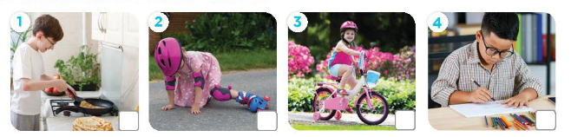
Question 1. Number 1
A. Tick B. Cross
Question 2. Number 2
A. Tick B. Cross
Question 3. Number 3
A. Tick B. Cross
Question 4. Number 4
A. Tick B. Cross
Listen and tick.
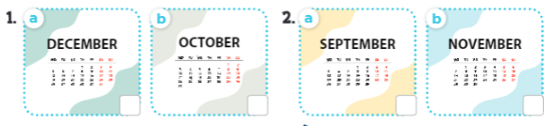
Question 5. Number 1
A. a B. b
Question 6. Number 1
A. a B. b
Listen and number.
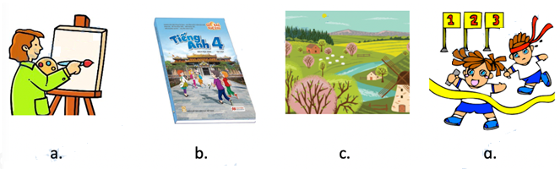
Question 7. Number 1
A. b B. a C. d D. c
Question 8. Number 2
A. a B. b C. d D. c
Question 9. Number 3
A. c B. d C. b D. a
Question 10. Number 4
A. c B. b C. d D. a
Reorder the words to make correct sentences.
Question 11. weekend?/you/the/in/Were/last/countryside
→
Question 12. was/countryside/last/I/the/weekend./in
→
Question 13. day./sports/of/a/picture/It’s/our
→
Question 14. subjects/today?/What/have/do/you →
Question 15. have/maths./English/I/and →
Question 16. I/on/it/have/Mondays/Fridays./and
→
Question 17. at/are/many/buildings/How/school?/your/there
→
Question 18. roller/she/skate?/Can →
Question 19. the/you/Can/play/guitar? →
Question 20. do/do/Wednesdays?/you/on/What →
Question 21. What/do/Mondays?/do/you/on →
Question 22. time/do/get/up?/you/What →
Question 23. you/What/do/time/have/breakfast? →
Read and write True or False.
Hi. My name is Mary. I’m twelve years old. I’m a pupil. I live in a beautiful area in a big city. Every morning I get up at 5:30 o’ clock. After that, I dress up at 6. I have breakfast in ten minutes and go to school at half past six. My school is near my house so I often go to school on foot. I love English so much. I can read English books and sing some English songs.
Question 24. She's twelve years old.
A. True B. False
Question 25. She lives in a beautiful area in a big city.
A. True B. False
Question 26. Mary often goes to school by bus.
A. True B. False
Question 27. She can read English books and sing some English songs.
A. True B. False
Choose A, B, C or D.
Question 28. Where’s he from?
A. He’s from Malaysia. B. She’s from Thailand.
C. She’s from Japan. D. _
Question 29. What time do you have breakfast?
A. on Monday B. last week C. at 6:30 a.m
Question 30. What do you want to drink?
A. I want som jam. B. I want some juice. C. I want some grapes.
KEYS
1. A | 2. B | 3. B | 4. A | 5. B | 6. A | 7. D | 8. B | 9. D | 10. C
11. Were you in the countryside last weekend?
12. I was in the countryside last weekend.
13. It’s a picture of our sports day.
14. What subjects do you have today?
15. I have English and maths.
16. I have it on Mondays and Fridays.
17. How many buildings are there at your school?
18. Can she roller skate?
19. Can you play the guitar?
20. What do you do on Wednesdays?
21. What do you do on Mondays?
22. What time do you get up?
23. What time do you have breakfast?
24. A | 25. A | 26. B | 27. A | 28. A | 29. C | 30. B

