END-OF-TERM TEST 4 (SEMESTER 2)
Time allowed: 35 mins
Full name: ............................................................................. Grade: ............. Mark: ............. / 10
I. Listen and number. (1 point)
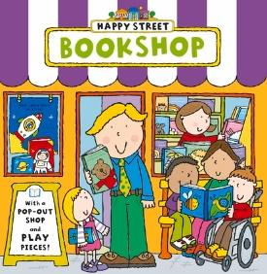 | 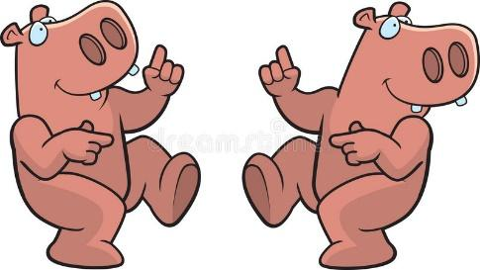 |  | 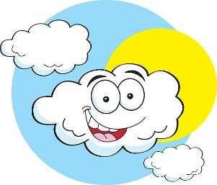
- ⬜ | - ⬜ | - ⬜ | - ⬜

II. Listen and draw lines. (1 point)
1. 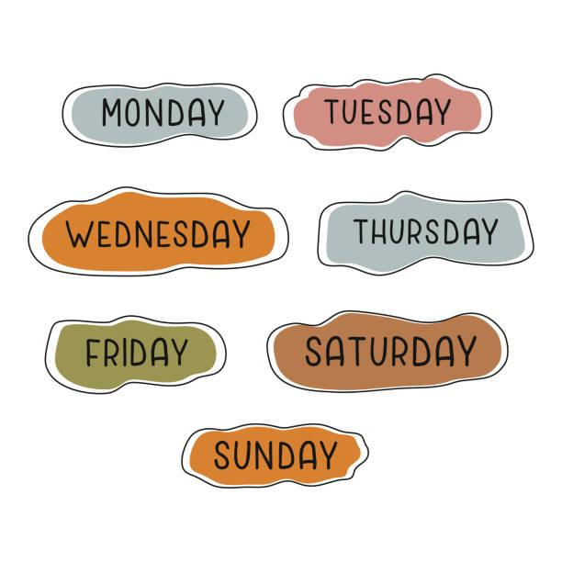 | a. 
2. | b. 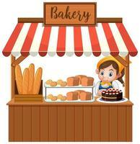
3. | c. 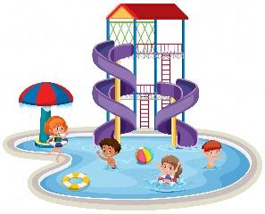
4. | d. 
III. Listen and complete. (1 point)
1. What does it say? – It says ‘____________’.
2. What is Ben doing? – He’s ________________.
3. How much is the _____________? – It’s 200,000 dong.
4. What was the weather like last weekend? – It was ____________.
IV. Read and choose A, B or C. (1 point)
1. |  | Do you want to go to the gift shop?  A. Yes, I can’t.  B. Sorry, I can’t.  C. Great, I can’t.
2. | 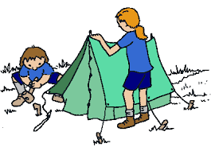 | What are they doing?  A. They’re building a campfire.  B. They’re dancing around a campfire.  C. They’re putting up a tent.
3. |  | What are these animals?  A. They’re crocodiles.  B. They’re birds.  C. It is a crocodile.
4. |  | What was the weather like last Sunday?  A. It says sunny.  B. It is sunny.  C. It was sunny.

V. Write suitable questions for the answers given. (0,75 point)
1. |  | - _______________________________?  - It was cloudy and rainy yesterday.
2. |  | - ___________________________________?  - It’s 70,000 dong.
3. |  | - ________________________________?  - Because they roar loudly.

VI. Read and write T (True) or F (False). (0,75 point)
Tim and his family are on a camping trip. The weather is sunny and windy. They camp near a lake. They put up a big tent. Tim helps to clean up. There is chicken and corn for lunch. When it gets dark, they start to build a campfire. They tell stories and dance around the campfire.
1. Tim and his family are on a camping trip. ___________
2. The weather is sunny and cloudy. ___________
3. They build a campfire and sing loudly. ___________

VII. Fill in the blanks. (1 point)
Today is my sister’s birthday. I go to a (1) _____________ to buy her a present. It’s next to the (2)  ___________. I choose a pink (3) ____________ for her. It looks beautiful. Then I go to the (4) 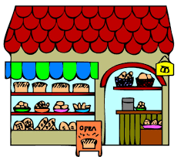_______ to buy a birthday cake. When I give her the present, she is very happy. She smiles and says “Thank you!”.

VIII. Write suitable answers to the questions using given words. (1 point)
taking a photo | turn right | sunny | great

1. Do you want to go to the water park?
⭢ ____________________________________________________
2. What is Lucy doing?
⭢ _____________________________________________________
3. What does it say?
⭢ ______________________________________________________
4. What was the weather like last Saturday?
⭢ ______________________________________________________

IX. Speaking
1. Talk about yourself.
- Where’s your school?
- What animals do you like?
- Where do you go on Sundays?
2. Talk about your favourite day of the week.
- What day is it?
- What do you do on that day?
- Where do you go on that day?
3. Talk about your favourite clothes?
- What is it?
- What does it look like?
- How much is it?
- Why do you like it?
ANSWER KEY
I.
Audio script:
1. – What is he doing?
– He’s putting up a tent.
2. – Do you want to go to the bookshop?
– Great! Let’s go.
3. – What was the weather like last weekend?
– It was sunny and cloudy.
4. – What are these animals?
– They’re hippos.
Key: 1.c 2.a 3.d 4.b
II.
Audio script:
1. – Where do you go on Monday?
– I go to the bakery.
2. – Where do you go on Saturday?
– I go to the food stall.
3. – Where do you go on Tuesday?
– I go to the gift shop.
4. – Where do you go on Friday?
– I go to the water park.
Key: 1. b 2. d 3. a 4. c

III.
1. – What does it say?
– It says ‘turn round’.
2. – What is Ben doing?
– He’s singing songs.
3. – How much is the T-shirt?
– It’s 200,000 dong.
4. – What was the weather like last weekend?
– It was rainy.
Key: 1. turn round 2. singing songs 3. T-shirt 4. rainy
IV.
1. B 2. C 3. A 4. C
V.
1. What was the weather like yesterday?
2. How much is the T-shirt?
3. Why do you like lions?
VI.
1. T 2. F 3. F
VII.
(1) gift shop
(2) bookshop
(3) skirt
(4) bakery
VIII.
1. Great! Let’s go.
2. She’s taking a photo.
3. It says ‘turn right’.
4. It was sunny.
IX.
Pupil’s answer

