END-OF-TERM TEST 3 (SEMESTER 2)
Time allowed: 35 mins
Full name: ............................................................................. Grade: ............. Mark: ............. / 10
I. Listen and number. (1 point)
 |  |  | 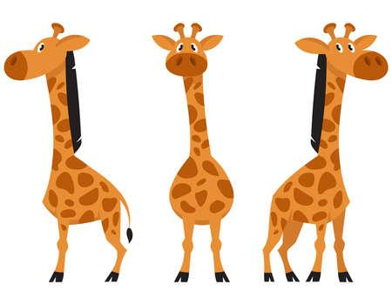
- ⬜ | - ⬜ | - ⬜ | - ⬜

II. Listen and draw lines. (1 point)
1.   Linh | a. 
2.  Mai | b. 
3.   Hoa | c. 
4.   An | d. 
III. Listen and complete. (1 point)
1. How can I get to the ____________? – Turn left.
2. How much is the __________? – It’s 200,000 dong.
3. What are these animals? – They’re ____________.
4. What was the weather like last weekend? – It was __________.

IV. Read and choose A, B or C. (1 point)
1. |  | Why do you like lions?  A. Because they sing beautifully.  B. Because they roar loudly.  C. Because they are roaring.
2. |  | Where’s the food stall?  A. It’s next to the gift shop.  B. It’s between the gift shop.  C. It’s behind the gift shop.
3. | 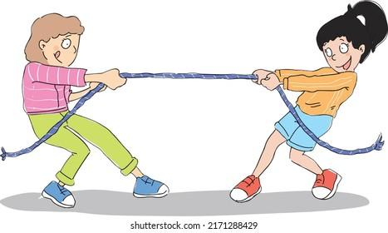 | What is Lan doing?  A. She plays tug of war.  B. They’re playing tug of war.  C. She’s playing tug of war.
4. |  | ________________ – It’s 150,000 dong.  A. How many skirts are there?  B. How much is the skirt?  C. Where’s the skirt?

V. Write suitable questions for the answers given. (0,75 point)
1. |  | - _____________________________?  - It’s opposite the bakery.
2. | 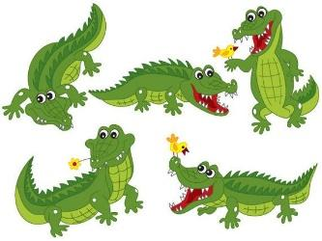 | - ________________________________?  - They’re crocodiles.
3. | 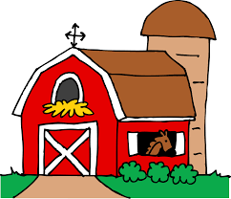 | - ___________________________________?  - Sorry, I can’t.

VI. Read and write T (True) or F (False). (0,75 point)
Our day at the zoo was so much fun! A zoo is a place where you can go and see the animals. It was a cloudy day and all kinds of animals were at the zoo. In the morning, we were able to see the crocodiles, the bears and the elephants. Next, there were the giraffes and the hippos. I liked the lions because they were so big and scary. I love going to the zoo!
1. The weather was sunny. ___________
2. There were giraffes and hippos at the zoo. ___________
3. I liked the lions because they were small and cute. ___________

VII. Fill in the blanks. (1 point)
The dad and his son are on a camping trip. They walk into the woods where there are a lot of trees. The weather is (1)  _____________. They put up a big red (2) ___________. They use some dried woods to build a (3) ___________. Soon, it is sunset. They enjoy telling stories and (4) 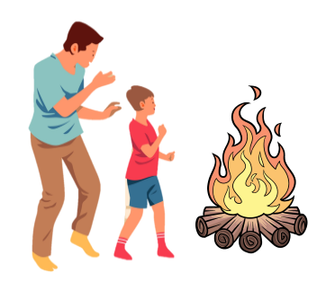____________ around the campfire.
VIII. Write suitable answers to the questions using given words. (1 point)
Sorry | dance beautifully | singing songs | turn round

1. What are Mai and Lan doing?
⭢ ________________________________________________________
2. What does it say?
⭢ ________________________________________________________
3. Do you want to go to the bookshop?
⭢ ________________________________________________________
4. Why do you like peacocks?
⭢ ________________________________________________________

IX. Speaking (2,5 points)
1. Talk about yourself.
- What animals do you like?
- Do you want to go to the bakery?
- How much is your shirt?
2. Talk about your routine at the weekend.
- What do you do?
- Where do you go?
- Who are you with?
3. Talk about your favourite animals.
- What are these animals?
- What do they look like?
- Why do you like them?

ANSWER KEY

I.
Audio script:
1. – What are these animals?
– They’re giraffes.
2. – What was the weather like last weekend?
– It was windy.
3. – What does it say?
– It says ‘stop’.
4. – What are they doing?
– They’re playing card games.
Key: 1.d 2.c 3.b 4.a
II.
1. – What is Linh doing?
– She’s telling a story.
2. – What is Mai doing?
– She’s singing songs.
3. – What is Hoa doing?
– She’s building a campfire.
4. – What is An doing?
– She’s taking a photo.
Key: 1. c 2. a 3. d 4. b

III.
1. – How can I get to the water park?
– Turn left.
2. – How much is the skirt?
– It’s 200,000 dong.
3. – What are these animals?
– They’re crocodiles.
4. – What was the weather like last weekend?
– It was rainy.
Key: 1. water park 2. skirt 3. crocodiles 4. rainy
IV.
1. B 2. A 3. C 4. B
V.
1. Where’s the water park?
2. What are these animals?
3. Do you want to go to the farm?
VI.
1. F 2. T 3. F
VII.
(1) sunny
(2) tent
(3) campfire
(4) dancing

VIII.
1. They’re singing songs.
2. It says ‘turn round’.
3. Sorry, I can’t.
4. Because they dance beautifully.
IX.
Pupil’s answer

