END-OF-TERM TEST 2 (SEMESTER 2)
Time allowed: 35 mins
Full name: ............................................................................. Grade: ............. Mark: ............. / 10
I. Listen and number. (1 point)

 | 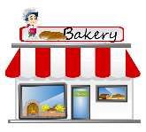   |  | 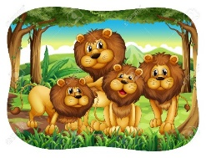
a. ⬜ | b. ⬜ | c. ⬜ | d. ⬜

II. Listen and draw lines. (1 point)
1.  | a.   200,000 dong
2.  | b.  150,000 dong
3. 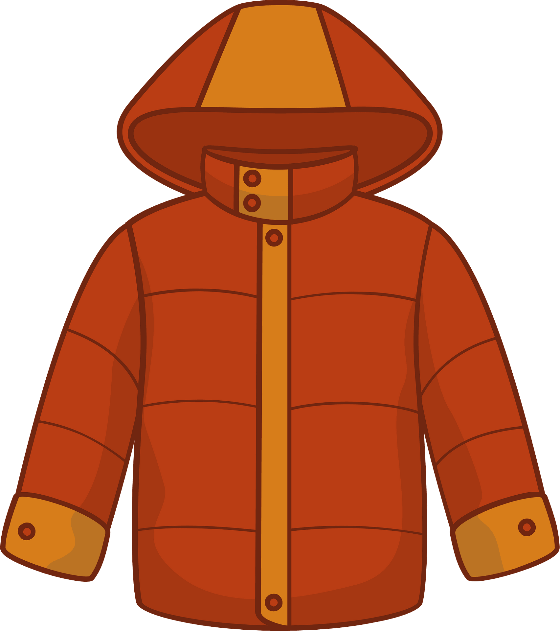 | c.  400,000 dong
4.  | d.  350,000 dong

III. Listen and complete. (1 point)
1. Where’s the bookshop? – It’s ________ the gift shop.
2. Do you want to go to the ____________? – Great! Let’s go.
3. What was the weather like last weekend? – It was ___________.
4. How can I get to the food stall? - _____________.

IV. Read and choose A, B or C. (1 point)
1. |  | What does it say?  A. It says ‘go straight’.  B. It says ‘stop’.  C. It says ‘turn round’.
2. | 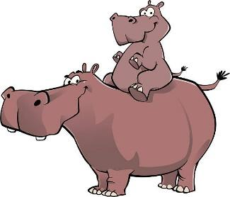 | What are these animals?  A. They’re hippo.  B. They’re hippos.  C. They are hippoes.
3. | 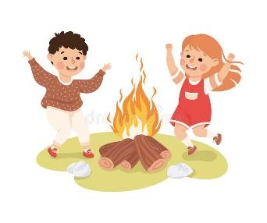 | What is Minh doing?  A. He dances around the campfire.  B. He’s dancing the campfire.  C. He’s dancing around the campfire.
4. |    | Do you want to go to the water park?  A. Great! I can’t.  B. Great! Let’s go.  C. Sorry, let’s go.

V. Write suitable questions for the answers given. (0,75 point)
1. |  | - ____________________________________?  - Sorry, I can’t.
2. | 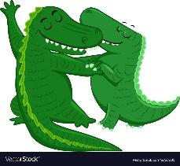 | - ____________________________________?  - Because they dance beautifully.
3. |  | - ____________________________________?  - It was rainy last Monday.

VI. Read and write T (True) or F (False). (0,75 point)
Friday  It was rainy today. So I was at home all day. | Saturday  There was a beautiful rainbow in the sky today. I was able to take lots of photos with my new camera.
Sunday  Today was very cold but I was still outside. There was a lot of fun at the park. | Monday  The weather was windy but I was not able to fly my kite today. I was outside for a walk and an ice cream.

1. It was rainy on Monday. ___________
2. I was at the park on Friday. ___________
3. There were lots of photos of the rainbow on Saturday. ___________

VII. Fill in the blanks. (1 point)
My name is Martin and I live in a small town. In my town, there is a (1) ___________ and a (2) ______________. There is a bus stop but there aren’t any airports. There are lots of houses, but there aren’t any tall buildings. My favourite place is the (3) 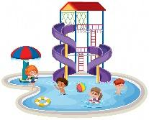 ___________. It’s near a (4)  ___________. I love playing with my little brother there.
VIII. Write suitable answers to the questions using given words. (1 point)
turn right | run quickly | putting up a tent | cloudy

1. Why do you like horses?
⭢ _______________________________________________________
2. What are they doing?
⭢ _______________________________________________________
3. What does it say?
⭢ _______________________________________________________
4. What was the weather like yesterday?
⭢ _______________________________________________________
IX. Speaking (2,5 points)
1. Talk about yourself.
- What animals do you like?
- Where do you go on Saturdays?
- What does your mother do?
2. Talk about your favourite clothes.
- What is it?
- How much is it?
- Why do you like it?
3. Talk about your favourite place.
- What is it?
- Where is it?
- What do you do in this place?

ANSWER KEY

I.
Audio script:
1. – Do you want to go to the bakery?
– Sorry, I can’t.
2. – What are these animals?
– They’re lions.
3. – How much is the shirt?
– It’s 200,000 dong.
4. – What are they doing?
– They’re playing tug of war.
Key: a. 4 b. 1 c. 3 d. 2
II.
Audio script:
1. – How much is the T-shirt?
– It’s 350,000 dong.
2. – How much is the skirt?
– It’s 200,000 dong.
3. – How much is the jacket?
– It’s 400,000 dong.
4. – How much is the hat?
– It’s 150,000 dong.
Key: 1. d 2. a 3. c 4. b

III.
Audio script:
1. – Where’s the bookshop?
– It’s behind the gift shop.
2. – Do you want to go to the farm?
– Great! Let’s go.
3. – What was the weather like last weekend?
– It was sunny.
4. – How can I get to the food stall?
– Turn right.
Key: 1. behind 2. farm 3. sunny 4. Turn right
IV.
1. A 2. B 3. C 4. B
V.
1. Do you want to go to the food stall?
2. Why do you like crocodiles?
3. What was the weather like last Monday?
VI.
1. T 2. F 3. T
VII.
(1) bookshop
(2) bakery
(3) water park
(4) gift shop
VIII.
1. Because they run quickly.
2. They’re putting up a tent.
3. It says ‘turn right’.
4. It was cloudy.
IX.
Pupil’s answer

