END-OF-TERM TEST 1 (SEMESTER 2)
Time allowed: 35 mins
Full name: ............................................................................. Grade: ............. Mark: ............. / 10
I. Listen and number.
 |  |  | 
a. ⬜ | b. ⬜ | c. ⬜ | d. ⬜

II. Listen and draw lines.
1. 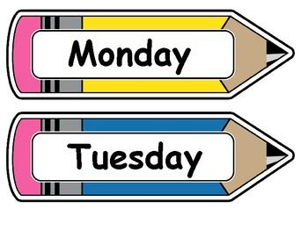 | a. 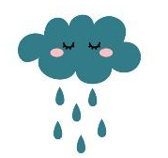
2. | b. 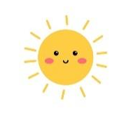
3. 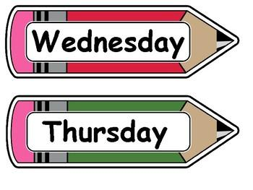 | c. 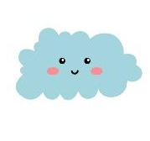
4. | d. 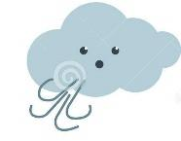

III. Listen and complete.
1. How can I get to the supermarket? – Go straight. Then _______________.
2. Why do you like _____________? – Because they roar loudly.
3. What are they doing? – They’re ____________________.
4. How much is the _____________? – It’s 150,000 dong.

IV. Read and choose A, B or C.

1. |    | Do you want to go to the bookshop?  A. Great! Let’s go.  B. Sorry. Let’s go.  C. Great! I can’t.
2. |  | Why do you like birds?  A. Because they roar loudly.  B. Because they dance beautifully.  C. Because they sing merrily.
3. | 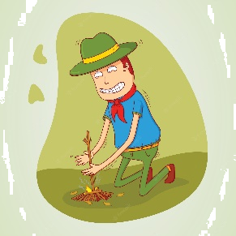 | What is he doing?  A. He builds a campfire.  B. He’s building a campfire.  C. She’s building a campfire.
4. |  | What does it say?  A. It says ‘turn right’.  B. It says ‘turn left’.  C. It says ‘turn round’.

V. Write suitable questions for the answers given.
1. | 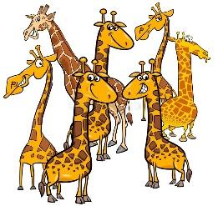 | - ____________________________________?  - They’re giraffes.
2. | 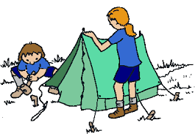 | - ____________________________________?  - They’re putting up a tent.
3. |  | - ____________________________________?  - It says ‘go straight’.

VI. Read and write T (True) or F (False).
Lizzy was at the zoo with her parents. For lunch, there were some sandwiches for her mum and a hamburger for her dad. There were some giraffes in their photos. Next, they were able to see the monkeys. The monkeys were able to swing from the trees and they were so funny. That was their great day at the zoo.
1. There were some sandwiches and a hamburger for her parents. __________
2. There were some monkeys in the photos. __________
3. The monkeys were very funny. __________

VII. Fill in the blanks.
Today, I go to a campsite with my family. The weather is (1)  ____________. We get to the campsite by car. When we arrive, we put up a big (2) __________. My dad builds a (3) _____________. We cook and sing songs around it, too. My sister brings some cards and we play (4) 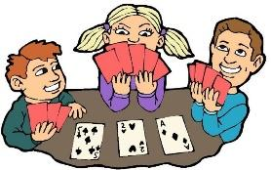 _____________ together.

VIII. Write suitable answers to the questions using given words.
crocodiles | rainy | telling a story | go straight

1. What does it say?
⭢ _____________________________________________________________
2. What are these animals?
⭢ _____________________________________________________________
3. What was the weather like last weekend?
⭢ _____________________________________________________________
4. What is Lan doing?
⭢ _____________________________________________________________
IX. Speaking
1. Talk about yourself
- Do you want to go to the bookshop?
- What do you do in the morning?
- Where do you go on Saturdays?
2. Talk about your mother.
- What does she look like?
- What does she do?
- Where does she work?
3. Talk about your favourite animals
Suggested questions:
- What are they?
- What do they look like?
- Why do you like them?

ANSWER KEY

I.
Audio script:
1. What was the weather like last weekend? – It was sunny.
2. What is she doing? – She’s taking a photo.
3. What are these animals? – They’re hippos.
4. What does it say? – It says ‘turn left’.
Key: a. 4 b. 1 c. 3 d. 2

II.
Audio script:
1. – What was the weather like last Monday?
– It was sunny.
2. – What was the weather like last Tuesday?
– It was rainy.
3. – What was the weather like last Wednesday?
– It was windy.
4. – What was the weather like last Thursday?
– It was cloudy.
Key: 1. b 2. a 3. d 4. c
III.
Audio script:
1. How can I get to the supermarket? – Go straight. Then turn left.
2. Why do you like lions? – Because they roar loudly.
3. What are they doing? – They’re singing songs.
4. How much is the T-shirt? – It’s 150,000 dong.
Key:
1. turn left 2. lions 3. singing songs 4. T-shirt
IV.
1. A 2. C 3. B 4. C
V.
1. What are these animals?
2. What are they doing?
3. What does it say?
VI.
1. T 2. F 3. T
VII.
(1) sunny (2) tent (3) campfire (4) card games
VIII.
1. It says ‘go straight’.
2. They’re crocodiles.
3. It was rainy.
4. She’s telling a story.
IX.
Pupil’s answer

