MID-TERM TEST 5 (SEMESTER 2)
Time allowed: 15 mins
Full name: ............................................................................. Grade: ............. Mark: ............. / 10
I. Listen to the sounds and circle the correct words. (3 points)

E.g. | A. wash | B. watch | C. street
1. | A. farmer | B. actor | C. cinema
2. | A. nurse | B. hair | C. floor
3. | A. big | B. tree | C. bear
4. | A. cinema | B. go | C. cook

II. Listen and circle the correct pictures. (3 points)
E.g. | A.  | B.  | C. 

1. | A.  | B.  | C. 

2. | A.  | B.  | C. 

3. |   A. 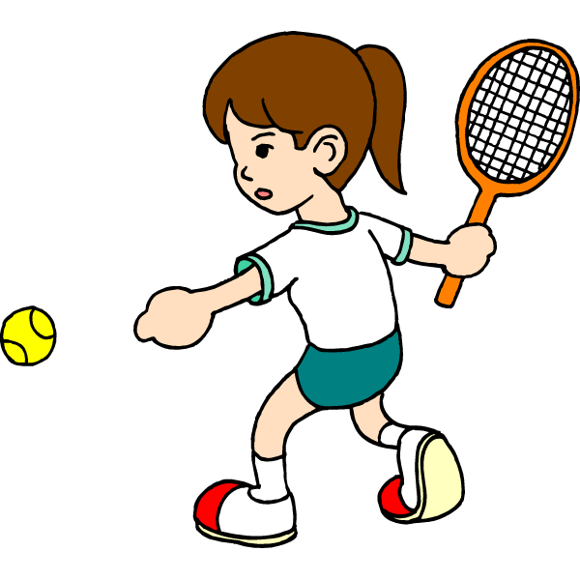 | 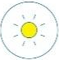  B. |   C.

4. | A.  | B.  | C. 
III. Circle the correct answers. (2 points)
E.g. |  | Where does Lucy work?  A. She works on a farm.  B. She works at a factory.  C. She works at a school
1. |  | What do you do in the morning?  A. I clean the floor.  B. I wash the clothes.  C. I cook meals.
2. |  | What does Linh do?  A. She’s a policeman.  B. She’s a farmer.  C. She’s a nurse.
3. |  | What’s the street like?  A. It’s a busy street.  B. It’s a quiet street.  C. It’s a noisy street.
4. |  | Where does Mr Long go on Sundays?  A. He goes to the swimming pool.  B. She goes to the sports centre.  C. He goes to the sports centre.

IV. Fill in the blanks. (2 points)

This is my brother. His name is Nam. He’s an (1)  _____________. He has short (2)  _________. On Saturday mornings, he often plays (3) __________. Sometimes my brother and I go to the (4)  ________________. We both can swim well. Then we go back home and help our mum with the cooking.
ANSWER KEY
I.
Audio script:
Example: / tʃ/
1. / ɑː/
2. / ɜː/
3. / iː/
4. / ɡ/
Key: 1. A 2. A 3. B 4. B
II.
Audio script:
Example:
– What does he look like?
– He’s tall and thin.
1. – Where does she go on Fridays?
– She goes to the cinema.
2. – What do you do at noon?
– I help with the cooking.
3. – When does she play tennis?
– She plays tennis in the evening.
4. – What does your uncle do?
– He’s an actor.
Key: 1. A 2. B 3. C 4. A
III.
1. A 2. C 3. B 4. C
IV.
(1) office worker
(2) hair
(3) tennis
(4) swimming pool

