MID-TERM TEST 4 (SEMESTER 2)
Time allowed: 15 mins
Full name: ............................................................................. Grade: ............. Mark: ............. / 10
I. Listen to the sounds and circle the correct words. (3 points)
E.g. | A. cinema | B. go | C. cook
1. | A. long | B. round | C. farm
2. | A. slim | B. television | C. centre
3. | A. farmer | B. factory | C. nurse
4. | A. street | B. big | C. quiet

II. Listen and tick the correct pictures. (3 points)
E.g. | A. 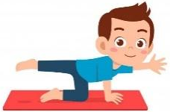 | B.  | C. 

1. | A.  | B. 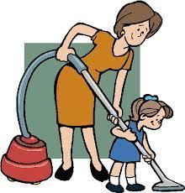 | C. 

2. | A.  | B.  | C. 

3. | A.  | B.  | C. 

4. | A. 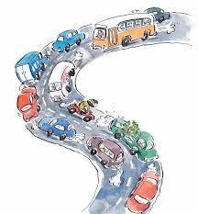 | B.  | C. 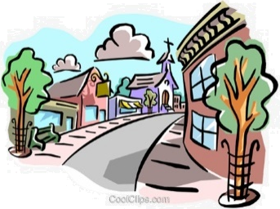

III. Circle the correct answers. (2 points)
E.g. |  | What does she look like?  A. He has short hair.  B. She’s short.  C. She has short hair.
1. |  | What do you do at noon?  A. I wash the clothes.  B. I wash the dishes.  C. I clean the floor.
2. |  | What does Lan do?  A. She’s a farmer.  B. She’s a nurse.  C. She’s a doctor.
3. |  | Where does Ben go on Wednesdays?  A. He goes to the shopping centre.  B. He goes to the swimming pool.  C. He goes to the cinema.
4. |  | When do you go to school?  A. We go to school in the morning.  B. They go to school in the morning.  C. We go to school in the evening.

IV. Fill in the blanks. (2 points)
My name is Emily. I am 25 years old. I have long (1)  _______ and big eyes. I am an (2) ___________. In the morning, I often (3)  ___________ because it’s good for my health. Then I go to work. I work from
8 a.m to 5 p.m. On weekdays, I go back home and cook dinner. At the weekends, I go to the (4)  ___________ with my friends.

ANSWER KEY
I.
Audio script:
E.g. /ɡ/ /ɡ/
1. /r/ /r/
2. /ʒ/ /ʒ/
3. /ɜː/ /ɜː/
4. /iː/ /iː/
Key: 1. B 2. B 3. C 4. A
II.
Audio script:
E.g. – What does he do on Mondays?
– He does yoga.
1. – What do you do in the afternoon?
– I help my mum with the cleaning.
2. – Where does Bill work?
– He works at a factory.
3. – What does she look like?
– She’s short.
4. – What’s the street like?
– It’s busy.
Key: 1. B 2. A 3. B 4. A

III.
1. B 2. A 3. C 4. A
IV.
(1) hair
(2) office worker
(3) do yoga
(4) shopping centre

