MID-TERM TEST 3 (SEMESTER 2)
Time allowed: 15 mins
Full name: ............................................................................. Grade: ............. Mark: ............. / 10
I. Listen to the sounds and circle the correct words. (2 points)

E.g. | A. farmer | B. actor | C. cinema
1. | A. pool | B. cook | C. go
2. | A. wash | B. watch | C. street
3. | A. big | B. street | C. quiet
4. | A. hair | B. round | C. long

II. Listen and circle the correct pictures. (3 points)
E.g. | A.  | B. 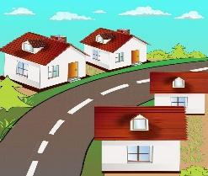 | C. 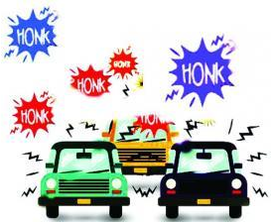

1. | A.  | B. 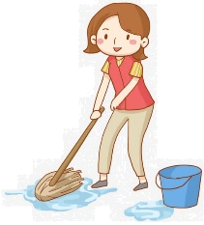 | C. 


2. |   A.  | B. | C.

3. | A.  | B.  | C. 

4. | A.  | B.  | C. 
III. Circle the correct answers. (2 points)
E.g. |  | What does he look like?  A. He has short hair.  B. He’s short.  C. He has long hair.
1. |  | What does your mother do?  A. She works in a nursing home.  B. She’s a nurse.  C. She is a doctor.
2. |    | When do you read books?  A. I read books in the evening.  B. I read books at noon.  C. I read books in the morning.
3. |  | Where does Minh go on Sundays?  A. He goes to the swimming pool.  B. He goes to the park.  C. He goes to the bakery.
4. | 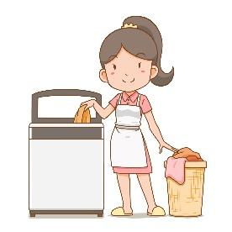 | What do you do in the afternoon?  A. I wash the clothes.  B. I watch TV.  C. I wash the dishes.

IV. Fill in the blanks. (3 points)
On Saturdays I often visit my friend’s house. She lives in a big (1) ___________. There is a small (2)  ___________ in the garden. We swim there for hours. Then we go to the (3) ____________. There is a (4) ____________ where we often watch films together. Then we go back home and cook dinner.
ANSWER KEY
I.
Audio script:
Example
/ ɑː/ / ɑː/
1. / ɡ/ / ɡ/
2. / ʃ/ / ʃ/
3. / ɪ/ / ɪ/
4. / l/ / l/
Key: 1. C 2. A 3. A 4. C
II.
Audio script:
Example: – Where do you live?
– I live in a busy street.
1. – What do you do in the evening?
– I cook meals.
2. – When do you wash the dishes?
– I wash the dishes in the afternoon.
3. – What does your sister do?
– She’s an office worker.
4. – Where does he go on Thursdays?
– He goes to the sports centre.
Key: 1. C 2. A 3. B 4. C

III.
1. B 2. C 3. A 4. A
IV. Fill in the blanks.
(1) street
(2) swimming pool
(3) shopping centre
(4) cinema

