MID-TERM TEST 2 (SEMESTER 2)
Time allowed: 15 mins
Full name: ............................................................................. Grade: ............. Mark: ............. / 10
I. Listen to the sounds and circle the correct words. (2 points)

E.g. | A. round | B. long | C. hospital
1. | A. nurse | B. hair | C. floor
2. | A. clean | B. clothes | C. wash
3. | A. street | B. big | C. quiet
4. | A. slim | B. television | C. centre
II. Listen and circle the correct pictures. (3 points)
E.g. | 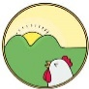  A.  | 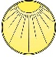  B. 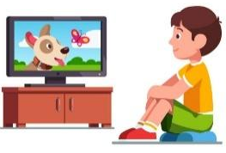 | 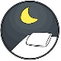  C. 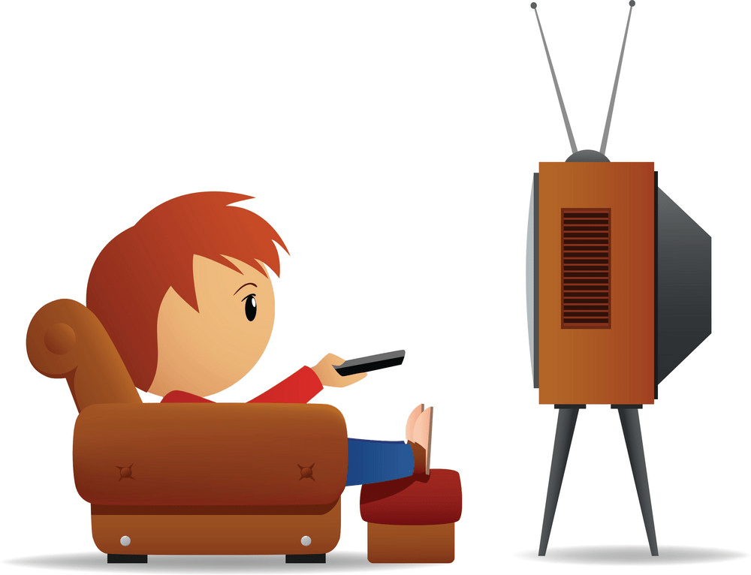
1. | A. 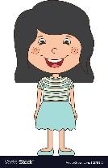 | B. 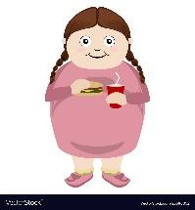 | C. 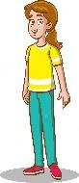

2. | A. 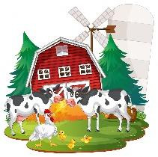 | B.  | C. 

3. | A.  | B. 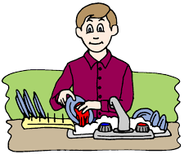 | C. 

4. | A. 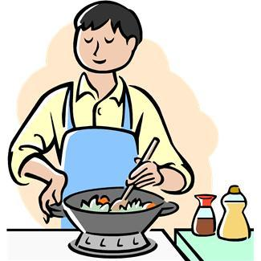 | B. 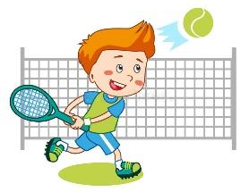 | C. 

III. Circle the correct answers. (2 points)
E.g. | 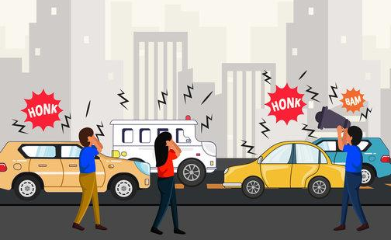 | Where do you live?  A. I live in a big street.  B. I live in a noisy street.  C. I live in a quiet street.
1. |  | What does your father do?  A. He’s an office worker.  B. He works in an office.  C. She’s an office worker.
2. | 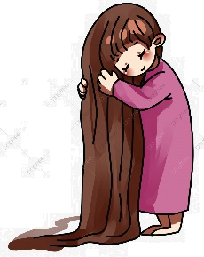 | What does she look like?  A. She has short hair.  B. She has dark hair.  C. She has long hair.
3. | 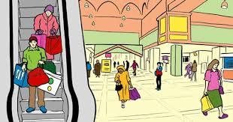 | Where does he go on Fridays?  A. He goes to the swimming pool.  B. He goes to the shopping centre.  C. He goes to the sports centre.
4. |  | What do you do in the morning?  A. I help my mum with the cooking.  B. I wash the dishes with my mum.  C. I clean the floor with my mum.

IV. Fill in the blanks. There is ONE extra word. (3 points)

long | big | tall | hair | slim

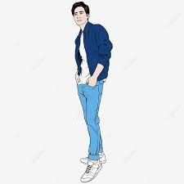 | Susan: What does your dad look like?  John: He has short, black (1) _____________.  Susan: Is he (2) ___________?  John: Yes, he is. And he is thin.
 | Susan: Can you describe your mum?  John: She has (3) ___________, brown hair.  Susan: Is she big?  John: No, she isn’t. She’s (4) ____________.

ANSWER KEY
I.
Audio script:
Example: /r/ /r/
1. /ɜː/ /ɜː/
2. /ʃ/ /ʃ/
3. /iː/ /iː/
4. /ʒ/ /ʒ/
Key: 1. A 2. C 3. A 4. B
II.
Audio script:
Example
– When do you watch TV?
– I watch TV in the evening.
1. – What does she look like?
– She’s big.
2. – Where does he work?
– He works on a farm.
3. – What does he do on Tuesdays?
– He washes the clothes.
4. – What do you do in the morning?
– I play tennis.
Key: 1. B 2. A 3. C 4. B

III.
1. A 2. C 3. B 4. A
IV.
(1) hair
(2) tall
(3) long
(4) slim

