END-OF-TERM TEST 4 (SEMESTER 1)
Time allowed: 35 mins
Full name: ............................................................................. Grade: ............. Mark: ............. / 10

I. Listen and number. (1 point)
 | 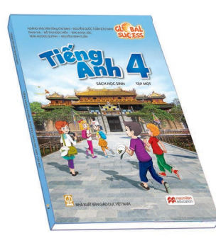 | 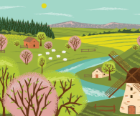 | 
- ⬜ | - ⬜ | - ⬜ | - ⬜

II. Listen and draw lines. (1 point)
1. Sue | a.  Sydney
2. Anna | b. 
3. Tom | c. 
4. Bill | d.  Tokyo
III. Listen and complete. (1 point)
1. – Were you on the _____________ last weekend?
– Yes, I was.
2. – What’s your favourite subject?
– It’s __________________.
3. – When do you have maths?
– I have it on ___________.
4. – Where’s your school?
– It’s in the _____________.
IV. Read and choose A, B or C. (1 point)
1. |  | What do you do on Saturdays?  A. I listen to music.  B. I study at school.  C. I do housework.
2. | 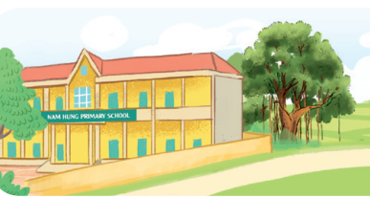 | Where’s your school?  A. It was in Bangkok.  B. It’s in the village.  C. It was at the beach.
3. |  | Is your sports day in July?  A. No, it is.  B. Yes, it is.  C. No, it isn’t.
4. | 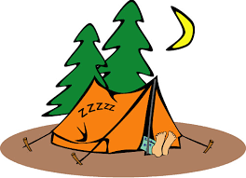 | Where were you last summer?  A. I was at the campsite.  B. I was in the countryside.  C. I was in the city.

V. Write suitable questions for the answers given. (0,75 point)
1. |  | – _________________________________?  – Because I want to be an English teacher.
2. |  | – ___________________________________?  – I have it on Mondays.
3. | 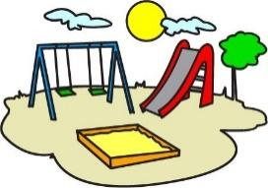 | – ___________________________________?  – There are two playgrounds at my school.

VI. Read and write T (True) or F (False). (0,75 point)
Monday is my favourite day! Here is what I usually do. I get up, eat my breakfast and go to school at half past seven. I usually take a bus, but sometimes I ride my bike. I like Mondays because we have English. It’s my favourite subject! I always eat lunch at the school canteen. In the afternoon, I have music and maths. They are interesting! Then I go home and do my homework. Then I watch TV with my dad before having dinner.
1. She usually goes to school by bike. _____________
2. She likes Mondays because she has English. _____________
3. When she goes home, she does housework. _____________
VII. Fill in the blanks. (1 point)
Hello, my name is Sarah. I am ten years old. I’m from (1)  _____________. I study in a school in London. There is a big (2) 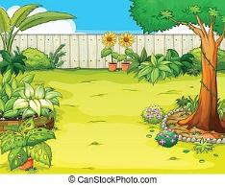_____________ at my school. My favourite subject is (3) ______________. I also like computers a lot! There are two (4)  ______________ where we learn IT every Wednesday. After school, I often go for a walk in the park with my friends.
VIII. Write suitable answers to the questions using the given words. (1 point)
music | December | Sydney | mountains

1. When is your sports day?
⭢ _______________________________________________________________
2. Where were you last summer?
⭢ _______________________________________________________________
3. What subjects do you have today?
⭢ _______________________________________________________________
4. Where’s your school?
⭢ _______________________________________________________________
IX. Speaking (2,5 point)
Answer the following questions.
Suggested questions:
- When do you have English?
- What’s your favourite subject?
- Were you in the countryside last weekend?
- Where is your school?
- How many classrooms are there at your school?
- Which place/ room do you like most in your school?
- What subjects do you have on Wednesdays?
- What’s your favourite subject?
- Why do you like that subject?
ANSWER KEY
I.
Audio script:
1 . – Where were you last summer?
– I was in the countryside.
2 . – What subjects do you have today?
– I have English.
3. – Why do you like art?
– Because I want to be a painter.
4 . – When’s your sports day?
– It’s in July.
Key: 1. c 2. b 3. a 4. d

II.
Audio script:
1. – Where were you last week, Sue?
– I was in Bangkok.
2. – Were you in Tokyo last month, Anna?
– No, I wasn’t. I was in London.
3. – Where were you last summer, Tom?
– I was in Sydney.
4. – Were you in Tokyo last year, Bill?
– Yes, I was.
Key: 1. b 2. c 3. a 4. d
III.
Audio script:
1. – Were you on the beach last weekend?
– Yes, I was.
2. – What’s your favourite subject?
– It’s art.
3. – When do you have maths?
– I have it on Thursdays.
4. – Where’s your school?
– It’s in the town.
Key:
1. beach 2. art 3. Thursdays 4. town
IV.
1. A 2. B 3. B 4. A
V.
1. Why do you like English?
2. When do you have science (maths/ English…)?
3. How many playgrounds are there at your school?
VI.
1. F 2. T 3. F
VII.
1. Japan 2. garden 3. art 4. computer rooms
VIII.
1. It’s in December.
2. I was in Sydney.
3. I have music.
4. It’s in the mountains.

