END-OF-TERM TEST 2 (SEMESTER 1)
Time allowed: 35 mins
Full name: ............................................................................. Grade: ............. Mark: ............. / 10

I. Listen and number. (1 point)
 |  | 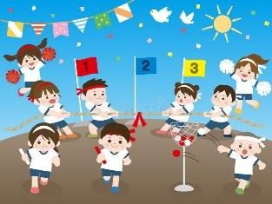 | 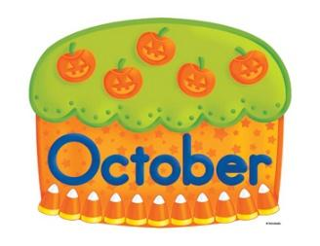
a. ⬜ | b. ⬜ | c. ⬜ | d. ⬜

II. Listen and draw lines. (1 point)
1.  Nam | a. 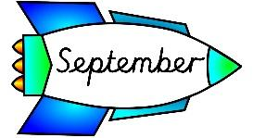
2.  Linh | b. 
3.  Minh | c. 
4.  Hoa | d. 

III. Listen and complete. (1 point)
1. – Can he ___________________?
– Yes, he can.
2. – How many _______________ are there at your school?
– There are two.
3. – When do you have ______________?
– I have it on Mondays.
4. – Where were you last weekend?
– I was in the _________________.
IV. Read and choose A, B or C. (1 point)
1. | 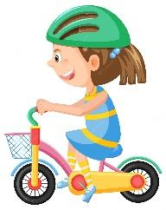 | What do you do on Wednesdays?  A. I do housework.  B. I study at school.  C. I ride a bike.
2. | 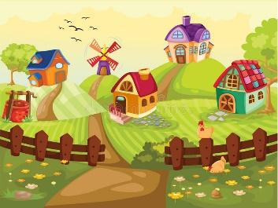 | Where’s your house?  A. It’s in the city.  B. It’s in the village.  C. It’s in the mountains.
3. | 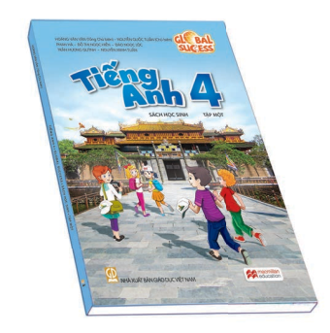 | What subjects do you have today?  A. I have English.  B. I have science.  C. I have art.
4. | 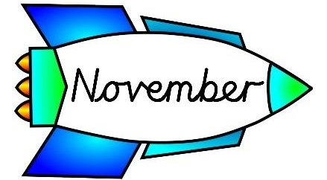 | Is your sports day in June?  A. No, it isn’t.  B. No, it is.  C. Yes, it is.

V. Read and write T (True) or F (False). (0,75 point)
My name is Annie. I’m nine years old. I live in a big city. I can ride a bike but I can’t swim. Every Monday, I play football with my brother. Every Tuesday, I sing English songs with my friends at school. On Wednesdays, I help my mum do housework. On Thursdays, I roller skate in the park. Every Friday, I ride a bike.
1. Annie sings English songs on Tuesday. __________
2. She can swim. __________
3. She does housework with her mum every Thursday. __________
VI. Write suitable questions for the answers given. (0,75 point)
1. |  | – ____________________________________?  – I was in Sydney last summer.
2. | 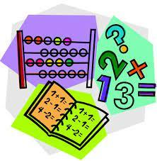 | – ____________________________________?  – I have it on Fridays.
3. |  | – ____________________________________?  – I want some grapes.
VII. Fill in the blanks. (1 point)
Ken is ten years old. His best friend is Adam. Ken and Adam like to (1) _____________. They play in the (2) ____________. Sometimes they (3) _____________ with other kids. They have lots of fun. Before going home, they drink some (4)  _____________.
VIII. Write suitable answers to the questions using the given words. (1 point)
October | beach | Mondays | three

1. How many buildings are there in your school?
⭢ _______________________________________________________________
2. Where were you last weekend?
⭢ _______________________________________________________________

3. When’s your sports day?
⭢ _______________________________________________________________

4. When do you have maths?
⭢ _______________________________________________________________

IX. Speaking (2,5 points)
Answer the following questions.
- Where’s your school?
- What subjects do you have today?
- Where were you last weekend?
- Which subject is it?
- When do you have it?
- Why do you like it?
- Where is your school?
- How many classrooms are there at your school?
- Is it big or small?
- Is there a garden in your school?
ANSWER KEY
I.
Audio script:
1. – When’s your birthday?
– My birthday’s in October.
2. – How many computer rooms are there at your school?
– There are three.
3. – Is your sports day in November?
– Yes, it is.
4. – What subjects do you have today?
– I have art.
Key: 1. d 2. a 3. c 4. b
II.
Audio script:
1. – When’s Nam’s birthday?
– It’s in March.
2. – When’s Linh’s birthday?
– It’s in January.
3. – When’s Minh’s birthday?
– It’s in September.
4. – When’s Hoa’s birthday?
– It’s in July.
Key: 1. b 2. d 3. a 4. c

III.
Audio script:
1. – Can he ride a horse?
– Yes, he can.
2. – How many playgrounds are there at your school?
– There are two.
3. – When do you have science?
– I have it on Mondays.
4. – Where were you last weekend?
– I was in the countryside.
Key:
1. ride a horse 2. playgrounds 3. science 4. countryside
IV.
1. C 2. B 3. A 4. A
V.
1. T 2. F 3. F
VI.
1. Where were you last summer?
2. When do you have maths?
3. What do you want to eat?
VII.
(1) play football (2) park (3) roller skate (4) lemonade

VIII.
1. There are three buildings (in my school).
2. I was at the beach.
3. It’s in October.
4. I have it on Mondays.

