END-OF-TERM TEST 1 (SEMESTER 1)
Time allowed: 35 mins
Full name: ............................................................................. Grade: ............. Mark: ............. / 10

I. Listen and number. (1 point)
 | 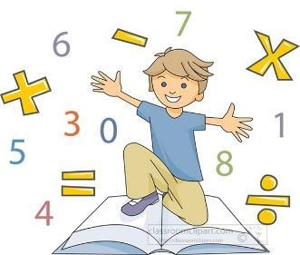 |  | 
a. ⬜ | b. ⬜ | c. ⬜ | d. ⬜

II. Listen and draw lines. (1 point)
1.  | a. 
2.  | b. 
3.  | c. 
4.  | d. 

III. Listen and complete. (1 point)
1. When’s your birthday? – It’s in _____________.
2. Where’s your school? – It’s in the ____________.
3. Why do you like ____________? – Because I want to be a painter.
4. Were you at the ________ last weekend? – Yes, I was.
IV. Read and choose A, B or C. (1 point)
1. |  | What time do you have lunch?  A. I have lunch at twelve fifteen.  B. I have lunch at half past twelve.  C. I have lunch at twelve o’clock.
2. |  | Where were you last month?  A. I was in Tokyo.  B. I were in Tokyo.  C. I was on Tokyo.
3. |  | What subjects do you have today?  A. I have Vietnamese.  B. I have maths.  C. I have English and science.
4. | 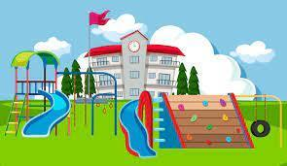 | How many playgrounds are there at your school?  A. There are one.  B. There is one playgrounds.  C. There is one.
V. Read and write T (True) or F (False). (0,75 point)
This is Jack. He is my best friend. He is from Australia. He has been in Thailand for two years. He has two older brothers. They all live in a big house in Bangkok. Jack and his brothers go to the beach in the summer. They play beach ball or go swimming. Jack is very strong and he can swim fast.
1. Jack is from Thailand. ___________
2. Jack goes to the beach in the summer. ___________
3. Jack can swim fast. ___________

VI. Write suitable questions for the answers given. (0,75 point)
1. |  | _____________________________________?  - Because I want to be an English teacher.
2. | 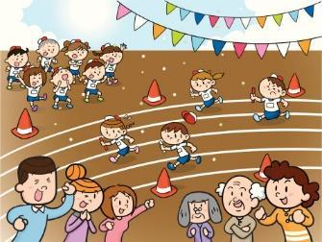 | _____________________________________?  - It’s in October.
3. |  | _____________________________________?  - I want some chips.

VII. Fill in the blanks. (1 point)
Hi, I’m Sue. I’m 7 years old. This is my school. It’s not big but it’s beautiful. There are twenty (1) 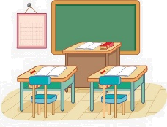 __________________ in my school. There is a small
(2) 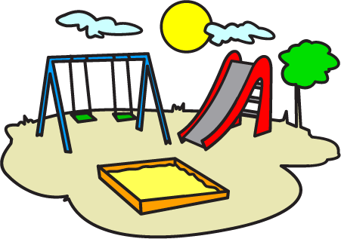 ____________. We often run and play there at break time. There is also a (3)  _________. We plant trees and flowers there.
We (4)  ___________ at the school canteen.
VIII. Write suitable answers to the questions using given words. (1 point)
Tuesdays | city | maths teacher | art and science

1. Where’s your school?
⭢ _____________________________________________________________
2. Why do you like maths?
⭢ _____________________________________________________________
3. What subjects do you have today?
⭢ _____________________________________________________________
4. When do you have science?
⭢ _____________________________________________________________
IX. Speaking (2,5 points)
Answer the following questions.
Suggested questions:
- Where are you from?
- When’s your birthday?
- What’s your favourite subject?
- What time do you have breakfast?
- What do you eat for breakfast?
- What do you drink for breakfast?
- When’s your sports day?
- What do you do?
- Which activity do you like most?

ANSWER KEY
I.
Audio script:
1. I want to drink some juice.
2. She was on the beach yesterday.
3. My favourite subject’s maths.
4. I go to school on Mondays.
Key: 1. d 2. c 3. b 4. a
II.
Audio script:
1. What do you do on Mondays?
– I study at school.
2. What do you do on Wednesdays?
– I listen to music.
3. What do you do on Thursdays?
– I do housework.
4. What do you do on Sundays?
– I go swimming.
Key: 1. a 2. c 3. d 4. b
III.
Audio script:
1. When’s your birthday?
– It’s in September.

2. Where’s your school?
– It’s in the mountains.
3. Why do you like art?
– Because I want to be a painter.
4. Were you at the campsite last weekend?
– Yes, I was.
Key:
1. September 2. mountains 3. art 4. campsite
IV.
1. B 2. A 3. C 4. C
V.
1. Why do you like English?
2. When is your sports day?
3. What do you want to eat?
VI.
1. F 2. T 3. T
VII.
(1) classrooms (2) playground (3) garden (4) have lunch
VIII.
1. It’s in the city.
2. Because I want to be a maths teacher.
3. I have art and science.
4. I have it on Tuesdays.

IX.
Pupil’s answer

