MID-TERM TEST 4 (SEMESTER 1)
Time allowed: 15 mins
Full name: ............................................................................. Grade: ............. Mark: ............. / 10
I. Listen and circle the correct words. (3 points)

E.g. | A. America | B. Australia | C. Malaysia
1. | A. bed | B. get | C. head
2. | A. jam | B. grapes | C. water
3. | A. Japan | B. juice | C. January
4. | A. yes | B. jet | C. get
II. Listen and number the pictures. (3 points)
a. b. c. d. e.
 | 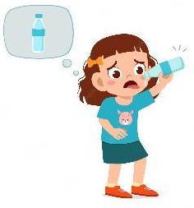 | 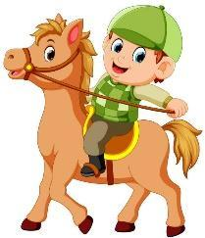 |  | 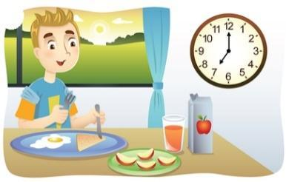
 | ⬜ | ⬜ | ⬜ | ⬜

III. Read and tick the correct sentences. (2 points)
E.g. |  | Where’s he from?  🗹 He’s from Japan.  ⬜ I’m from Japan.
1. |  | What time do you go to bed?  ⬜ I go to bed at nine fifteen.  ⬜ I go to bed at nine o’clock.
2. |  | What do you do on Fridays?  ⬜ I do homework.  ⬜ I do housework.
3. |  | What do you want to eat?  ⬜ I want some grapes.  ⬜ I want some jam.
4. |  | Can she swim?  ⬜ No, she can.  ⬜ No, she can’t.

IV. Fill in the blanks. (2 points)
My name is Alice. Every day, I (1) ___________ at seven o’clock.
I brush my teeth and take a shower. At eight o’clock, I (2) ____________. I eat some bread and some (3) __________ and drink a glass of
(4) ____________. Then I go to school by bus. I study at school in the
morning. In the afternoon, I go to a football club. I play football with my friends.

ANSWER KEY
I.
Audio script:
Example: America
1. get 2. water 3. juice 4. yes
Key:
1. B 2. C 3. B 4. A
II.
Audio script:
Example: 1. – What day is it today?
– It’s Thursday.
2. – When’s your birthday?
– It’s in July.
3. – What time do you have breakfast?
– I have breakfast at 7 o’clock.
4. – What do you want to drink?
– I want some water.
5. – Can he ride a horse?
– Yes, he can.
Key:
2. d 3. e 4. b 5. c
III.
1. I go to bed at nine o’clock.
2. I do housework.
3. I want some grapes.
4. No, she can’t.
IV.
(1) get up (2) have breakfast (3) jam (4) milk

