MID-TERM TEST 3 (SEMESTER 1)
Time allowed: 15 mins
Full name: ............................................................................. Grade: ............. Mark: ............. / 10
I. Listen and circle the correct words. (3 points)

E.g. | A. Sunday | B. Thursday | C. juice
1. | A. Saturday | B. study | C. music
2. | A. water | B. grapes | C. January
3. | A. yes | B. jam | C. Wednesday
4. | A. March | B. bed | C. get

II. Listen and put a (✓) or a (🗴). (3 points)
E.g. | 1. | 2. | 3. | 4.
 |  |  |  | 
🗹 | ⬜ | ⬜ | ⬜ | ⬜

III. Tick the correct questions. (2 points)
E.g. |  | – ___________________?  – I’m from Viet Nam.  ⬜ Where is she from?  🗹 Where are you from?
1. |  | – ___________________?  – It’s in May.  ⬜ When’s your birthday?  ⬜ What day is it today?
2. |  | – ___________________?  – No, he can’t.  ⬜ Can he cook?  ⬜ Can she cook?
3. |  | – __________________?  – I want some lemonade.  ⬜ What do you want to eat?  ⬜ What do you want to drink?
4. |  | – ___________________?  – I listen to music.  ⬜ What do you do on Sundays?  ⬜ What time do you listen to music?

IV. Fill in the blanks. (2 points)
Hello, my name is Alice. I’m from (1) 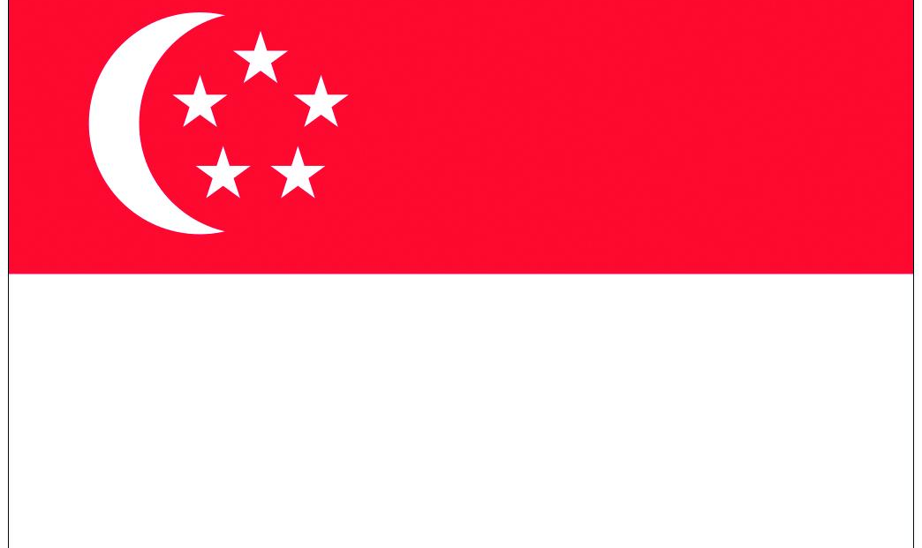____________. I speak English.
In my country, we like to (2)  _____________ or baseball. Our favourite food is fish and (3)  ___________. Most people like tea or coffee, but my favourite drink is (4)  __________.

ANSWER KEY
I.
Audio script:
E.g. /ʌ/ /ʌ/
1. /juː/ /juː/
2. /w/ /w/
3. /j/ /j/
4. /t/ /t/
Key:
1. C 2. A 3. A 4. C
II.
Audio script:
Example:
– What do you want to eat?
– I want some chips.
1. – What do you do on Tuesdays?
– I study at school.
2. – Can she ride a bike?
– Yes, she can.
3. – Where’s he from?
– He’s from Singapore.
4. – When’s your birthday?
– It’s in March.
Key: 1. ✓ 2. 🗴 3. 🗴 4. ✓
III.
1. When’s your birthday?
2. Can he cook?
3. What do you want to drink?
4. What do you do on Sundays?
IV.
(1) Singapore (2) play football (3) chips (4) lemonade

