MID-TERM TEST 2 (SEMESTER 1)
Time allowed: 15 mins
Full name: ............................................................................. Grade: ............. Mark: ............. / 10
I. Listen and circle the correct words. (2 points)

E.g. | A. get | B. bed | C. red
1. | A. music | B. Tuesday | C. juice
2. | A. water | B. jam | C. grapes
3. | A. America | B. Australia | C. Malaysia
4. | A. Sunday | B. Monday | C. Thursday
II. Listen and tick (✓) the correct pictures. (3 points)
E.g. | - ⬜  | B. 🗹  | C. ⬜ 

1. | A. ⬜  | B. ⬜  | C.⬜ 

2. | A.⬜  | B. ⬜  | C.⬜ 

3. | A.⬜ 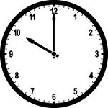 | B. ⬜ 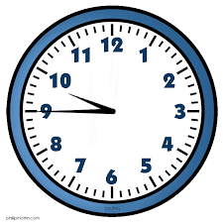 | C.⬜ 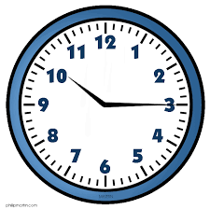

4. | A.⬜  | B. ⬜  |   C.⬜

III. Read and circle the correct sentences. (2 points)

E.g. | 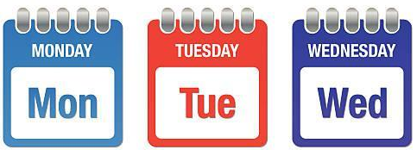  ? | What day is it today?  A. It’s Thursday.  B. It’s Tuesday.  C. It’s Saturday.
1. | 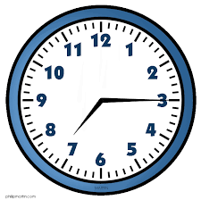 | What time do you go to school?  A. I go to school at seven fifteen.  B. I go to school at seven forty-five.  C. I go to school at half past seven.
2. |  | Where’s he from?  A. He’s from Malaysia.  B. He’s from Singapore.  C. He’s from Viet Nam.
3. |  | What do you want to eat?  A. I want some apples.  B. I want some juice.  C. I want some grapes.
4. | 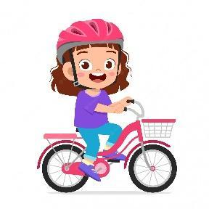 | Can she ride a bike?  A. Yes, she can.  B. Yes, he can.  C. Yes, I can.

IV. Fill in the blanks. (3 points)
Hi, I’m Rosie. This is my sister, Sue and my parents. We all can (1)  ___________ but we can’t skateboard. My dad can (2)  __________ and my sister can (3) _________. My sister can (4) __________ but I can’t. She often takes me to the park near my house by bike.

ANSWER KEY
I.
Audio script:
Example: get
1. juice 2. water 3. Malaysia 4. Sunday
Key:
1. C 2. A 3. C 4. A
II.
Audio script:
Example: – Where are you from?
– I’m from Thailand.
1. – When’s your birthday?
– It’s in November.
2. – What do you want to drink?
– I want some water.
3. – What time do you go to bed?
– I go to bed at nine forty-five.
4. – Can you draw?
– No, I can’t.
Key:
1. C 2. A 3. B 4. C
III.
1. A 2. C 3. C 4. A

IV.
- roller skate (2) play the guitar (3) play the piano (4) ride a bike

