MID-TERM TEST 1 (SEMESTER 1)
Time allowed: 15 mins
Full name: ............................................................................. Grade: ............. Mark: ............. / 10
I. Listen to the sounds and circle the correct words. (2 points)
Example: | A. water | B. Japan | C. June
1. | A. jam | B. yes | C. grapes
2. | A. party | B. music | C. Sunday
3. | A. Malaysia | B. where | C. here
4. | A. train | B. juice | C. beach
II. Listen and tick (✓) the correct pictures. (3 points)
Example | A. 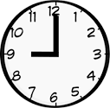 | B. 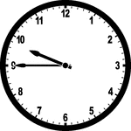 | C. 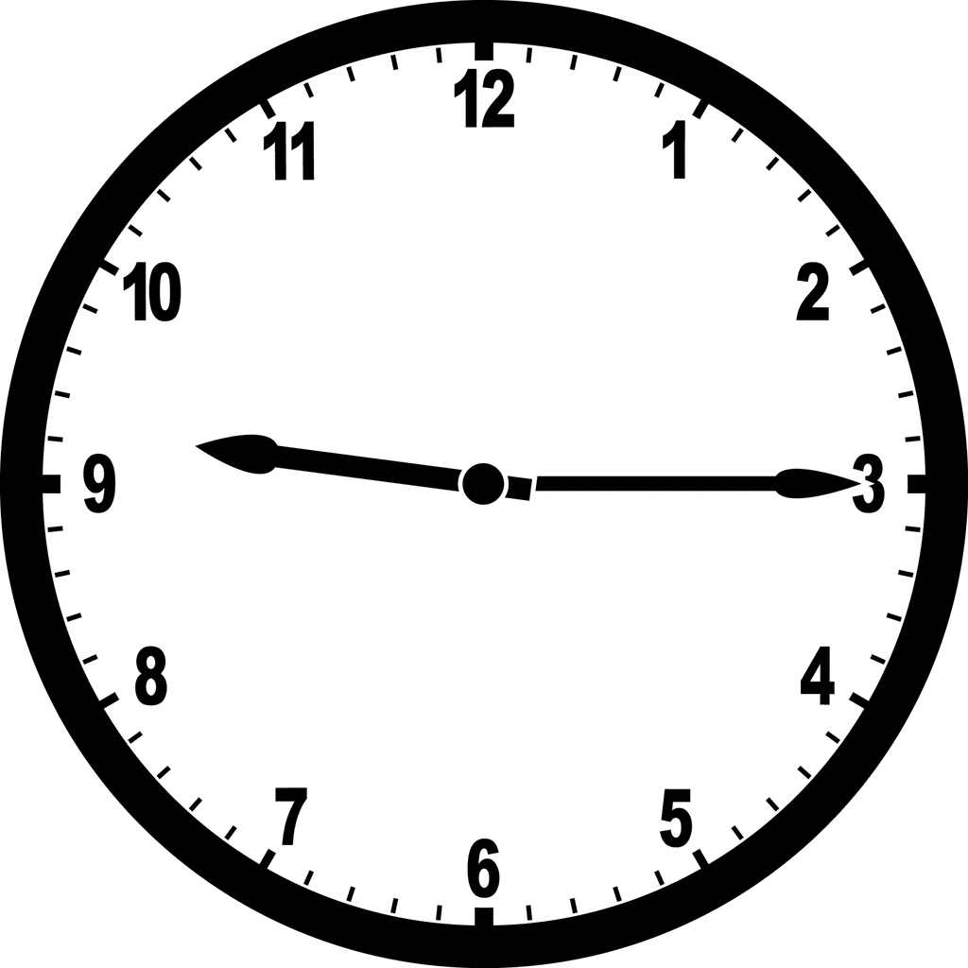

1. | A.  | B.  | C. 

2. | A.  | B.  | C. 

3. | A.  | B.  | C. 

4. | A.  | B.  | C. 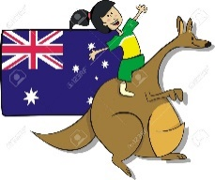

III. Circle the correct answers. (2 points)
Example: |  | Where is he from?  A. He’s from Thailand.  B. He’s from Malaysia.  C. He’s from Japan.
1. |  | What do you do on Mondays?  A. I listen to music.  B. I do housework.  C. I study at school.
2. | 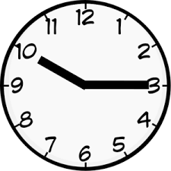 | What time is it?  A. It’s ten fifteen.  B. It’s ten o’clock.  C. It’s ten forty-five.
3. | 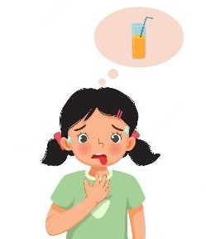 | What do you want to drink?  A. I want some water.  B. I want some juice.  C. I want some grapes.
4. |  | Can he cook?  A. Yes, I can.  B. Yes, he can’t.  C. Yes, he can.

IV. Fill in the blanks. (3 points)
Hi. My name is Mary and I am from (1) _____________ . Today is the
sixth of March. It is my birthday. I am having a great time. I have a big birthday
(2) ________ from my parents. Lots of friends come to my party. We eat some (3) _________ and drink some (4)  __________. They give
me many beautiful presents.
ANSWER KEY
I.
Audio script:
Example: /w/ /w/
1. /j/ /j/
2. /ʌ/ /ʌ/
3. /iə/ /iə/
4. /dʒ/ /dʒ/
Key:
1. B 2. C 3. A 4. B
II.
Audio script:
Example: – What time is it?
– It’s nine forty-five.
1. – What day is it today?
– It’s Saturday.
2. – What do you want to eat?
– I want some chips.
3. – What can he do?
– He can play the guitar.
4. – Where are you from?
– I’m from Australia.
Key:
1. A 2. C 3. A 4. C
III.
1. A 2. A 3. B 4. C
IV.
(1) America (2) cake (3) chips (4) milk

