LUYỆN NGHE GIỮA HỌC KỲ I PHẦN 2

LISTEN AND CHOOSE
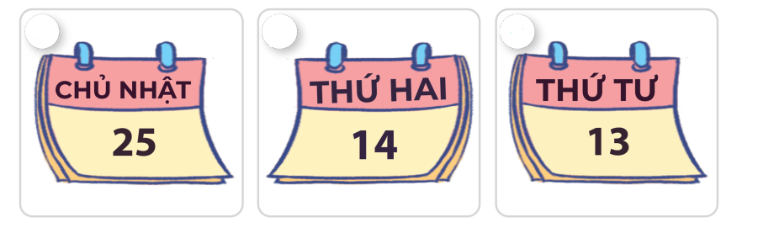
Question 1. Number 1
A. Sunday
B. Monday
C. Wednesday
Question 2. Number 2
A. Sunday
B. Monday
C. Wednesday
Question 3. Number 3
A. Sunday
B. Monday
C. Wednesday

LISTEN AND CHOOSE

Question 4. Number 1
A. Australia
B. Thailand
C. Malaysia
Question 5. Number 2
A. Australia
B. Thailand
C. Malaysia
Question 6. Number 3
A. Australia
B. Thailand
C. Malaysia

LISTEN AND CHOOSE
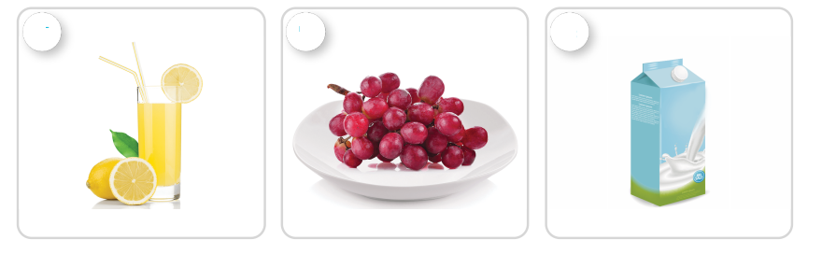
Question 7. Number 1
A. grapes
B. lemonade
C. milk
Question 8. Number 2
A. grapes
B. lemonade
C. milk
Question 9. Number 3
A. grapes
B. lemonade
C. milk

LISTEN AND CHOOSE
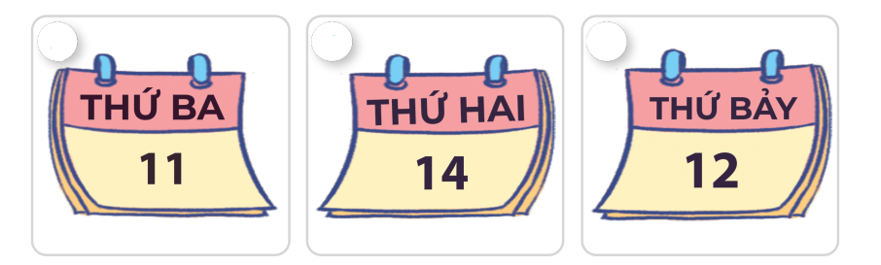
Question 10. Number 1
A. Today is Monday.
B. Today is Tuesday.
C. Today is Saturday.
Question 11. Number 2
A. Today is Monday.
B. Today is Tuesday.
C. Today is Saturday.
Question 12. Number 3
A. Today is Monday.
B. Today is Tuesday.
C. Today is Saturday.

LISTEN AND CHOOSE
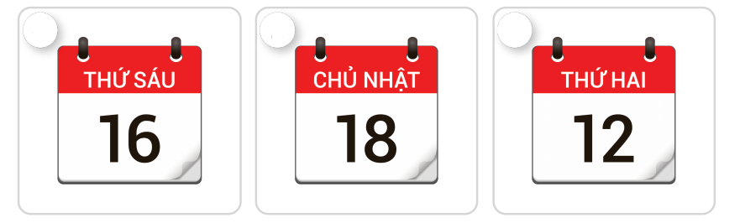
Question 13. Number 1
A. Today is Monday.
B. Today is Sunday.
C. Today is Friday.
Question 14. Number 2
A. Today is Monday.
B. Today is Sunday.
C. Today is Friday.
Question 15. Number 3
A. Today is Monday.
B. Today is Sunday.
C. Today is Friday.
ĐÁP ÁN

LISTEN AND CHOOSE
Question 1. Number 1
A. Sunday
B. Monday
C. Wednesday
Question 2. Number 2
A. Sunday
B. Monday
C. Wednesday
Question 3. Number 3
A. Sunday
B. Monday
C. Wednesday

LISTEN AND CHOOSE
Question 4. Number 1
A. Australia
B. Thailand
C. Malaysia
Question 5. Number 2
A. Australia
B. Thailand
C. Malaysia
Question 6. Number 3
A. Australia
B. Thailand
C. Malaysia

LISTEN AND CHOOSE
Question 7. Number 1
A. grapes
B. lemonade
C. milk
Question 8. Number 2
A. grapes
B. lemonade
C. milk
Question 9. Number 3
A. grapes
B. lemonade
C. milk

LISTEN AND CHOOSE
Question 10. Number 1
A. Today is Monday.
B. Today is Tuesday.
C. Today is Saturday.
Question 11. Number 2
A. Today is Monday.
B. Today is Tuesday.
C. Today is Saturday.
Question 12. Number 3
A. Today is Monday.
B. Today is Tuesday.
C. Today is Saturday.

LISTEN AND CHOOSE
Question 13. Number 1
A. Today is Monday.
B. Today is Sunday.
C. Today is Friday.
Question 14. Number 2
A. Today is Monday.
B. Today is Sunday.
C. Today is Friday.
Question 15. Number 3
A. Today is Monday.
B. Today is Sunday.
C. Today is Friday.

