LUYỆN NGHE GIỮA HỌC KỲ I PHẦN 4

LISTEN AND CHOOSE
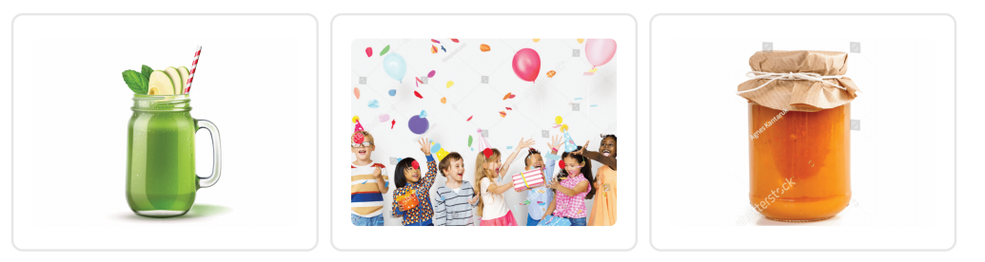
Question 1. Number 1
A. jam
B. juice
C. party
Question 2. Number 2
A. jam
B. juice
C. party
Question 3. Number 3
A. jam
B. juice
C. party

LISTEN AND CHOOSE

Question 4. Number 1
A. birthday party
B. May
C. chips
Question 5. Number 2
A. birthday party
B. May
C. chips
Question 6. Number 3
A. birthday party
B. May
C. chips

LISTEN AND WRITE
Question 7.
He can ………… . .
Question 8.
But he can't ………… . .

LISTEN AND WRITE
Question 9.
I get up at five ………… . .

LISTEN AND WRITE
Question 10.
On Fridays, I ………… . at school.

LISTEN AND CHOOSE
Question 11. Can he ride a bike?
A. No, he can't.
B. Yes, he can.

LISTEN AND CHOOSE
Question 12. What do you do on Mondays?
A. I listen to music.
B. I do housework.
C. I study at school.

LISTEN AND CHOOSE
Question 13
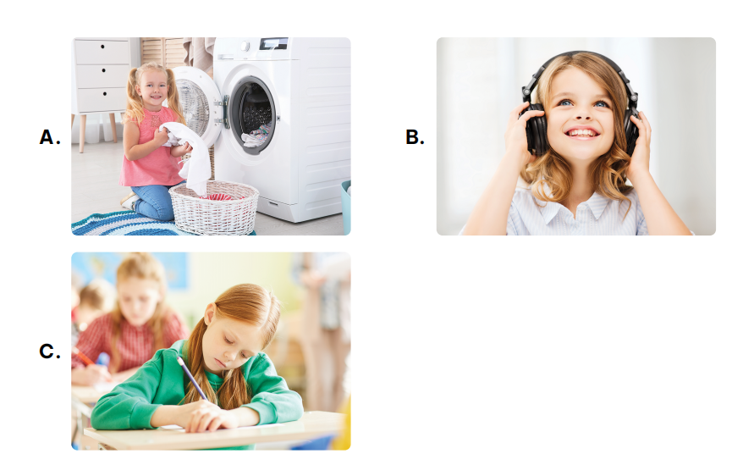
Question 13.
A. picture A
B. picture B
C. picture C

LISTEN AND CHOOSE
Question 14
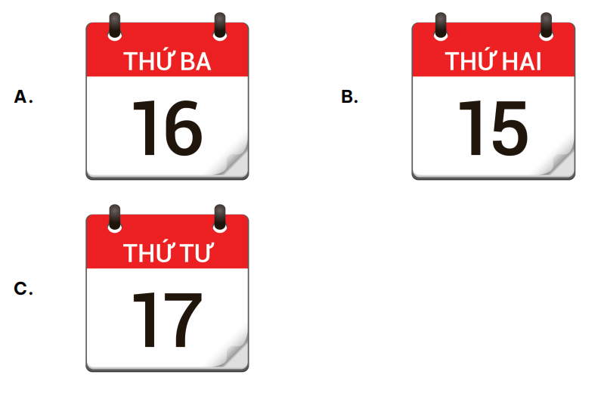
Question 14.
A. picture A
B. picture B
C. picture C
ĐÁP ÁN

LISTEN AND CHOOSE
Question 1. Number 1
A. jam
B. juice
C. party
Question 2. Number 2
A. jam
B. juice
C. party
Question 3. Number 3
A. jam
B. juice
C. party

LISTEN AND CHOOSE
Question 4. Number 1
A. birthday party
B. May
C. chips
Question 5. Number 2
A. birthday party
B. May
C. chips
Question 6. Number 3
A. birthday party
B. May
C. chips

LISTEN AND WRITE
Question 7.
He can cook.
Question 8.
But he can't swim .

LISTEN AND WRITE
Question 9.
I get up at five thirty .

LISTEN AND WRITE
Question 10.
On Fridays, I study at school.

LISTEN AND CHOOSE
Question 11. Can he ride a bike?
A. No, he can't.
B. Yes, he can.

LISTEN AND CHOOSE
Question 12. What do you do on Mondays?
A. I listen to music.
B. I do housework.
C. I study at school.

LISTEN AND CHOOSE
Question 13
Question 13.
A. picture A
B. picture B
C. picture C

LISTEN AND CHOOSE
Question 14
Question 14.
A. picture A
B. picture B
C. picture C

