LUYỆN NGHE GIỮA HỌC KỲ I PHẦN 1

LISTEN AND CHOOSE

Question 1. Number 1
A. swim
B. dance
C. cook
Question 2. Number 2
A. swim
B. dance
C. cook
Question 3. Number 3
A. swim
B. dance
C. cook

LISTEN AND CHOOSE
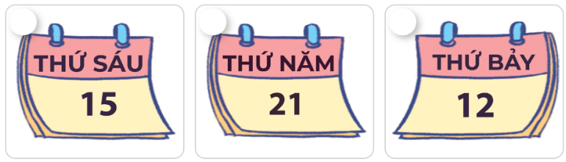
Question 4. Number 1
A. Friday
B. Thursday
C. Saturday
Question 5. Number 2
A. Friday
B. Thursday
C. Saturday
Question 6. Number 3
A. Friday
B. Thursday
C. Saturday

LISTEN AND CHOOSE

Question 7. Number 1
A. February
B. March
C. January
Question 8. Number 2
A. February
B. March
C. January
Question 9. Number 3
A. February
B. March
C. January

LISTEN AND CHOOSE
Question 10. What time is it?
A. It's twelve twenty-five
B. It's twelve forty-five

LISTEN AND CHOOSE
Question 11. What day is it today?
A. It's Saturday.
B. It's Sunday.

LISTEN AND CHOOSE
Question 12. What day is it today?
A. It's Thursday.
B. It's Wednesday.

LISTEN AND CHOOSE

Question 13
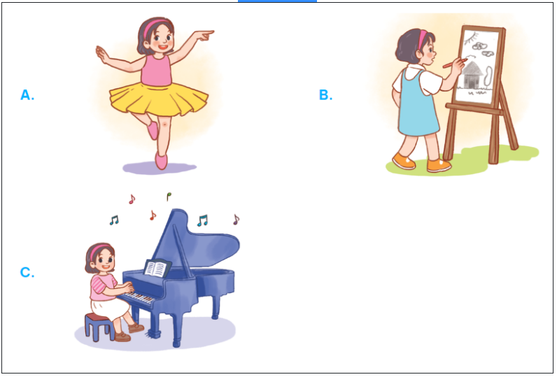
Question 13. Can your sister dance?
A. No, she can't. But she can play the guitar.
B. No, she can't. But she can draw.
C. No, she can't. But she can play the piano.
ĐÁP ÁN

LISTEN AND CHOOSE
Question 1. Number 1
A. swim
B. dance
C. cook
Question 2. Number 2
A. swim
B. dance
C. cook
Question 3. Number 3
A. swim
B. dance
C. cook

LISTEN AND CHOOSE
Question 4. Number 1
A. Friday
B. Thursday
C. Saturday
Question 5. Number 2
A. Friday
B. Thursday
C. Saturday
Question 6. Number 3
A. Friday
B. Thursday
C. Saturday

LISTEN AND CHOOSE
Question 7. Number 1
A. February
B. March
C. January
Question 8. Number 2
A. February
B. March
C. January
Question 9. Number 3
A. February
B. March
C. January

LISTEN AND CHOOSE
Question 10. What time is it?
A. It's twelve twenty-five
B. It's twelve forty-five

LISTEN AND CHOOSE
Question 11. What day is it today?
A. It's Saturday.
B. It's Sunday.

LISTEN AND CHOOSE
Question 12. What day is it today?
A. It's Thursday.
B. It's Wednesday.

LISTEN AND CHOOSE

Question 13
Question 13. Can your sister dance?
A. No, she can't. But she can play the guitar.
B. No, she can't. But she can draw.
C. No, she can't. But she can play the piano.

