ĐỀ 6 | ĐỀ ÔN TẬP CUỐI HỌC KỲ II  NĂM HỌC 2025-2026  MÔN: TIẾNG ANH LỚP 5
PART A. LISTENING
Question 1. Listen and number in the box. There is one example.walk

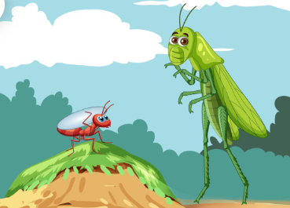
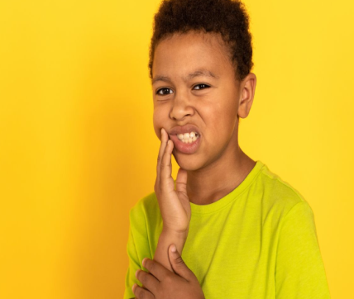

b.
c.

a.



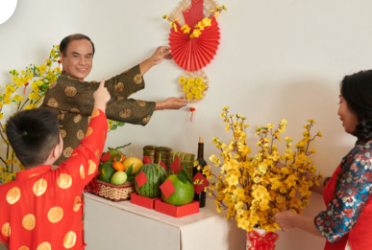

0

e.
f.

d.

Question 2. Listen and write the missing words. There is one example.
0. A: What drinks will you have at the party?
B: We'll have apple juice.
1. A: What do you usually wear in autumn?
B: I wear …………………….
2. A: How did he run?
B: He ran…………...………..
3. A: Did you swim?
B: Yes, I did. I ………………….. with my mother.
4. A: How does he stay healthy?
B: He plays ……………….
5. A: How can I get to Hoan Kiem Lake?
B: You can get there by ……………………..
PART B READING AND WRITING
Question 3. Look, read and put a tick in the box. There is one example.
0. What did your family do in Ha Long Bay?- They bought souvenirs .
a. b. c.
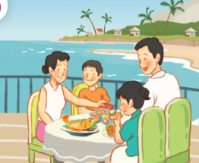



1. How does he stay healthy?- He plays sports.

a. b. c.

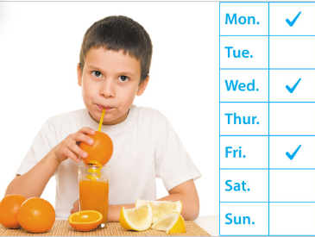


2. How’s the weather in Ha Noi in spring?- It’s warm.

a. b. c.




3. How can I get to Tower Bridge? – You can get there by bike.

a. b. c.

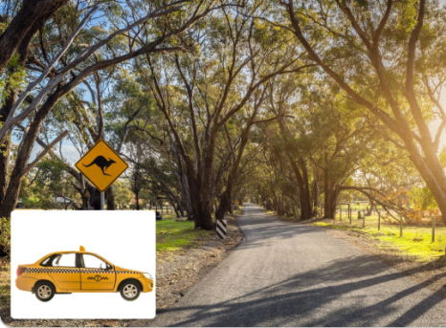


4. How far is it from Can Tho to Vinh Long?- It’s about forty kilometres.

a. b. c.
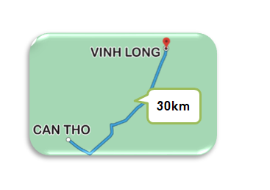
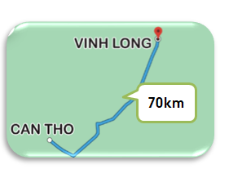
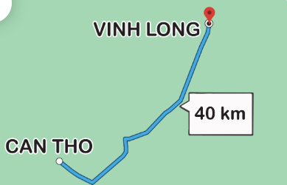

Question 4. Read and match. There is one example.
0. Will you decorate the house? | a. They are the ant and the grasshopper. | 0.d
1. What’s the matter? | b. I’m going to Huong River. | 1….
2. Who are the main characters in the story? | c. I think it’s beautiful. | 2….
3. Where are you going to visit this summer? | d. Yes, I will. | 3….
4. What do you think of Ba Na Hills? | e. I have a toothache. | 4….
Question 5. Read and complete using words in the box. There is one example.
headache taxi fantastic want healthy

My name is Jenny. I (0)want to stay healthy. Every day, I do morning exercise. I also eat (1)……………………….. food like fruits and vegetables. Last week, I had a (2) ………………………... My mom told me to have a rest. Now, I feel better. Next month, I want to visit Da Nang. I am going to Dragon Bridge. It looks (3) ……………………….. at night. I will go there by (4) ………………………... I am very excited. It will be a fun trip!
Question 6. Order the letters. There is one example.
Ex. | 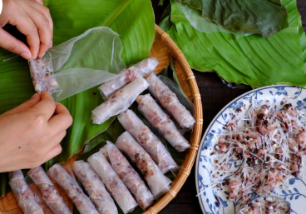 | rispng rlsol | spring rolls
1. |  | beurgrs | …………………….
2. | 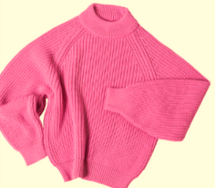 | juermp | …………………….
3. |  | sgin bafulleutiy | …………………….
4 |  | peaceful | …………………….

Question 7. Rearrange the words to make complete sentences. There is one example.
0. will / flower / I / a / festival / to / go /
-> I will go to a flower festival.
1. sister / often / does / yoga / how / your / do / ?
________________________________________
2. do / wear / you / usually / in / the / what / summer / ?
________________________________________
3. Sam Son Beach / bus / go / we / to / by / beautiful / sunset / a / to / watch / can /.
________________________________________
4. Hoi An Old Town / exciting / is / think / I /.
________________________________________
PART C SPEAKING
Question 8. Look and answer the questions.
1. What’s the matter? 
2. What will you go at Tet? 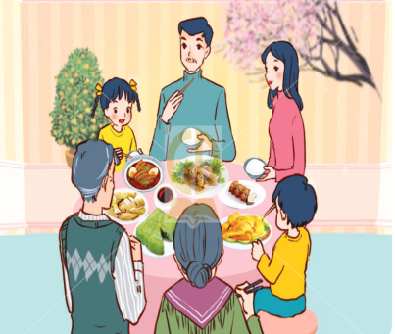
3. How’s the weather in winter? 
4. Who are the main characters in the story? 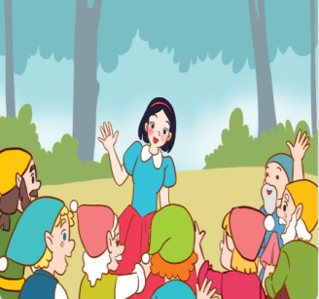
5. What is she going to visit this summer? 
Question 9. Answer the questions.
1. Will you buy roses for Tet?
2. What food will you have at the party?
3. How can you get to Ha Noi City?
4. What are you going to do this weekend?
5. What do you usually wear in the autumn?

