ĐỀ 5 | ĐỀ ÔN TẬP CUỐI HỌC KỲ II  NĂM HỌC 2025-2026  MÔN: TIẾNG ANH LỚP 5
PART I. LISTENING (2.5 points)
Question 1. Listen and number. There is one example. (1 point)
 |  | 0
 | 
Question 2. Listen and complete. There is one example. (0.75 points)
It is Mid-Autumn Festival next week. We celebrate it on the (0) fifteenth day of the eighth month of the lunar year. This year, we will have a celebration and a small party in our class. There will be a lot of exciting activities. First, Mai and Lan will (1) ________________ about Mid-Autumn. Then, a group of students will (2) ________________ about Mid-Autumn and dance. The class will be divided into 4 teams and compete in the game: (3) ________________ decoration for Mid-Autumn Festival. There will be a sweet party after the celebration. We will have a lot of food and drinks such as pizza, salads, popcorn, apple juice, and lemonade. It will be a wonderful party.
Question 3. Listen and choose A, B, or C. There is one example. (0.75 points)
 | When is the best time to go to Co To Island?
 | - Spring | - Summer | - Winter
 | How far is it from Ha Long City to Co To island?
 | - 94 kilometres | - 84 kilometres | - 64 kilometres
 | How can you get to Co To Island from Ha Long City?
 | - You can get there by a speed boat. | - You can get there by car or bus, and a speed boat. | - You can get there by bus.
 | How is Co To seafood?
 | - fishy | - hot and chilly | - fresh and delicious
PART II. READING (2.5 points)
Question 4. Fill in each blank with one given phrase of words. There is one example. (1 point)
It is Teachers’ Day next week. In Viet Nam, we celebrate it on the 20th of (0) November. This year, we will have a celebration and a party in our class. There will be a lot of meaningful activities. First, Mai and Lan will (1) ________________ to say thank you to our teachers. Then, Minh and Linh will sing a song about the teachers. Phong and Huong will give our teachers small gifts. There will be (2) ________________ after the celebration. We will have a lot of food and (3) ________________ such as pizza, salads, popcorn, apple juice and lemonade. It will be a (4) ________________ party. | drinks  read a poem  November  a sweet party  wonderful
Question 5. Read and choose A, B or C. There is one example. (0.75 points)
 | My brother drinks coconut water __________a week .
 | - twice | - two | - one
 | _____________ do you usually wear in winter?
 | - Where | - Why | - What
 | The crow sang _____________.
 | - beautifully | - beauty | - beautiful
 | How can I ________ Hoan Kiem Lake?
 | - get on | - get up | - get to
Question 6. Read and tick True or False. There is one example. (0.75 points)

Hello, my name is Lisa. Last summer, my friend and I went to an eco-farm. We had a great time there. This summer, we are going to visit Phu Quoc Island. We are going to visit Hon Thom Nature Park in the south of the island and visit the Vinpearl Safari in the north of the island. We are excited to explore the local food there. When we get home, I am going to join a dancing club. I am going to take some Zumba lessons. In my free time, I am going to learn foreign languages with my friends. We are going to learn Chinese and Korean.
 | True | False
- Lisa and her friend went to a camping site last summer. |  | ✓
- They are going to Phu Quoc this summer.
- They are going to both Hon Thom Nature Park and Vinpearl Safari.
- Lisa will learn Chinese and her friend will learn Korean.
PART III. WRITING (2.5 points)
Question 7. Read and answer the questions. There is one example. (1 point)
Once upon a time there were three little pigs. The first pig was lazy, so he quickly built his house with straw. The second pig was lazy too, so he quickly built his house with sticks. The third pig worked hard and built his house with bricks. A big bad wolf saw and chased the two first little pigs to the straw house. The wolf blew it down in minutes. The wolf chased them to the stick house and blew it down in one hour. Now, the two little pigs were scared and ran to the third pig’s brick house. The wolf tried to blow the house down, but he could not. The house was very strong because it was made of bricks. The wolf tried to go into the house through the chimney. But the wolf fell into a big pot of boiled water under the chimney and died. The two little pigs now felt sorry, then they worked hard to build their houses with bricks and lived happily ever after.
- Who are the main characters in this story?
They are the three little pigs and the wolf.
- How did the first two pigs build their houses?
____________________________________________________________.
- How did the third pig work?
____________________________________________________________.
- Why was the third pig’s house strong?
____________________________________________________________.
- Which character do you like?
____________________________________________________________.
Question 8. Answer the questions with the given words. There is one example. (0.75 points)
- Where will you go at Tet? (my grandparents’ house)
I will go to my grandparents’ house at Tet.
- What’s the matter with you? (stomach ache)
____________________________________________________________.
- How often does your father play tennis? (twice a week)
____________________________________________________________.
- What drinks will we have at the party? (apple juice and milk tea)
____________________________________________________________.
Question 9. Use the given words to make sentences. There is one example. (0.75 points)
- you / do / What / on Children’s Day? / will
What will you do on Children’s Day?
- cool and cloudy / It / in autumn. /is / in Hanoi
____________________________________________________________.
- the tortoise and the hare./ The main characters / are / in the story
____________________________________________________________.
- Hoan Kiem Lake / I / want to / visit / this summer
____________________________________________________________.
PART IV. SPEAKING (2.5 points)
Question 10. Introduction. (1 point)
- What’s your name? How old are you?
- What class are you in?
- What’s your favourite animal? Do you have any pet?
- What’s your favourite subject? Why do you like it?
Question 11. Look at the pictures and answer the following questions. (0.5 points)
 | 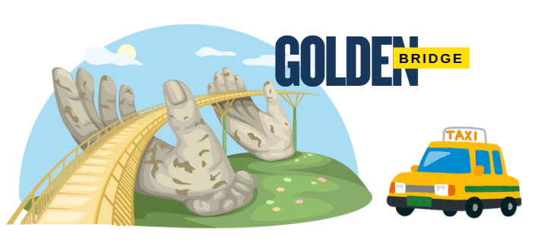 | Question: Where do you want to visit? How can you get there?
 | 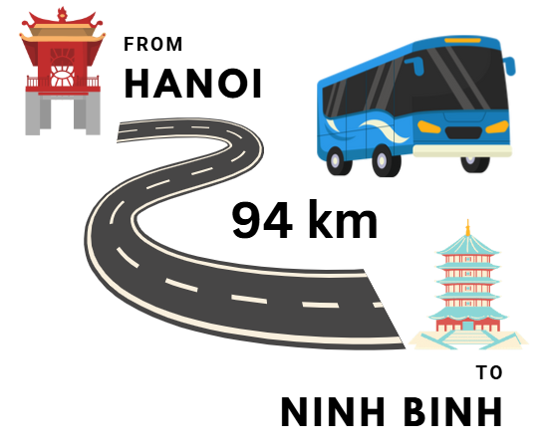 | Question: How far is it from Hanoi to Ninh Binh? How can I get there?
Question 12. Let’s talk. (1 point)
- Do you have any sister or brother? Does he/she play sports?
- How does he/she stay healthy? How often does he/she do it?
- What will you do on Children’s Day?
- What food and drinks will you have at the Children’s Day party?\
ĐÁP ÁN
PART I. LISTENING (2.5 points)
QUESTION 1: Listen and number (1 point)
Mỗi câu đúng 0.25 điểm (0.25x4)
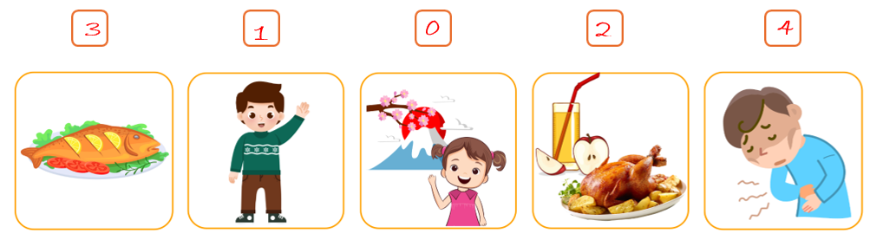
QUESTION 2: Listen and complete (0.75 points)
Mỗi câu đúng 0.25 điểm (0.25x3)
- read a poem | - sing a song | - fruits
QUESTION 3: Listen and choose A, B, or C (0.75 points)
Mỗi câu đúng 0.25 điểm (0.25x3)
- A | - B | - C
PART II. READING (2.5 points)
QUESTION 4: Fill in each blank with one given phrase of words (1 point)
Mỗi câu đúng 0.25 điểm (0.25x4)
- read a poem | - a sweet party | - drinks | - wonderful
QUESTION 5: Read and choose A, B, or C (0.75 points)
Mỗi câu đúng 0.25 điểm (0.25x3)
- C | - A | - C
QUESTION 6: Read and tick True or False (0.75 points)
Mỗi câu đúng 0.25 điểm (0.25x3)
- True | - True | - False
PART III. WRITING (2.5 points)
QUESTION 7: Read and answer the questions (1 point)
Mỗi câu đúng 0.25 điểm (0.25x4)
- They built their houses quickly.
- The third pig worked hard.
- Because it was made of brick.
- I like the first/second/third pig / I like the wolf.
QUESTION 8: Answer the questions with the given words (0.75 pointS)
Mỗi câu đúng 0.25 điểm (0.25x3)
- I have a stomach ache.
- He plays tennis twice a week.
- We will have apple juice and milk tea.
QUESTION 9. Use the given words to make sentences (0.75 points)
Mỗi câu đúng 0.25 điểm (0.25x3)
- It is cool and cloudy in Hanoi in autumn.
- The main characters in the story are the tortoise and the hare.
- I want to visit Hoan Kiem Lake this summer.
PART IV. SPEAKING (2.5 points)
QUESTION 10: Introduction (1 point)
Mỗi câu trả lời 0.25 điểm (0.25x4)
QUESTION 11. Look at the picture and answer the following questions. (0.5 points)
Mỗi câu trả lời 0.25 điểm (0.25x2)
- I want to visit Golden Bridge. I can get to Golden Bridge by taxi.
- It’s about ninety four kilometres. You can get there by bus.
QUESTION 12: Let’s talk (1 point)
Mỗi câu trả lời 0.25 điểm (0.25x4)

