ĐỀ 4 | ĐỀ ÔN TẬP CUỐI HỌC KỲ II  NĂM HỌC 2025-2026  MÔN: TIẾNG ANH LỚP 5
PART I. LISTENING (2.5 points)
Question 1. Listen and tick. There is one example. (1 point)
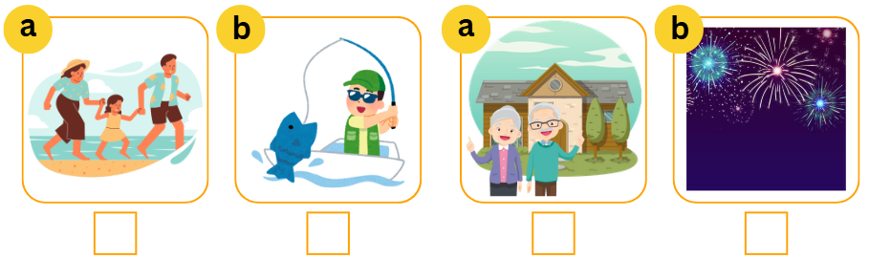
✓
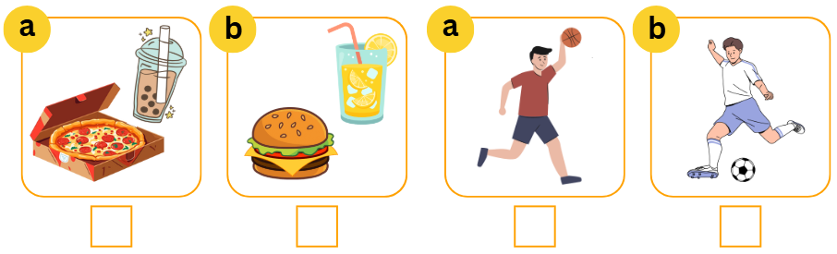
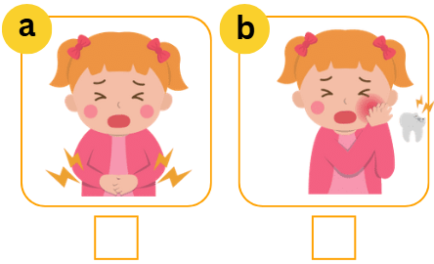
Question 2. Listen and complete the table. (0.75 points)
THE CLIMATES IN VIET NAM
 | The north | The south
How many seasons? | There are 4 seasons:  Spring, summer, (0) autumn, and winter | There are 2 seasons:  (2) __________ and rainy season.
The weather | - Spring: warm and rainy  - Summer: sunny and hot  - Autumn: (1) ______________________  - Winter: very cold | - Dry season: dry and cool  - Rainy season: (3) ____________________
Question 3. Listen and tick True or False. (0.75 points)
 | True | False
- The hare won the race. |  | ✓
- Lan can get to Ngo Mon Square by bus.
- Bill thinks that Hoi An Old Town is exciting and busy.
- Anna is going to visit Nha Trang Beach this summer by bus.
PART II. READING (2.5 points)
Question 4. Read and choose A, B or C. There is one example. (0.75 points)

HOW TO TREAT A SORE THROAT YOURSELF
To help soothe a sore throat and shorten how long it lasts, you should:
- You should gargle with warm and salty water.
- You should drink plenty of water.
- You should eat cool or soft foods.
- You should avoid smoking or smoky places.
- You may suck ice cubes, ice lollies or hard sweets.
- You should have a rest.
- If you do not feel better, you should go to the doctor.

 | Which water should you use to gargle with?
 | - warm and salty water. | - cold and salty water | - drinking water
 | What should you eat when you have a sore throat?
 | - cool or soft foods | - hot and spicy foods | - hard foods
 | What shouldn’t you do when having a sore throat?
 | - smoking | - go to smoky places | - both A & B
 | What should you do if you do not feel better?
 | - go to the doctor | - go to the dentist | - go to school
Question 5. Fill in each blank with a phrase of words. There is one example. (0.75 points)
traditional holiday Spring peach blossoms
Hi, my name is Harry. I am from London. I am visiting Viet Nam. Now, I am in Ha Noi, the capital city of Viet Nam. (0) Spring is coming, but it is still very cold here. I like travelling to mountainous places like Fansipan and Mau Son. These places are attractive because they have lovely (1) ___________. Sometimes, they get a soft layer of snow. It makes them more beautiful. I want to stay in Ha Noi for Tet. It is a special (2) ___________ of Vietnamese. I love (3) ___________ food in Ha Noi, especially pho noodle and bun cha.
Question 6. Reorder the sentences to make a complete conversation. There is one example. (1 point)
 | We’re going to fly to Hue. Then we are going to join a tour from Hue to Da Nang and see many sights along the road.
 | Sure, Ben. My family is going to visit Hue and Da Nang City.
 | Hi Hoa. Do you have any plan for this summer?
 | What a wonderful summer! Have a good time!
 | Amazing! You are going to travel a lot. What are you going to do there?
ANSWER: 3 – _________________
PART III. WRITING (2.5 points)
Question 7. Fill in the blanks with suitable words. There is one example. (1 point)
- I will buy  a peach blossom for Tet decoration.
- My sister  ___________ every day.
- The main characters in the story are the ant and 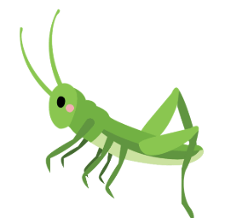 ___________.
- You can get to Hoan Kiem Lake  ___________.
- I’m going to practice  ___________ this summer.
Question 8. Reorder the words to make complete sentences. There is one example. (0.75 points)
- will / We / pizza and milk tea / at the birthday party. / have
We will have pizza and milk tea at the birthday party.
- don’t usually / I / because / they are not / healthy. / eat chips
____________________________________________________________.
- a headache / My father / today. / has
____________________________________________________________.
- it / in Ha Noi / hot and humid / in summer? / Is
____________________________________________________________?
Question 9. Read and answer the questions. There is one example. (0.75 points)
“Phong Nha Ke Bang National Park is a wonderful place to visit. It’s best to go there in summer. It is about 129 kilometres from here. You can get there by bus or car. There are many interesting things to see and do. You can take photos of caves, ride a bicycle, go hiking, and explore the hidden cultural values of Phong Nha Ke Bang National Park. Overnight camping in the cave is the most interesting option for adventurers. You can spend the night within the heart of these ancient caves, surrounded by the secrets of the underground world. It is a very peaceful and beautiful place. You should go and see once in lifetime!”
- How far is it from Phong Nha Ke Bang to the place of the writer?
It’s about 129 kilometres.
- How can you get there?
____________________________________________________________.
- What is the most interesting option for adventurers?
____________________________________________________________.
- Is it possible to take photos or film inside the caves?
____________________________________________________________.
PART IV. SPEAKING (2.5 points)
Question 10. Introduction. (1 point)
- What’s your name? How old are you?
- What class are you in?
- What’s your favourite school activity? Why do you like it?
- What’s your favourite food?
Question 11. Describe the pictures by answering the following questions. (0.5 points)
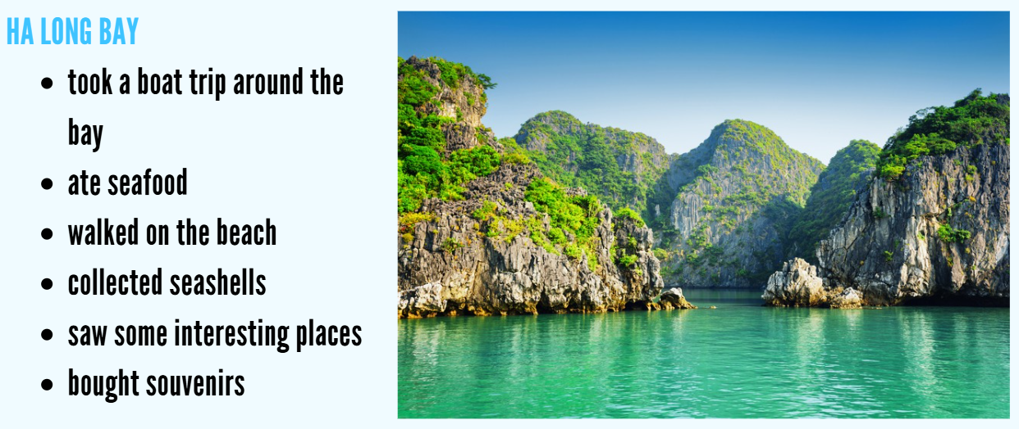
- Where did your family go last summer?
- What did you do there?
- What do you think of Ha Long Bay?
Question 12. Let’s talk. (1 point)
- How is the weather in your hometown now?
- What do you usually wear in this season?
- How does your grandmother stay healthy? How often does she do it?
- Does your grandmother give you any advice on staying healthy?
ĐÁP ÁN
PART I. LISTENING (2.5 points)
QUESTION 1: Listen and tick (1 point)
Mỗi câu đúng 0.25 điểm (0.25x4)
- a | - a | - b | - b
QUESTION 2: Listen and complete the table (0.75 points)
Mỗi câu đúng 0.25 điểm (0.25x3)
- cool and cloudy | - Dry season | - rainy and humid
QUESTION 3: Listen and tick True or False (0.75 points)
Mỗi câu đúng 0.25 điểm (0.25x3)
- True | - False | - True
PART II. READING (2.5 points)
QUESTION 4: Read and choose A, B, or C (0.75 points)
Mỗi câu đúng 0.25 điểm (0.25x3)
- A | - C | - A
QUESTION 5: Fill in each blank with a phrase of words (0.75 points)
Mỗi câu đúng 0.25 điểm (0.25x4)
- peach blossoms | - holiday | - traditional
QUESTION 6: Reorder the sentences to make a complete conversation (1 point)
Mỗi câu đúng 0.25 điểm (0.25x4)
ANSWER: 3 – 2 – 5 – 1 – 4
PART III. WRITING (2.5 points)
QUESTION 7: Fill in the blanks with suitable words (1 point)
Mỗi câu đúng 0.25 điểm (0.25x4)
- does yoga | - the grasshopper | - by bicycle | - swimming
QUESTION 8: Reorder the words to make complete sentences (0.75 pointS)
Mỗi câu đúng 0.25 điểm (0.25x3)
- I don’t usually eat chips because they are not healthy.
- My father has a headache today.
- Is it hot and humid in Ha Noi in summer?
QUESTION 9. Read and answer the questions (0.75 points)
Mỗi câu đúng 0.25 điểm (0.25x3)
- You can get there by bus or car.
- It is overnight camping in the cave.
- Yes, it is.
PART IV. SPEAKING (2.5 points)
QUESTION 10: Introduction (1 point)
Mỗi câu trả lời 0.25 điểm (0.25x4)
QUESTION 11. Describe the pictures by answering the following questions. (0.5 points)
Mỗi câu trả lời 0.25 điểm (0.25x2).
- We went to Ha Long Bay. / We took a boat trip around the bay / ate seafood / walked on the beach / collected seashells / saw some interesting places / bought souvenirs.
- I think it’s exciting / fantastic / peaceful / beautiful.
QUESTION 12: Let’s talk (1 point)
Mỗi câu trả lời 0.25 điểm (0.25x4)

