ĐỀ 3 | ĐỀ ÔN TẬP CUỐI HỌC KỲ II  NĂM HỌC 2025-2026  MÔN: TIẾNG ANH LỚP 5
PART I. LISTENING (2.5 points)
Question 1. Listen and match. There is one example. (1 point)
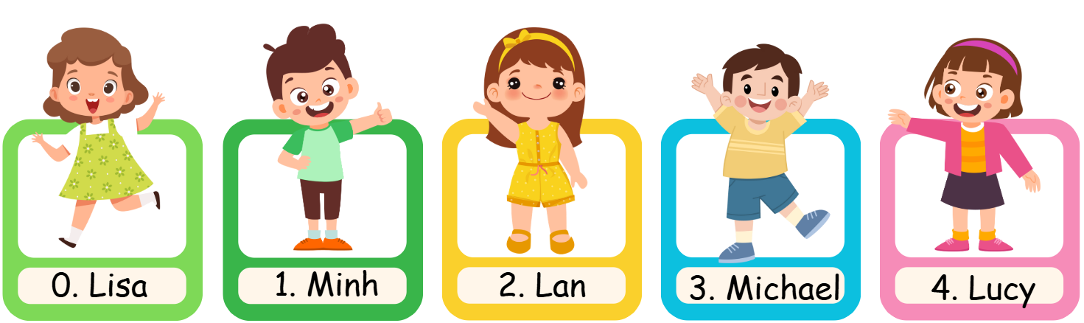
 | 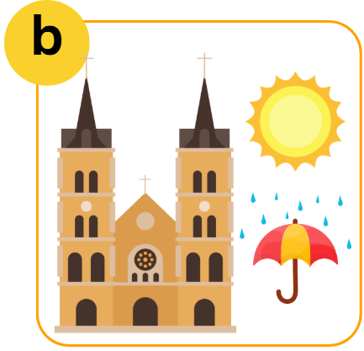 |  | 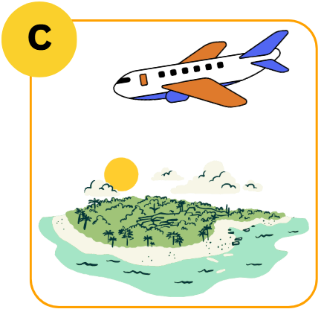 |  |  | 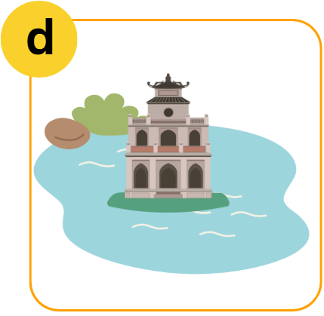 |  | 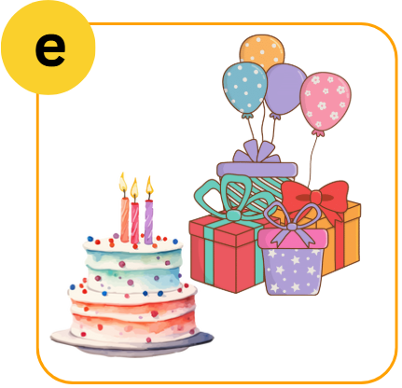
Question 2. Listen and complete the table. (0.75 points)
HOW TO TREAT A SORE THROAT YOURSELF
DO |  | DON’T
• gargle with warm and salty water (0) three times a day  • drink plenty of water  • eat (1) ___________________  • suck ice cubes, ice lollies or hard sweets  • have (3) ___________________  • go to the doctor |  | • eat too hot or too hard food  • (2) ___________________ or go to smoky places  • watch too much TV
Question 3. Listen and tick True of False. There is one example. (0.75 points)
 | True | False
- Anna’s family went to Nha Trang Beach last summer. |  | ✓
- Her family went to a dolphin show.
- Anna didn’t eat crabs and shrimps.
- Anna thinks Ha Long Bay is pretty and peaceful.
PART II. READING (2.5 points)
Question 4. Read and choose the correct words or phrases. Write the correct words. There is one example. (1 point)
Teachers’ Day stomach ache opera house
on foot summer
- We move around by walking. | ____on foot_________
- The season when the weather is hot and sunny. | ___________________
- You have a pain in your stomach. | ___________________
- A special day when you express your gratitude to your teachers. | ___________________
- People go to this building to see shows. | ___________________
Question 5. Read, circle and write. There is one example. (0.75 points)
- Who are the main (characters / character) characters in the story?
- You should go to the (eye clinic / dentist) ______________when you have toothache.
- I think Hanoi city is (exciting/ excited) ___________________.
- What are you (go to / going to) _______________ visit Phu Quoc Island this summer.
Question 6. Read and tick True or False. There is one example. (0.75 points)
Little Red Riding Hood lived in the wood with her mother. One day she brought a nice cake to her grandmother. On her way she met a wolf and told the wolf that she was going to her grandmother’s house. The wolf ran to the grandmother’s house and ate her up. He got into bed and pretended to be the grandmother. A little later, Little Red Riding Hood reached the house. The wolf tried to eat Little Red Riding Hood. Luckily, a woodcutter was in the wood. He heard a loud scream and ran to the house. The woodcutter hit the wolf over the head. The wolf opened his mouth wide and shouted and the grandmother jumped out. The wolf ran away, and Little Red Riding Hood never saw the wolf again.

 | True | False
- The main characters in this story are Little Red Riding Hood and the wolf . | ✓
- Little Red Riding Hood met the wolf when she went to school.
- The wolf ate the grandmother and tried to eat Little Red Riding Hood.
- The woodcutter did not help Little Red Riding Hood.
PART III. WRITING (2.5 points)
Question 7. Fill in each box with one letter to make complete words. There is one example. (1 point)
 |  |  | 
 | E  H  A  C  D  A  H  E |  | P  U
 |  |  | 
 | S  W  F |  | F  P
 | 
E
L

G

E

Question 8. Reorder the words to make complete sentences. There is one example. (0.75 points)
- stay / How / your brother / does / healthy?
How does your brother stay healthy?
- have a rest. should / take some medicine / and / You
________________________________________________________________.
- a warm blouse / I / a scarf / and / in winter. / wear / usually
________________________________________________________________.
- ran slowly, / he / won the race. / The tortoise / but
________________________________________________________________.
Question 9. Look at the pictures and answer the questions. There is one example. (0.75 points)
 |  | Question: Where are you going to visit this summer?  Answer: I’m going to visit Hanoi Opera House.
 |  | Question: How can I get to Golden Bridge?  Answer: __________________________________________.
 | 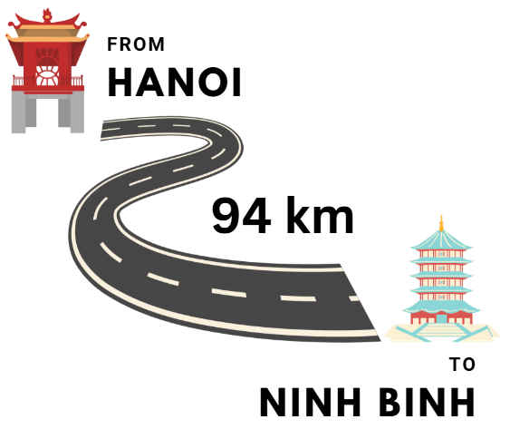 | Question: How far is it from Hanoi to Ninh Binh?  Answer: __________________________________________.
 |  | Question: How is the weather in Ho Chi Minh city in summer?  Answer: __________________________________________.
PART IV. SPEAKING (2.5 points)
Question 10. Introduction. (1 point)
- What’s your name? How old are you?
- What class are you in?
- What’s your favorite color?
- What’s your favourite animal?
Question 11. Describe the people by answering the following questions. (1 point)
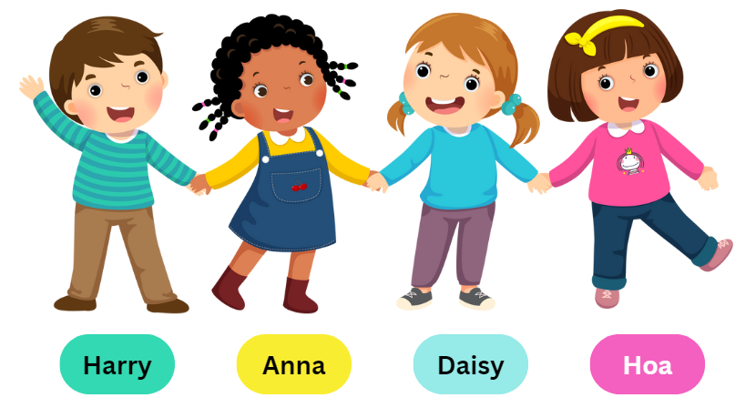
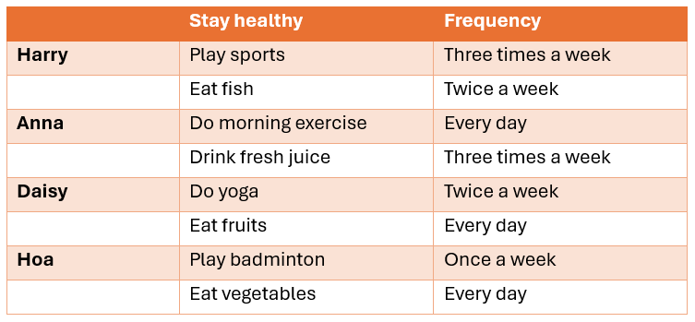
The teacher points at two of four children and asks the following questions:
- What is his / her name? How does he / she stay healthy?
- How often does he / she + V?
Question 12. Let’s talk. (0.5 points)
- When is Children’s Day? What will you do on Children’s Day?
- What food / drinks will you have at the party?
ĐÁP ÁN
PART I. LISTENING (2.5 points)
QUESTION 1: Listen and match. (1 point)
Mỗi câu đúng 0.25 điểm (0.25x4)
- d | - b | - a | - e
QUESTION 2: Listen and complete the table (0.75 points)
Mỗi câu đúng 0.25 điểm (0.25x3)
- cool or soft foods | - smoke | - a rest
QUESTION 3: Listen and tick True or False (0.75 points)
Mỗi câu đúng 0.25 điểm (0.25x3)
- True | - False | - True
PART II. READING (2.5 points)
QUESTION 4: Read and choose the correct words or phrases (1 point)
Mỗi câu đúng 0.25 điểm (0.25x4)
- summer | - stomach ache | - Teachers’ Day | - opera house
QUESTION 5: Read, circle, and write (0.75 points)
Mỗi câu đúng 0.25 điểm (0.25x3)
- dentist | - exciting | - going to
QUESTION 6: Read and tick True or False (0.75 points)
Mỗi câu đúng 0.25 điểm (0.25x3)
- False | - True | - False
PART III. WRITING (2.5 points)
QUESTION 7: Fill in each box with one letter to make complete words (1 point)
Mỗi câu đúng 0.25 điểm (0.25x4)
- JUMPER | - FIREWORKS | - PEACEFUL | - VEGETABLES
QUESTION 8: Reorder the words to make complete sentences (0.75 pointS)
Mỗi câu đúng 0.25 điểm (0.25x3)
- You should take some medicine and have a rest.
- I usually wear a scarf and a warm blouse in winter.
- The tortoise ran slowly, but he won the race
QUESTION 9. Look at the pictures and answer the questions (0.75 points)
Mỗi câu đúng 0.25 điểm (0.25x3)
- You can get there by taxi.
- It’s about ninety four kilometres.
- It’s hot and sunny.
PART IV. SPEAKING (2.5 points)
QUESTION 10: Introduction (1 point)
Mỗi câu trả lời 0.25 điểm (0.25x4)
QUESTION 11. Describe the people by answering the following questions. (1 point)
Mỗi câu trả lời 0.25 điểm (0.25x4)
QUESTION 12. Let’s talk. (0.5 points)
Mỗi câu trả lời 0.25 điểm (0.25x2)

