ĐỀ 2 | ĐỀ ÔN TẬP CUỐI HỌC KỲ II  NĂM HỌC 2025-2026  MÔN: TIẾNG ANH LỚP 5
PART I. LISTENING (2.5 points)
Question 1. Listen and tick or cross. There is one example. (1 point)
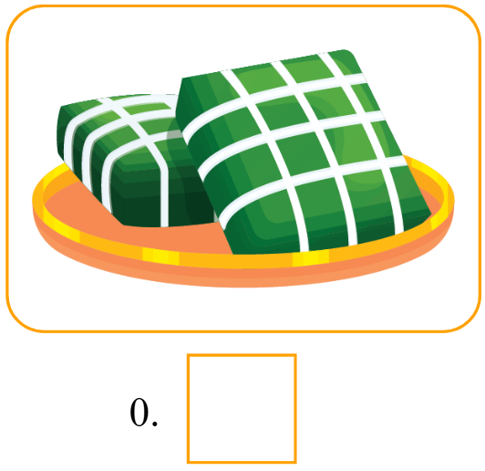  ✓ | 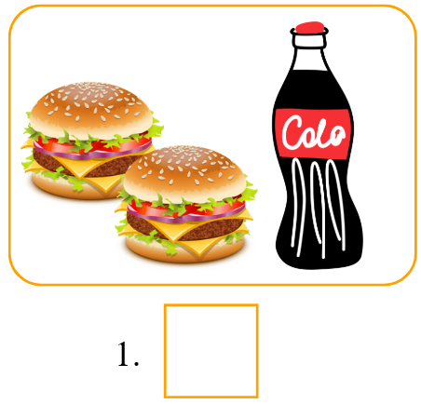 | 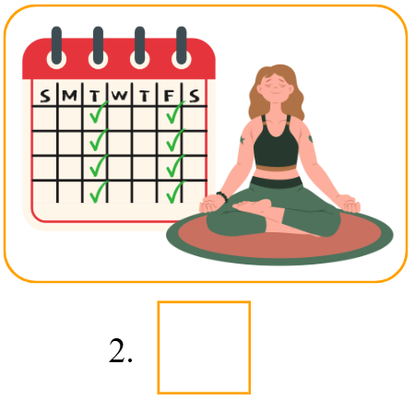
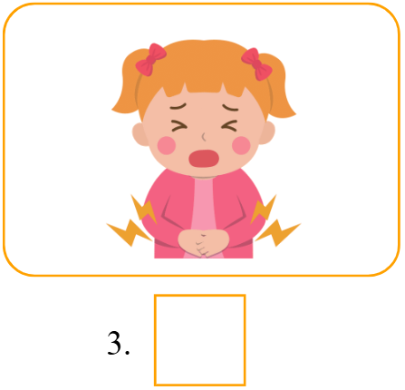 | 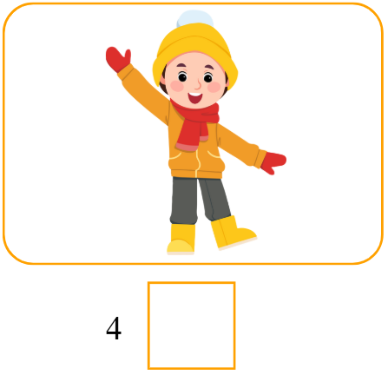
Question 2. Listen and complete. There is one example. (0.75 points)
Once upon a time, there were (0) three pigs. The first pig was lazy, so he quickly built his house with straw. The second pig was lazy too, so he quickly built his house with sticks. The third pig (1) __________________ and built his house with bricks. A big bad wolf saw and chased the two first little pigs to the straw house. The wolf blew it down right away. The wolf chased them to the stick house and blew it down (2) __________________. Now, the two little pigs were scared and ran to the third pig’s brick house. The wolf tried to blow the house down, but he could not. The house was very (3) __________________ because it was made of bricks.
Question 3. Listen and choose A, B or C. There is one example. (0.75 points)
 | How can Lan get to Dragon Bridge?
 | - By bus. | - By bus and taxi | - On foot
 | How far is it from Hoan Kiem Lake to West Lake?
 | - Three kilometres | - Five kilometres | - One kilometre.
 | What can you enjoy at Wings of Time in the evening?
 | - A fireworks show. | - A show with music and lights | - A music show
 | Where is David going to learn this summer?
 | - A music club | - How to play the piano | - How to play the guitar
PART II. READING (2.5 points)
Question 4. Read and choose A, B or C. There is one example. (1 point)
 | __________ did you do in Ho Chi Minh last summer?
 | - Why | - What | - Where
 | My sister will __________ the house for Tet.
 | - decorate | - make | - do
 | We’ll __________ sports and games on Sports Day.
 | - watch | - play | - see
What’s the matter with your teeth?
I have __________.
 | - a headache | - a sore throat | - toothache
 | How did Snow White __________?
 | - cook | - cooked | - cooking
Question 5. Fill in each blank with a suitable phrase of words. There is one example. (0.75 points)
Dear Lan,  fresh juice  active sports  fish and vegetables  How are you? Today, I want to tell you about the healthy lifestyles of my family. My family has four members: my father, my mother, my brother, and me. My father often goes for a walk in the morning. He likes eating (0) fish and vegetables. | 
My mother drinks (1) __________________ every day. She loves orange juice, lemonade, and apple juice. My brother likes (2) __________________. He plays sports after school every day. About me, I’m very (3) __________________. I always get up early in the morning. Twice a week, I do yoga with my mother.
How about you? How do you stay healthy?
Mai.
Question 6. Read and choose A, B or C. There is one example. (0.75 points)

HISTORICAL SINGAPORE BICYCLE TOUR
Why not ride a bicycle tour in Singapore? Singapore is a small country. You can have a bicycle tour around the city to explore its famous tourist attraction. You should ride next to the Singapore River. Then you can visit Marina Bay and City Hall.
With a tour guide, you will listen a lot of interesting stories about the city. For example, you can learn about the history of the Merlion, the story of one Singapore dollar coin.
Along the way, you can enjoy a local snack and a drink at a coffee shop. You should try some potato chips. Its taste is wonderful!
You can visit Singapore in any season. It’s always hot and sunny there. So, you can wear a T-shirt and shorts every day. But it has frequent rains. Don’t forget to bring your own umbrella.
It will be a great experience in your life!
- What should you try in Singapore?  - A boat tour along the Singapore River.  - A bicycle tour around the city.  - A tourist bus tour. | - What will you learn with a tour guide?  - Interesting stories about Singapore.  - History of Merlion and the story of one Singapore dollar coin.  - Both A and B.
- How’s the weather in Singapore?  - It’s always cool and snowy.  - It’s often rainy.  - It’s not hot and sunny. | - What should you wear in Singapore?  - A T-shirt and shorts.  - A jumper and trousers.  - A warm blouse and jeans.

PART III. WRITING (2.5 points)
Question 7. Fill in the blanks with suitable words. There is one example. (1 point)
 | 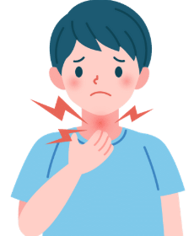
- What’s the matter with him?
- He has a sore throat.
 |  |  | 
 | - Where will you go at Tet?  - I’ll go to __________________. |  | - What food will you have at the party?  - We’ll have __________________.
 |  |  | 
 | - How can I get to Ngo Mon Square?  - You can get there __________________. |  | - What are you going to do this summer?  - I’m going to learn __________________.
Question 8. Use the given words to make sentences. There is one example. (0.75 points)
- will / a flower festival / We / go to / at Tet.
We will go to a flower festival at Tet.
- play / sports and games / They / will / on Sports Day.
_______________________________________________________________.
- usually / do you / wear / in winter? / What
_______________________________________________________________?
- cleaned the house / with seven dwarfs, / Snow White lived / very well / and she
_______________________________________________________________.

Question 9. Answer the questions with the given words. There is one example. (0.75 points)
- How does your grandfather stay healthy? (do exercise, every morning)
He does exercise every morning.
- How is the weather in Hanoi in winter? (cold and windy)
_______________________________________________________________.
- Do you like the crow or the fox? (fox)
_______________________________________________________________.
- Where do you want to visit? (Dam Sen Aquarium)
_______________________________________________________________.
PART IV. SPEAKING (2.5 points)
Question 10. Introduction. (1 point)
- What’s your name? How old are you?
- What class are you in?
- How is the weather in your hometown now?
- What do you usually wear in this season?
Question 11. Look at the pictures and answer the following questions. (0.5 points)
 | - How often does he play sports?
 | - What will they do on Teachers’ Day?  .
Question 12. Let’s talk. (1 point)
- Do you like reading books? What is your favorite story?
- Who are the main characters in this story?
- Which character do you like in this story?
- How did she/he + V? (depending on the story that the student chooses, the teacher will ask suitable questions)
ĐÁP ÁN
ĐÁP ÁN VÀ HƯỚNG DẪN CHẤM THI ĐỀ SỐ 2
PART I. LISTENING (2.5 points)
QUESTION 1: Listen and tick or cross (1 point)
Mỗi câu đúng 0.25 điểm (0.25x4)
- x | - ✓ | - x | - x

QUESTION 2: Listen and complete (0.75 points)
Mỗi câu đúng 0.25 điểm (0.25x3)
- worked hard | - in one hour | - strong
QUESTION 3: Listen and choose A, B or C (0.75 points)
Mỗi câu đúng 0.25 điểm (0.25x3)
- A | - B | - C
PART II. READING (2.5 points)
QUESTION 4: Read and choose A, B or C (1 point)
Mỗi câu đúng 0.25 điểm (0.25x4)
- A | - B | - C | - A
QUESTION 5: Fill in each blank with a suitable phrase of words (0.75 points)
Mỗi câu đúng 0.25 điểm (0.25x3)
- fresh juice | - sports | - active
QUESTION 6: Read and choose A, B or C (0.75 points)
Mỗi câu đúng 0.25 điểm (0.25x3)
- C | - B | - A
PART III. WRITING (2.5 points)
QUESTION 7: Fill in the blanks with suitable words (1 point)
Mỗi câu đúng 0.25 điểm (0.25x4)
- a fireworks show | - burgers and pizza | - by bus | - dancing
QUESTION 8: Use the given words to make sentences (0.75 pointS)
Mỗi câu đúng 0.25 điểm (0.25x3)
- They will play sports and games on Sports Day.
- What do you usually wear in winter?
- Snow White lived with seven dwarfs, and she cleaned the house very well.
QUESTION 9. Answer the questions with the given words (0.75 points)
Mỗi câu đúng 0.25 điểm (0.25x3)
- It is cold and windy.
- I like the fox.
- I want to visit Dam Sen Aquarium.
PART IV. SPEAKING (2.5 points)
QUESTION 10: Introduction (1 point)
Mỗi câu trả lời 0.25 điểm (0.25x4)
QUESTION 11. Look at pictures and answer the following questions. (0.5 points)
Mỗi câu trả lời 0.25 điểm (0.25x2)
- He plays sports twice a week.
- They will sing and dance.
QUESTION 12: Let’s talk (1 point)
Mỗi câu trả lời 0.25 điểm (0.25x4)

