ĐỀ 1 | ĐỀ ÔN TẬP CUỐI HỌC KỲ II  NĂM HỌC 2025-2026  MÔN: TIẾNG ANH LỚP 5

PART I. LISTENING (2.5 points)
Question 1. Listen and number. There is one example. (1 point)
 |  | 0
 |  | 

Question 2. Listen and complete the table. There is one example. (0.75 points)
Name | Place | Season | Weather | Clothes
Linh | Ha Noi | - (0) Spring | - warm and rainy | - a (2) ________ and jeans  - a dress
Eiko | Tokyo | - Winter | - (1) ________ and dry  - snowy | - a jumper, a coat and jeans  - a scarf and (3) ________
Question 3. Listen and tick True of False. There is one example. (0.75 points)
 | True | False
- Anna is going to grow vegetables at an e-co farm this summer. | ✓
- Ba Na Hills is very far from Da Nang.
- The grasshopper worked hard to gather food for the winter.
- You can get to Hanoi Opera House by bus.

PART II. READING (2.5 points)
Question 4. Read and match. There is one example. (1 point)
- No, I won’t. I’ll make spring rolls.
0. Did you collect seashells with your sister?

B. She does morning exercise every day.
1. Will you make banh chung for Tet?

C. I have toothache.
2. What will you do at the birthday party?
D. Yes, I did.
3. How does your sister stay healthy?

E. We’ll play games and sing songs.
4. What’s the matter with you?

Question 5. Read and choose A, B or C. There is one example. (0.75 points)
 | ____________ the weather in your city now?
 | - What’s | - How | - How’s
 | The main characters in the story ____________ the ant and the grasshopper.
 | - are | - is | - were
 | I want to visit the ____________ to learn more about the history of the city.
 | - theatre | - museum | - lake
 | How ___________ is it from here to the Ha Noi Opera House?
 | - long | - distance | - far
Question 6. Read and tick True or False. There is one example. (0.75 points)
Hoan Kiem Lake is a wonderful place to visit. It is the symbol of Hanoi City. You can visit there in any season. In spring, it’s warm and beautiful. You can wear a thin jumper and trousers. You can see young buds on tree branches and flowers pots for Tet decoration everywhere. In summer, it’s hot and sunny. The lake will make you feel cooler under the shadows of trees. You can have a walk around the lake and eat Trang Tien ice cream. In autumn, it’s cool and comfortable. You can sit on the stone benches and feel the gentle breeze of autumn. Finally, when it is very cold in winter, you can have some hot street food and drinks when you visit the walking street around the lake.

 | True | False
- You can visit Hoan Kiem Lake in any season. | ✓
- It’s very cold in spring, so you must wear a thick jumper and trousers.
- The lake will make you feel hotter in the summer.
- In winter, it’s very cold, you can have some hot street food on the walking street.
PART III. WRITING (2.5 points)
Question 7. Fill in each blank with one word. There is one example. (0.75 points)
 |  | The main characters in this story are the tortoise and the hare.
 | 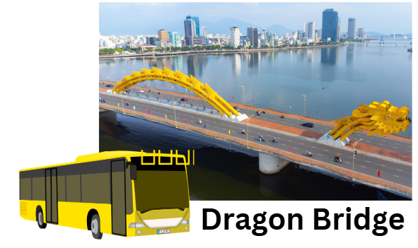 | You can get to Dragon Bridge by ________.
 | 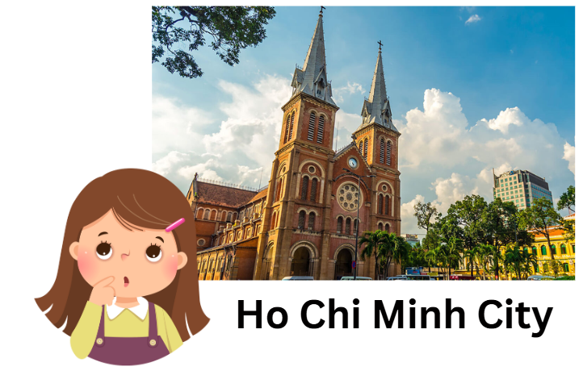 | What do you ________ of Ho Chi Minh City?
 |  | I’m going to learn to play the ________ this summer.
Question 8. Reorder the words to make complete sentences. There is one example. (1 point)
- last summer? / Did / you / Ba Na Hills / go to /
Did you go to Ba Na Hills last summer?
- you / decorate the house / Will / for Tet?
____________________________________________________________________
- will / burgers and pizza / have / on Children’s Day. / We
____________________________________________________________________
- eats / every day / My grandmother / vegetables / to stay healthy.
____________________________________________________________________
- take / You / some / medicine. /should
____________________________________________________________________
Question 9. Answer the questions with the given words. There is one example. (0.75 points)
- How’s the weather in Hai Phong in summer? (hot, sunny)
It’s hot and sunny.
- Which character do you like in the story Snow White and seven dwarfs? (Snow White, seven dwarfs)
____________________________________________________________________
- What do you think of Hoi An Old Town? (peaceful, beautiful)
____________________________________________________________________
- Where are you going to visit this summer? (Phu Quoc Island)
____________________________________________________________________
PART IV. SPEAKING (2.5 points)
Question 10. Introduction. (1 point)
- What’s your name? How old are you?
- What class are you in?
- Where was your family last summer?
- What did you do there?
Question 11. Look at the picture and answer the following questions. (1 point)
The teacher shows the map to the student. The teacher points at the starting point “You’re here”. Then ask the students questions about the distance from the starting point to the places and the means of transport to get to a place. The teacher asks 4 questions.
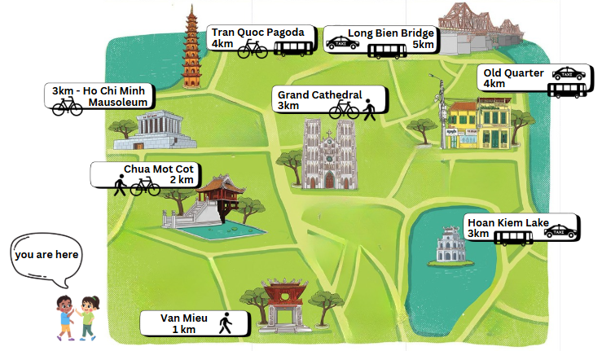
- How far is it from your standing point to Van Mieu / Tran Quoc Pagoda / Ho Chi Minh Mausoleum / Grand Cathedral / Long Bien Bridge / Hoan Kiem Lake / Old Quarter? How can you get there?
- What do you think of Hanoi / Van Mieu / Tran Quoc Pagoda / Ho Chi Minh Mausoleum / Grand Cathedral / Long Bien Bridge / Hoan Kiem Lake / Old Quarter?
Question 12. Let’s talk. (0.5 points)
- Where are you going to visit this summer?
- What are you going to do?
ĐÁP ÁN
PART I. LISTENING (2.5 points)
QUESTION 1: Listen and number (1 point)
Mỗi câu đúng 0.25 điểm (0.25x4)
4 | 2 | 0 | 1 | 3

QUESTION 2: Listen and complete the table (0.75 points)
Mỗi câu đúng 0.25 điểm (0.25x3)
- cold | - blouse | - gloves
QUESTION 3: Listen and tick True or False (0.75 points)
Mỗi câu đúng 0.25 điểm (0.25x3)
- False | - False | - True
PART II. READING (2.5 points)
QUESTION 4: Read and match (1 point)
Mỗi câu đúng 0.25 điểm (0.25x4)
- A | - E | - B | - C
QUESTION 5: Read and choose A, B or C (0.75 points)
Mỗi câu đúng 0.25 điểm (0.25x3)
- A | - B | - C
QUESTION 6: Read and tick True or False (0.75 points)
Mỗi câu đúng 0.25 điểm (0.25x3)
- False | - False | - True
PART III. WRITING (2.5 points)
QUESTION 7: Fill in each blank with one word (0.75 points)
Mỗi câu đúng 0.25 điểm (0.25x3)
- bus | - think | - guitar
QUESTION 8: Reorder the words to make complete sentences (1 point)
Mỗi câu đúng 0.25 điểm (0.25x4)
- Will you decorate the house for Tet?
- We will have burgers and pizza on Children’s Day.
- My grandmother eats vegetables every day to stay healthy.
- You should take some medicine.
QUESTION 9. Answer the questions with the given words (0.75 points)
Mỗi câu đúng 0.25 điểm (0.25x3)
- I like Snow White / seven dwarfs.
- I think it’s peaceful and beautiful.
- I’m going to visit Phu Quoc Island.
PART IV. SPEAKING (2.5 points)
QUESTION 10: Introduction (1 point)
Mỗi câu trả lời 0.25 điểm (0.25x4)
QUESTION 11. Look at the picture and answer the following questions. (1 point)
Mỗi câu trả lời 0.25 điểm (0.25x4)
- It’s about … kilometres.
I can get there on foot / by bicycle / by bus / by taxi.
- I think it’s exciting / beautiful / peaceful / busy / fantastic.
QUESTION 12: Let’s talk (0.5 points)
Mỗi câu trả lời 0.25 điểm (0.25x2)

