ĐỀ 8 | ĐỀ ÔN TẬP CUỐI HỌC KỲ I  NĂM HỌC 2025-2026  MÔN: TIẾNG ANH 5

PART A: LISTENING
- Listen and number. There is 1 example .(1 point)

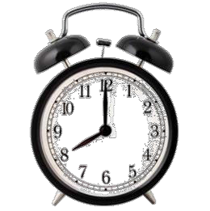

0
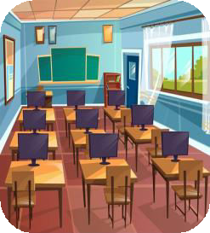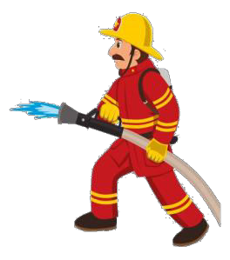A B
C
D
E

Listen and tick ( ) or cross ( ) . There is 1 example .(0.75 point)

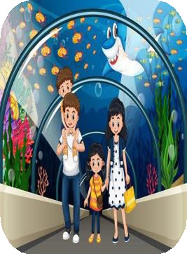
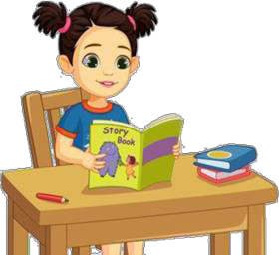1 2 3
0

Listen and write . There is 1 example .(0.75 point)

- A: Could you tell me the way to the gym ?
B: Go past the library and turn right .
- A: What did you do at the campsite ?
B: We around the
campfire..

2. Look! Linda’s pencils are my
school bag.
- A: What activity does he like ?
B: He likes .

PART B: READING
  - Look, read and circle the answer. There are examples. ( 1.25 points)



0. A: What is your favourite food ?
B: It’s a sandwich/ hamburger.

1. She likes playing games / reading books, because it’s good for her studying.

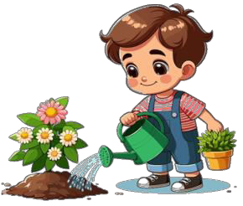

2. I often water flowers / go for a walk
in my free time.

3. My friend would like to be a/ an
firefighter / gardener.



4. My new English teacher is Australian / American.

5. I played chess / listened to music
last weekend.

Read the passage and choose the correct answer. There is 1 example .(1.25 points)

reporter
name
gardener
future
watch
clever

Hi! My
(0) name
is Daisy. I’m a primary student. At school, I have many
friends and all have different hobbies and dreams for the future. My friend Jack
wants to be a (1) when he grows up. So he often waters the flowers in the garden in his free time. Sarah likes reading books because she would like to be a

writer in the (2) . She wants to write stories for children so much. Sarah is a (3) girl, I think that she will be a famous writer. In my free time, I often read books or (4) news programme on TV. I’d like to be a (5) to talk to people what happens in the world. We all try our best to make our dreams become true.

PART C: WRITING
    - Complete the sentences. There is 1 example .(1.25 points)

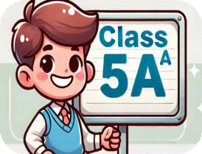0. I’m in class 5A .



- My penfriend is .
- We were at the last week.

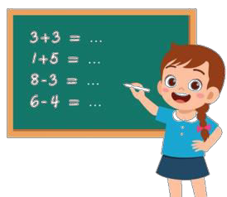

3. I’d like to be a/ an
. 4. She likes at school.



5. I sometimes at the weekend.

Reorder the words. There are examples. ( 1.25 points)
0. class 5B/ in/ I’m.

I’m in class 5B.

1. boy/ a/ brother/ My/ clever/ is.
.
4. the/ like/ I/ flowers/ watering.
- friend/ likes/ My/ reading/ school/ at/ books/.
.
  - I'd/ like/ future/ the/ to/ be/ a/ teacher/ in.

. .
  - friends/ Were/ at/ your/ yesterday/ the/ theatre?
.

PART D: SPEAKING
- Answer about you. ( 1 point)

1. What’s your name ?
.
3. Where do you live ?
.
2. Which class are you in?
.
- What is your favourite food ?
.

Look and say. There is one example. ( 1.5 points)

  - What nationality is she ?

She’s Vietnamese .

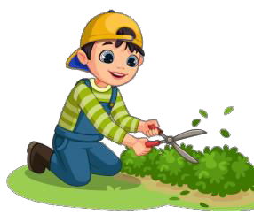

  - Why would you like to be a gardener ?
.
  - What school activity do you like ?
 .



  - What do you do at the weekend ?
.
  - What nationality is your friend ?
.



  - What did you do yesterday ?
.
  - Were you at the campsite last weekend ?
.

The end
Keys
PART A: LISTENNING
I. Listen and number

1. C | 2. D | 3. E | 4. A

II. Listen and tick or cross

1. V | 2. X | 3. X

III. Listen and T or F

1. sang and danced | 2. beside | 3. solving maths problems

PART B: READING
I. Read and circle the word.

1. reading books | 2. water flowers | 3. gardener | 4. American | 5.played chess

II. Read the passage and fill in the blanks

1. gardener 2. future
3. clever 4. watch 5.reporter

PART C: WRITING
I. Complete the sentences
1. Australian 2. aquarium
3. doctor 4. Solving maths problems
5. surf the Internet

II. Reorder the words
1. My brother is a clever boy. 2. My friend likes reading books at school.
3. I like watering the flowers. 4. I’d like to be a teacher in the future.
5. Were your friends at the theatre yesterday ?

PART D: SPEAKING
I. Answer about you
II. Look and say
1. Because I want to grow flowers. 2. I like doing projects.
3. I play the violin. 4. He’s / She’s Malaysian.
5. I listened to music. 6. No, I/ we weren’t.

