ĐỀ 6 | ĐỀ ÔN TẬP CUỐI HỌC KỲ I  NĂM HỌC 2025-2026  MÔN: TIẾNG ANH 5

PART A: LISTENING
- Listen and number. There is 1 example .(1 point)

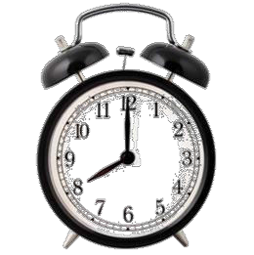
0
A B D E
C

Listen and tick ( ) or cross ( ) . There is 1 example .(0.75 point)

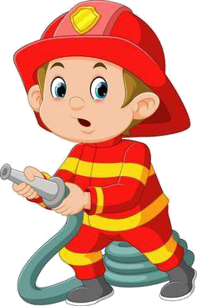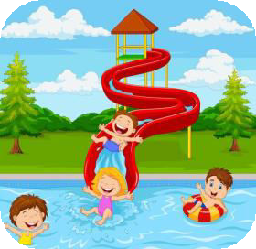
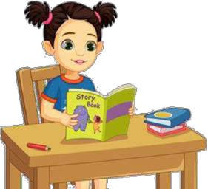1 2 3
0

Listen and write . There is 1 example .(0.75 point)

- A: Could you tell me the way to the
gym ?
- A: Look at this
this?
. Whose is

B: Go past the library and

turn right.
B: Ah, It’s Mai’s.

3. A: What would you like to be in the
- A: Where are the maps in your classroom ?

future ?
B: I’d like to be a/ an
B: They’re on the wall,
.
the board.

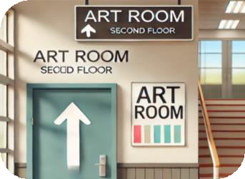PART B: READING

2. The art room is on the first floor.
  - Look, read and write T (true) or F (false). There are examples. ( 1.25 points)

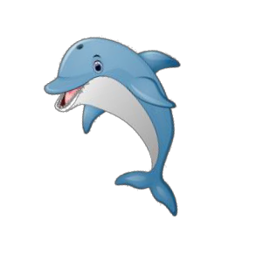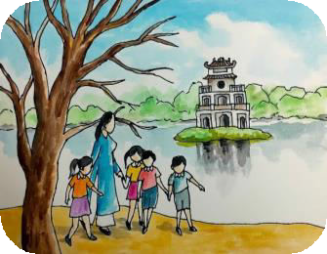
T

0. A: What is your favourite animal ?
B: It’s a dolphin.

1.We visited Hoan Kiem lake last week.

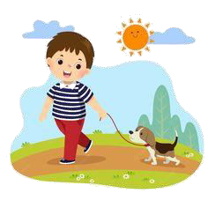
3. A: Where is the glue stick ?
B: On the table, beside the crayon box.
5. I often ride my by at the park at the
weekend.

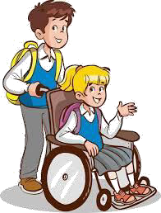Read the passage and choose the correct answer. There is 1 example .(1.25 points)

4. My brother is very helpful.

Hi, my name is Nam. I’m a student in grade five. Last weekend, our class had a school trip to Suoi Tien Theme Park. It was so much fun! We visited the aquarium and watched the fish swim around. We also played games at the funfair and walked around the lake to enjoy the beautiful views. Some of my friends danced, and we all listened to music together. In the afternoon, we went to the theatre and watched an exciting show. It was a memorable trip, and everyone had a great time!

0. Which grade is the boy in ?
- Grade 3 B. Grade 4 C. Grade 5 D. Grade 2

  - Where did the boy’s class go for their school trip ?
A. Ba Na Hill B. Suoi Tien Theme Park C. Bai Dinh Pagoda D. Hoan Kiem Lake
- What did they do at the aquarium ?
A. Played chess B. watched the fish C. visited buildings D. walked around
- What did the children do together during the trip ?
A. listened to music. B. danced C. sang. D. went to the theatre
- Where did the students go in the afternoon ?
A. To the funfair B. to the theatre C. to the aquarium D. to the campsite
- What did they do at the theatre ?
- watched the fish. B. listened to music. C. danced D. watched the show

PART C: WRITING
  - Complete the sentences. There is 1 example .(1.25 points)

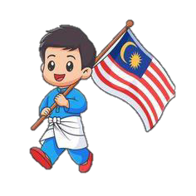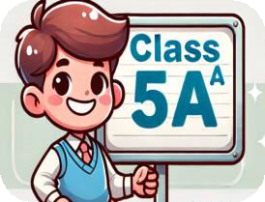0. I’m in class 5A .

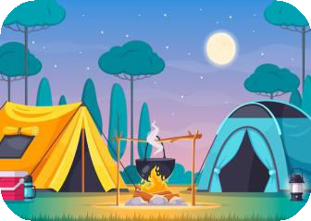

- My friend is .
- We were at the last week.



3. I’d like to be a/ an
. 4. I like at school.

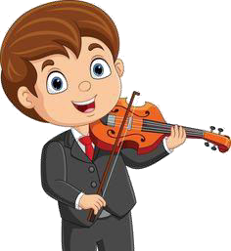

5. I sometimes at the weekend.

Reorder the words. There are examples. ( 1.25 points)
0. class 5B/ in/ I’m.

I’m in class 5B.

1. girl/ a/ sister/ My/ friendly/ is.

3. peaceful/ live/ I/ countryside/ in/ a/.
- tennis/ like/ I/ playing/ free time/ my/ in/.
.
  - funfair/ Were/ at/ you/ yesterday/ the/ ?

. .

  - I'd/ like/ future/ the/ to/ be/ a/ firefighter/ in.
.

PART D: SPEAKING
- Answer about you. ( 1 point)

1. What’s your name ?
.
3. Where do you live ?
.
2. Which class are you in?
.
- What is your favourite animal?
.

Look and say. There is one example. ( 1.5 points)

  - What nationality is she ?

She’s Vietnamese .



  - Why would you like to be a teacher ?
.
  - What school activity do you like ?
 .



  - What do you do at the weekend ?
.
  - What nationality is your teacher ?
.

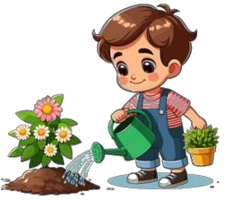

  - What did you do yesterday afternoon ?
.
  - Were you at the theatre las Sunday ?
.

The end
Keys
PART A: LISTENNING
I. Listen and number

1. E | 2. C | 3. D | 4. A

II. Listen and tick or cross

1. X | 2. V | 3. V

III. Listen and T or F

1. glue stick | 2. above | 3. firefighter

PART B: READING
I. Read and write T or F

1. T | 2. F | 3. T | 4. T | 5.F

II. Read the passage and fill in the blanks

1. B 2. B
3. A 4. B 5.D

PART C: WRITING
I. Complete the sentences
1. Malaysian 2. campsite
3. reporter 4. Doing projects
5. play the violin

II. Reorder the words
1. My sister is a friendly girl. 2. I like playing tennis in my free time.
3. I live in a peaceful countryside. 4. We were at the funfair yesterday.
5. I’d like to be a firefighter in the future.

PART D: SPEAKING
I. Answer about you
II. Look and say
1. I’d like to be a teacher. 2. I like reading books.
3. I listen to music. 4. He’s/ She’s American.
5. I watered the flowers. . 6. Yes, I/ We were.

