ĐỀ 5 | ĐỀ ÔN TẬP CUỐI HỌC KỲ I  NĂM HỌC 2025-2026  MÔN: TIẾNG ANH 5

PART A: LISTENING
- Listen and number. There is 1 example .(1 point)

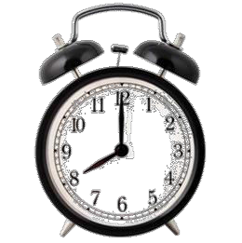

0
A B D E
C

Listen and tick ( ) or cross ( ) . There is 1 example .(0.75 point)

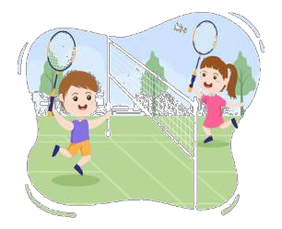
1 2 3
0

Listen and write . There is 1 example .(0.75 point)

- A: Could you tell me the way to the gym
B: Go past the library and turn right.
- A: What’s your new teacher like ?
B: She’s .

- A: Were you at the last Sunday ?
B: I with my dad.
- A: What did you do yesterday, Nam ?
B: I at home.

PART B: READING
  - Look, read and write T (true) or F (false). There are examples. ( 1.25 points)


T

0. A: What is your favourite animal ?
B: It’s a dolphin.

1. The clock is on the wall, under the pictures.



2. She likes reading books at school.

3. We were at the aquarium yesterday.

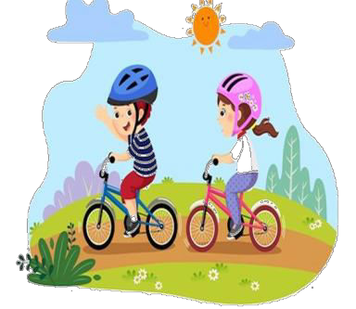

4. My new friend is American.

5. I often ride my by at the park at the weekend.

Read the passage and fill in the blanks. There is 1 example .(1.25 points)

writer
name
reading books
helpful
projects
doctor

My (0) name is John, and I have many hobbies. I often go for a walk with my dog, and I sometimes play the violin. I like doing these things in my free time. On the weekends, I usually surf the Internet and read books. I also enjoy solving maths problems because it’s (1) . In the future, I’d like to be a (2) . I think this job is very useful because I can help other people. My sister, Anna likes
(3) because she thinks it’s interesting. She says that she wants to be a

(4) because she loves to write stories. At school, my friends and I like doing different activities. My friend Tom likes to do (5) because he thinks it’s good for group work. My other friend Lucy loves to play games and read books.
PART C: WRITING
    - Complete the sentences. There is 1 example .(1.25 points)

0. I’m in class 5A .



- The pictures are the clock.
- I with my friends last week.

- Were you at ?
- I like at school.

- I sometimes at the weekend.

Reorder the words. There are examples. ( 1.25 points)
0. class 5B/ in/ I’m.

I’m in class 5B.

- girl/ a/ sister/ My/ friendly/ is.

- tennis/ like/ I/ playing/ free time/ my/ in/.
.

- peaceful/ live/ I/ countryside/ in/ a/.
- funfair/ Were/ at/ you/ yesterday/ the/ ?

. .

- I'd/ like/ future/ the/ to/ be/ a/ firefighter/ in.
.

PART D: SPEAKING
- Answer about you. ( 1 point)

1. What’s your name ?
.
3. Where do you live ?
.
2. Which class are you in?
.
- What is your favourite animal?
.

Look and say. There is one example. ( 1.5 points)
  - What nationality is she ?

She’s Vietnamese .

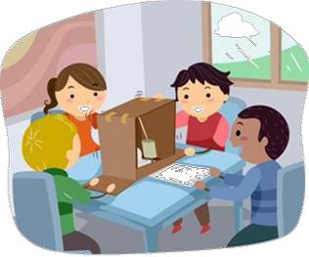

  - What would you like to be in the future?
 .
  - Why does she like doing projects ?
.



  - What do you do at the weekend ?
.
  - What nationality is your friend ?
.

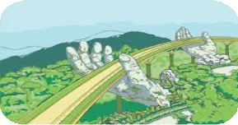

  - What did you do yesterday evening ?
.
  - Did you go to Ba Na Hill ?
.

The end
Keys

PART A: LISTENNING
I. Listen and number

1. D | 2. C | 3. E | 4. A

II. Listen and tick or cross

1. V | 2. X | 3. V

III. Listen and T or F

1. helpful | 2. funfair | 3. listened to music

PART B: READING
I. Read and match

1. F | 2. F | 3. T | 4. F | 5.T

II. Read the passage and fill in the blanks

1. helpful 2. doctor
3. reading books 4. writer 5. projects

PART C: WRITING
I. Complete the sentences
1. under 2. Walked around the lake/ went for a walk
3. the campsite 4. Playing badminton
5. surf the Internet

II. Reorder the words
1. My sister is a friendly girl. 2. I like playing tennis in my free time.
3. I live in a peaceful countryside. 4. We were at the funfair yesterday.
5. I’d like to be a firefighter in the future.

PART D: SPEAKING
I. Answer about you
II. Look and say
1. I’d like to be a gardener. 2. Because it’s good for group work.
3. I play chess. 4. He/ She is Japanese.
5. I listened to music. 6. No, I didn’t.

