ĐỀ 4 | ĐỀ ÔN TẬP CUỐI HỌC KỲ I  NĂM HỌC 2025-2026  MÔN: TIẾNG ANH 5

PART A: LISTENING
- Listen and number. There is 1 example .(1 point)



A B D E
0
C

Listen and tick ( ) or cross ( ) . There is 1 example .(0.75 point)

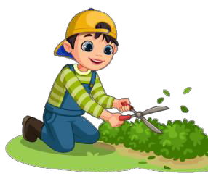
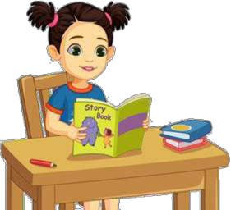1 2 3
0

Listen and write . There is 1 example .(0.75 point)

- A: Could you tell me the way to the gym
- A: What did you do yesterday afternoon?

B: Go past the library and

turn right .
B: I at the theatre with Lan.

- A: Why does your friend like doing projects ?
B: Because it’s good for
- A: Were you at the last weekend ?
B: Yes, we were. We saw a lot of beautiful
. fish.

PART B: READING
- Look, read and match. There are examples. ( 1.25 points)
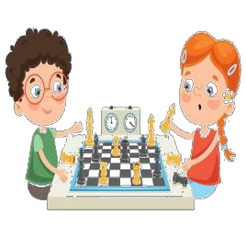
0. A: What is your favourite animal ?
B: It’s a dolphin.
a.
1. A: I have a new friend at school.
B: What nationality is he ?
A: He’s Malaysian.
b.
2. A: Where are the pictures ?
B: They’re on the wall, under the clock.
c.
3. A: What did you do yesterday evening ?
B: I played chess with my brother at home.
d.
4. A: What is your brother like ?
B: He’s a clever boy.
e.

f.
5. A: Why does she like playing sports ?
B: Because it’s useful and intersting.

Read the passage and answer the questinos. There is 1 example .(1.25 points)

Minh is a friendly and clever boy. In his free time, he likes playing the violin and going for a walk. On the weekends, he often helps his mother water the flowers in the garden and sometimes surfs the Internet. Minh’s best friend, Lan, likes reading books and doing projects at school. She thinks reading books is interesting and useful

because she can learn new things. In the future, Minh would like to be a firefighter
because he wants to help people. Lan, on the other hand, wants to be a writer because she likes writing stories. They both enjoy their hobbies and often do group work together.

0. What’s the boy’s name ?

His name’s Minh .
1. What does Minh like doing in his free time ?
.
- What school activity does Lan like ?
.
- Why does Lan think reading books is interesting ?

- What does Minh often do on the weekends ? .
.
- What would Minh like to be in the future? Why?
.

PART C: WRITING
  - Complete the sentences. There is 1 example .(1.25 points)

0. I’m in class 5A .

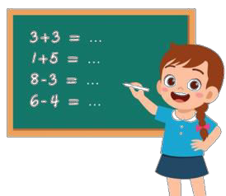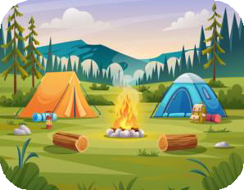

- She likes at school.
- We were at the last weekend.


- At the weekend, I often . 3. My friend is .

5. I were at yesterday.

Reorder the words. There are examples. ( 1.25 points)
0. class 5B/ in/ I’m.

I’m in class 5B.

1. do/ at/ What/ you/ do/ the/ weekend?
.
3. clock/ the/ above/ is/ pictures/ the/.
- Why/ she/ would/ to/ gardener/ like/ a/ be?
.
  - the/ like/ I/ flowers/ watering.

. .
  - your/ free/ What/ in/ you/ like/ doing/ do/ time?
.

PART D: SPEAKING
- Answer about you. ( 1 point)

1. What’s your name ?
.
3. Where do you live, in the city or in the
countryside?
.
2. Which class are you in?
.
- What is your favourite colour?
.

Look and say. There is one example. ( 1 point)
  - What nationality is she ?

She’s Vietnamese .



  - Where is the map ?
.
  - What did you do yesterday ?
.

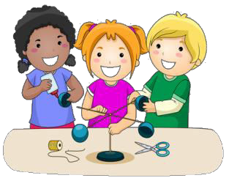

  - What do you do at the weekend ?
.
  - What school activity does she like ?
.



  - What did you do at Dam Sen Theme park ?
.
  - Were you at the funfair last Sunday ?
.

The end
Keys

PART A: LISTENNING
I. Listen and number

1. D | 2. C | 3. E | 4. A

II. Listen and tick or cross

1. V | 2. X | 3. V

III. Listen and write

1. listened to music | 2. group work | 3. aquarium

PART B: READING
I. Read and match

1. F | 2. A | 3. E | 4. B | 5.C

II. Read the passage and fill in the blanks

1. (He likes) playing violin and going for a walk.
2. (He) helps his mother water the flowers.
3. He’d like to be a firefighter because he wants to help people.
4. Shes likes reading books and doing projects
5. Because she can learn new things.

PART C: WRITING
I. Complete the sentences
1.solving maths problems 2. campsite
3. surf the Internet 4. Austrailian / from Australia
5. aquarium

II. Reorder the words
1. What do you do at the weekend ? 2. Why would she like to be a gardener ?
3. The clock is above the pictures. 4. I like watering the flowers.
5. What do you do in your free time ?

PART D: SPEAKING
I. Answer about you
II. Look and say
1. It’s on the wall, next to the board. 2. I listened to music.
3. I go for a walk. 4. She likes doing projects.
5. we/ I played games. 6. No, we weren’t.

